EXPERIMENTS

DA³-BES: Exploring Complex Adaptive Systems Using Dynamic Multi-Agent Models for Honey Bee Colony Environment Simulation

Benjamin Wingerter¹, Rubi Quiñones², and Dominic Cristiano³

¹School of Computing, University of Nebraska - Lincoln, Lincoln, NE 68583

²Department of Computer Science, Southern Illinois University Edwardsville, Edwardsville, IL 62026

³School of Natural Resources, University of Nebraska - Lincoln, Lincoln, NE 68583

Corresponding author: Rubi Quiñones (rquinones@siue.edu)

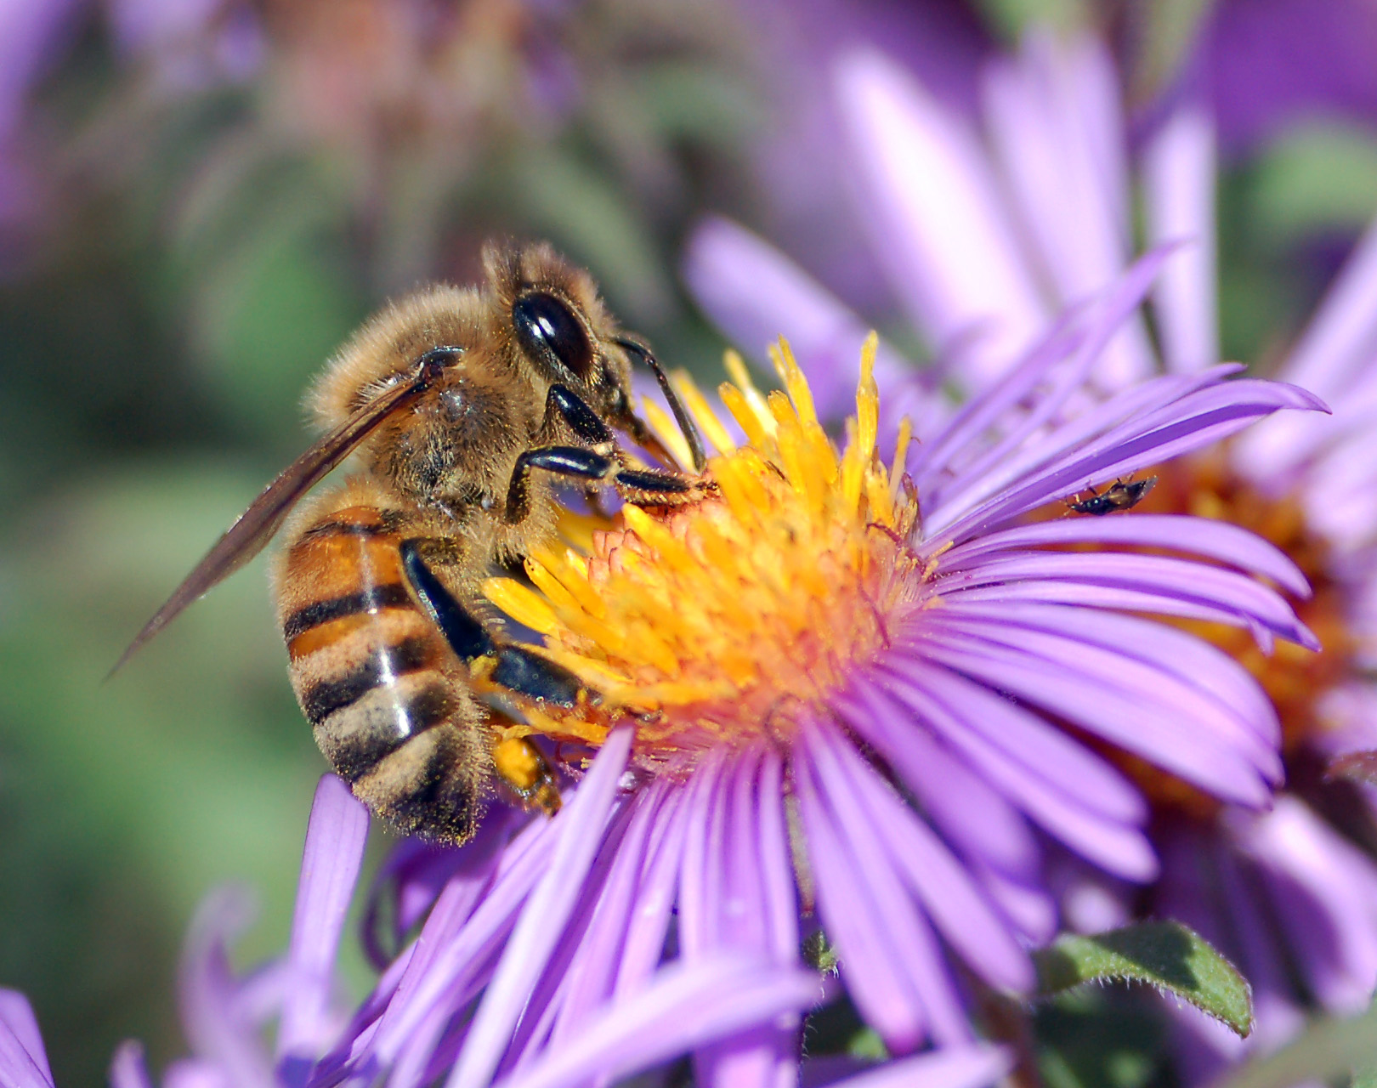
A honey bee (Apis mellifera) extracting food from a flower while foraging.
Licensing: Public Domain. Source

ABSTRACT
In this activity, students will learn about complex adaptive systems and ecological resilience through the evaluation of our novel multi-agent simulation, DA³-BES (Dynamic Three-Agent - Bee Environment Simulation). Students will use DA³-BES to study the impacts of a variety of dynamic multi-agent environmental parameters on honey bee colonies followed by a comprehensive evaluation of the influences of parameters. The simulation allows students to hypothesize, perform analytics, and answer concluding questions and thoughts.

FOUR DIMENSIONAL ECOLOGY EDUCATION (4DEE) FRAMEWORK
- Core Ecological Concepts:
  - Organisms
    - Abiotic and biotic features of the environment
  - Community
    - Stability - resistance, disturbance
    - Behavioral ecology
- Ecology Practices:
  - Quantitative Reasoning and Computational Thinking
    - Modeling and simulation
- Human-Environment Interactions:
  - How humans shape and manage ecosystems
- Cross-cutting Themes:
  - Spatial and Temporal
    - Scales, stability and change

CLASS TIME
This experiment would take 2 labs/classes for setup and experimentation. This assumes class time is 60 to 90 minutes. Any answering of discussion questions will happen outside of the classroom.
OUTSIDE OF CLASS TIME
Students should read the assignment prior to coming to class. It is also recommended that students follow steps 1 to 5 in the 'Simulation Tutorial' Section prior to the activity. Discussion questions should be completed outside of class time.
STUDENT PRODUCTS
Students provide written answers to three sets of questions following the completion of the exercise.
SETTING
This activity is conducted in a classroom or remote environment. It requires access to a computer where the student has permission to download and run the software.
COURSE CONTEXT
This activity is designed to be conducted in a class size of 30-40 students, or how many students an instructor can support in a classroom.
TRANSFERABILITY
This activity was designed for students in ecological and non-major computer science courses. It contains sufficient background information to understand multi-agents, simulation behavior, and complex adaptive systems. Furthermore, this content can be incorporated into any course that covers complex adaptive systems.
ACKNOWLEDGEMENTS
The authors thank the Council for Resilience Education at the University of Nebraska-Lincoln for providing their knowledge and expertise on complex adaptive systems. The authors of the Repast Simphony multi-agent modeling suite deserve recognition for building the libraries upon which this simulation was built.

This material is based upon work supported by the National Science Foundation under Grant No. DGE-1735362. Any opinions, findings, and conclusions or recommendations expressed in this material are those of the author(s) and do not necessarily reflect the views of the National Science Foundation. Also, the authors acknowledge the support provided by the Agriculture and Food Research Initiative Grant number NEB-21-176 and NEB-21-166 from the USDA National Institute of Food and Agriculture, Plant Health and Production and Plant Products: Plant Breeding for Agricultural Production.

SYNOPSIS OF THE EXPERIMENT

Principal Ecological Question Addressed
How can complex adaptive systems help us understand how honey bee colonies adapt to be successful in various environments?

What Happens
Students are introduced to the concepts of complex adaptive systems and general honey bee colony dynamics. Then, they learn the fundamentals of multi-agent simulation, exploring agent behavior and simulation parameters. Students begin the experiment by responding to hypothesis questions about probable simulation behavior. Students work through multiple experimental questions to guide their activity through the simulation, then they respond to their initial hypothesis questions. The experiment concludes with analytical questions and questions for further thought and discussion.

Experiment Objectives
- Describe the core principles of complex adaptive systems.
- Explain how the core principles of complex adaptive systems apply to certain social and ecological systems.
- Demonstrate how manipulating specific parameters impacts the outcomes of simulated honey bee colonies.
- Interpret the results of a simulated honey bee colony experiment.
Equipment/ Logistics Required
- Computer or Laptop running Windows, MacOS, or Linux where the student has permission to install software.
- Java 1.8+ (https://www.java.com/en/)
- Bee Simulation Model (https://github.com/benwingerter/bee-simulation/releases)
Summary of What is Due
Students submit their responses to the experiment questions (hypothesis questions, analytical questions, and questions for further thought and discussion) for evaluation. Graphs, charts, and environment grid images may be used as supporting materials or evidence of participation.

DETAILED DESCRIPTION OF THE EXPERIMENT

Introduction

As the most common pollinator species for crops worldwide, the western honey bee (Apis melifera) is one of the most important species for the health and wellbeing of humans (Hung et al. 2018). The global economy is greatly dependent on the health of these pollinators: honey bees alone contribute more than $15 billion to the United States economy (Office of the Press Secretary 2014). Alarmingly, the number of honey bee colonies has been halved over the past 60 years (Office of the Press Secretary 2014). Because of the integral role these organisms play in global food systems, it is critical to understand all aspects of their survival and behavior.

Honey bee colonies are highly social; they are sometimes referred to as superorganisms, where the entire colony functions in a manner similar to a cohesive unit (Mortensen et al. 2019). Furthermore, we can view honey bee colonies through the lens of complex adaptive systems, as the behavior of the entire colony may not be predictable based on the behavior and interactions among the individual members of the colony. Complex adaptive systems can inform our understanding of honey bees by providing insight on how the health and survival of colonies as a unit are impacted by internal and external factors.

What Defines a Complex Adaptive System

Holland (1995) used the term “complex adaptive systems” (CASs) to refer to systems that featured nonlinearity, aggregation, flows, diversity, tagging, and internal models. Levin (1998) reworked this definition of CASs to describe systems with “sustained diversity and individuality of components, localized interactions among components, and an autonomous process that selects from among those components, based on the results of local interactions.” In this activity, we use “complex adaptive systems” to refer to systems with the following six traits: 1) complex, 2) adaptable, 3) self-organizable, 4) open, 5) an emergent phenomena, and 6) hierarchical or in-network.

Complex: As the name implies, a CAS is complex - this does not mean complicated! A piece of machinery, for example, may be complicated but not complex. A complicated system may have a lot of components, but each part works in a predetermined and predictable way. A complex system, on the other hand, has multiple interacting and overlapping components and variables that may change and adjust unpredictably as their environment changes.

Adaptable: An adaptation is an adjustment by an entity or system to changing conditions or circumstances. Components in a CAS will make adjustments in order to maintain integrity in the system - that is, the agents adjust to ensure that the system can still perform its essential functions. These agents act independently of each other and of external influences.

Self-Organizable: Self-organization is the ability of system components to create structure without need for external influence or top-down controllers.

Open: The fourth trait of a CAS is an open system. An open system is one in which energy can be transferred in and out of the system and new components can become part of the system. A closed system, on the other hand, is isolated. New system components cannot be integrated into the system, at least not without difficulty. For example, cities are open systems - new people and resources move in and out of the city borders each day.

An Emergent Phenomena: Complex adaptive systems create emergent phenomena. This means the whole is greater than the sum of its parts. As components interact with each other, unexpected system characteristics arise that we would not otherwise have predicted to find in the system based on the individual agents. For example, consciousness in humans can be viewed as emergence. When looking at all of the individual parts of a human body, we probably wouldn’t have expected them to come together to form a conscious individual.

Hierarchical or In-Network: A CAS may be a network system or a hierarchical system. In a network system, components will be at the same scale and interact with each other equally. In a hierarchical system, components still interact with each other, but different components exist at different scales.

Complex Adaptive System Examples

Bird Flocks: In a flock of birds, each bird is flying independently and making individual decisions based on environmental conditions and the movements of surrounding birds. Ultimately, the decisions of these individual birds emerge into an ever-shifting, often-mesmerizing pattern as the flock moves from one place to another as a unit.

Ants: Ants also represent complex adaptive systems. Each ant acts independently, making decisions based on environmental factors and the actions of the ants around them. Some species of ants leave a trail of pheromones on the ground when they find food. Other ants will follow this path to find the food source, while depositing more pheromones on the ground. Greater concentrations of pheromones will attract more ants to follow the path to the food source. This synergy of individual ant activity of finding food and returning to the nest emerges as a highly efficient way to collect food (Dorigo et al. 2006). The individual activities of the ants are not guided by another, as in a hierarchy, but instead develop through relationships and processes among individuals, equal components that exist at the same scale. This makes food-collecting ants an example of a network complex adaptive system, one of the two possibilities referred to in the sixth CAS trait.

Bees: Honey bee colonies are commonly used as an example of complex adaptive systems. Individuals within colonies are divided into different roles (queen, drones, workers) that perform different tasks according to their role and age. Many of the individuals in the colony (workers) are non-reproductive; instead, they help with the rearing of offspring from the other members of the colony (Mortensen et al. 2019). Age-related division of labor is known as temporal polytheism - specific roles transition from further inside the colony to foraging and other work on the periphery and outside of the colony as bees age (Mortensen et al. 2019). This shift is related to the amount of juvenile hormone (JH) in adults, with higher titers of JH linked to foraging behaviors (Elekonich et al. 2001). JH is a property that may be interacting and overlapping with other known or unknown properties that could influence the way bees interact with one another and its environment. Hormone levels have been known to impact the colony’s functionality and shift the colony’s demographics (Mortensen et al. 2019). Furthermore, although individual bees are ectotherms, together they can regulate the temperature of their nest. When the surrounding air temperature drops or rises, honey bees respond by either fanning air over droplets of water to cool the hive or clustering and vibrating their wings to generate heat (Mortensen et al. 2019). These examples demonstrate how although bee colonies are made up of many individual bees that respond differently to pheromone signals or environmental changes, they work together as a nest to protect and maintain the nest.

These examples of complex adaptive systems–bird flocks, ants, and bees–are all controlled by the behaviors of the individual components. This stands in contrast to systems that have top-down control and determination. Computer scientists use an approach called multi-agent simulations to digitally model complex adaptive systems. In these simulations, every agent, or animal, is an independent unit that operates according to a well-defined set of rules in relation to the environment. Changes in the environment adjust agent behavior, and the interactions between agents leads to an emergent behavior. The randomness embedded in the simulation combined with the distributed decision makes the simulation complex.

Simulating honey bee environments gives scientists an easy and cost-effective glimpse into the behaviors of real-world complex systems. This is particularly useful when designing interventions to help animal populations avoid failure. A number of multi-agent bee simulations have been proposed. BeeHave by Becher et al. (2014) is designed to provide scientists and policymakers with a fast and cost-effective digital simulation for understanding stressors to bee colonies. The bee foraging algorithm designed by Lemmens et al. (2007) is a computer science-focused algorithm that applies bee colony dynamics to problem solving. Lemmens et al. did not provide a copy of their model program alongside their publication. This could be an issue if researchers want to replicate their work for scientific advancement. The simulation used in this module focuses on creating educational value for teaching complex adaptive systems. It includes simple dynamics inspired by natural bee colony behavior, simple reproduction, and adverse impacts inspired by real scenarios. Transparent grid visualization and access to data give students insight into colony dynamics. This model diverges from BeeHave because it is designed with education first and foremost, leaving out advanced topics necessary to modeling real bee colonies but not necessary to understanding complex adaptive systems, such as brood and swarms. Furthermore, it omits advanced configuration settings, including input files that do not contribute to the educational goal of DA³-BES.
Materials and Methods

Study Site

You will conduct this activity on your computer using the Repast Simphony multi-agent modeling toolkit.

Overview of Data Collection and Analysis Methods

Simulating Complex Adaptive Systems: In this experiment, you will be using a multi-agent simulation to study the behavior of simplified honey bee agents foraging for food in a digital environment. Honey bees live in environments containing many factors that influence the expression of emergent colony dynamics, demonstrating complex adaptiveness. Even if you understood an individual bee’s response and behavior completely, it is impossible to predict what an entire colony will look like in the future. Honey bees communicate physically and chemically to find food, build their nest, and perform other critical functions. Environmental structure and alterations interact in confounding ways to influence honey bee colony dynamics (EFSA Scientific Committee et al. 2021). Habitable environment size, flower density, colony harvests, and herbicide exposure to flowering plants are all conditions included in this simulation that influence the honey bee colony.

This simulation uses the Repast Simphony toolkit for creating agent-based models (North et al. 2013). Repast Simphony is a capable multi-agent modeling framework that has been used by ecologists to model natural environments. For example, Parry et al. (2006) used Repast Simphony to create a multi-agent model to demonstrate how aphid populations respond to changes in agricultural landscapes. This simulation is inspired by other in silico experiments that are designed to introduce new concepts to students, including Exploring how climate will impact plant-insect distributions and interactions using open data and informatics (Clement et al. 2019) and Gaming Ag Nitrogen Cycling (Russell et al. 2020). This experiment focuses on introducing multi-agent modeling and complex adaptive systems. In this simulation, the terms “honey bees” and “bees” will be used interchangeably.

This simulation is not designed to be an accurate representation of real honey bees, as it includes simplified reproduction, smaller dimensions compared to what real honey bees traverse, and a constant season. What this simulation demonstrates is the behaviors of complex adaptive systems as represented by a multi-agent simulation inspired by bees, and your task will be to understand how this multi-agent simulation demonstrates complex adaptive systems.

Environmental Design: Multi-agent simulations proceed one “tick” at a time. During each tick, every individual bee is allowed to make one action. The bee multi-agent simulation begins with the creation of a user-defined grid-size environment. Students are able to define the initial population of bees, initial density of full nectaries, honey harvest probability, proportion of honey harvested, bee death probability, birth rate of new bee cohorts, bee sight radius, food expended to create each new bee cohort, flower nectary refill rate, maximum number of ticks, food per flower patch, herbicide drift probability, grid dimensions, and random generator seed before a simulation run. Further discussion of these parameters is in the section Parameters. The simulation defines the three types of agents to be bees, flowers, and the nest (see section Agent Finite State Machines).

The bee cohort agents work to identify sources of food in the environment and return the food to the colony nest one by one. Bee re-population has been simplified in this model. We define that the nest will spawn a new bee cohort by a probability of parameter bee cohort birth rate at every tick. If the nest attempts to spawn more bees but does not have enough food (parameter cost of new bee cohort), it will not spawn more bees on that tick. The spawn of new bees originates at the colony's nest. The default cost of spawning new bees is two food counts. Therefore, greater food counts collected by the bee agents result in more successful regeneration attempts.

Real honey bees face multiple adverse events that can impact their success. To name a few, colonies can develop infections of varroa mites that sap energy out of the honey bees, honey bees have limited lifespans, and honey bee colonies rely on the health of nearby flowering vegetation for food. This simulation includes three adverse impacts inspired by real events: (1) bee cohorts have a parameterized probability of death per tick; (2) beekeepers may remove food from the nest that’s used to nurture pupae by a parameterized probability at every tick; and (3) herbicide drifts will result in flower death at a parameterized probability at each flower independently at every tick. See section Parameters for details about adjusting the probabilities of adverse events.

Agent Design: The bee agent behavior was inspired by the work of Lemmens. et al. (2007). This model differs from Lemmens solution because it contains more bee states (or current actions being taken) and parameters to increase the extent to which you can influence the environment.

The bee agents operate on a set of rules:
- If the bee cohort does not see food and has no knowledge of a food source, then randomly wander.
- If a bee cohort detects food while wandering, then pick up food and remember the source.
- If a bee cohort is carrying food, then return to the nest.
- If a bee cohort is at the nest with food, then deposit the food.
- If a bee cohort has knowledge of a food source at the nest, then waggle dance.
- If a bee cohort does not have knowledge of a food source at the nest, then observe waggle dances.
- If a bee cohort is observing waggle dances, then pick the best dance and exploit the food source encoded in the dance. The best dance is determined by the one that represents a flower patch with the highest $food-distance$ value.
- If a bee cohort is observing waggle dances and there are no dances, then wander.
- If a bee cohort has finished waggle dancing, then return to its remembered food source.
- If a bee cohort arrives at an empty food source, then wander.
- If a bee cohort detects food while exploiting a source, then pick up food and remember the source.

The bee cohort agents have the following possible behaviors:
- Wander
- Observe Waggle dances
- Go to Source
- Deposit Food
- Return to Nest
- Waggle Dance
- Pick up Food

Figure 1 shows how the simulation appears on an 80x80 grid in Repast Simphony. The simulation has one nest, 15 bee cohorts, and 664 flower patches in the environment. These parameters are the default in our simulation. The bee cohorts outside of the nest are either wandering or exploiting a source of food.
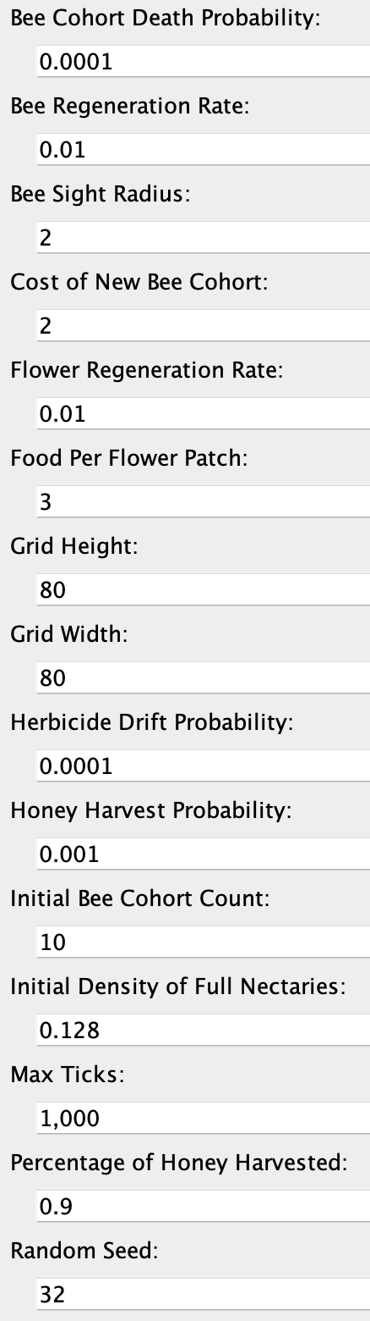
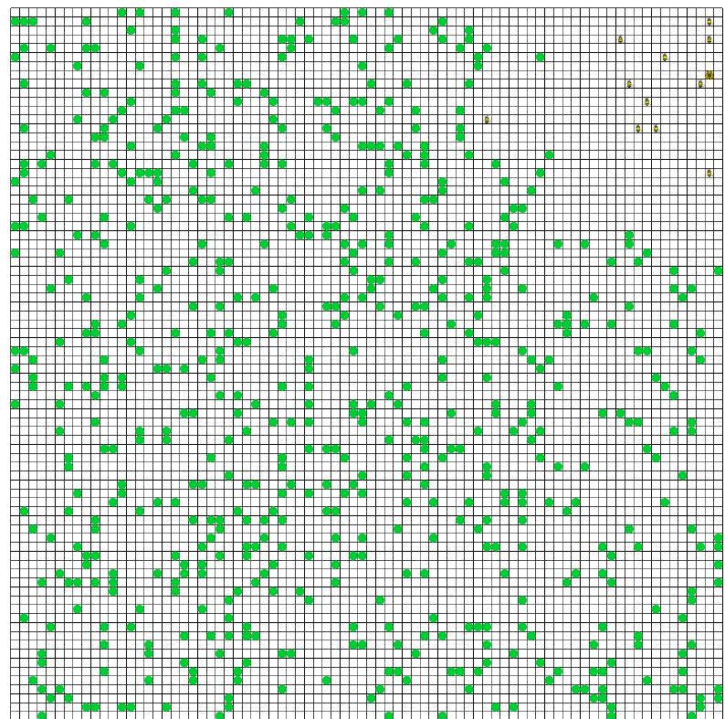
- (b)

Figure 1: Simulation grid (a) on tick 1000 with the listed parameters (b). The green dots represent the flowers, and the yellow dots (top right) represent the bees. The nest is located there, as well.

Agent Finite State Machines: The simulation has three types of agents that behave according to a well-defined set of rules. Bee cohorts are the primary agents of the simulation that act upon their environment. Flower patches and nests are additional agents that support the survival of bees. Bee cohorts are the only agent type that can change state, meaning that their intent can change based on stimuli from the environment. Figures 2, 3, and 4 detail the finite state machines for the three agent types, bee cohorts, flower patches, and nests, respectively. The rules that define agent behavior determine their state, or their intention, at any given moment. Since bee cohorts are the primary agent type that acts upon the world, they are the only agent type that can change state. Flower patches and nests are simply acted upon.

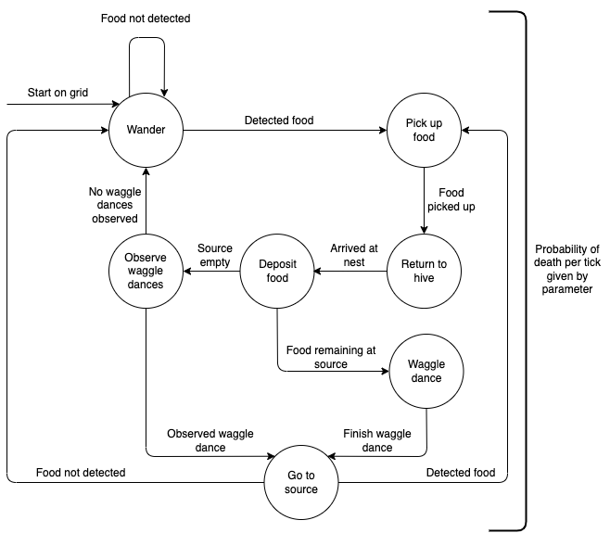

Figure 2: Bee finite state machine

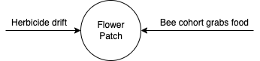

Figure 3: Flower patch finite state machine chart

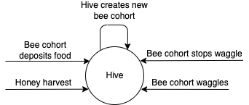

Figure 4: Nest finite state machine chart

Parameters: A set of simulation parameters may be tuned by the student to judge bee colony performance given different conditions. Table 1 below includes the default parameters for the simulation. Each value was chosen so that the simulation will reliably converge (refer to section Parameter Impacts) without changing any of the values. The values are not directly modeled to resemble a specific real-world environment.

The parameters can be adjusted to be inspired by a real-world environment if desired. For example, consider that every cell in the grid is 1/10 of a meter. The flower density for a mowed and unmowed grassland is 1.28 and 0.96 flowers per decimeter², respectively (Scriven et al. 2013). Clustering the flowers together into octuplets, we can set this density of groups to 0.16 and 0.12 groups per decimeter². We can therefore use these densities with a food count per flower of eight to abstractly model a mowed grassland or an unmowed grassland.

Table 1: Simulation parameters and its default values.
Parameter | Description | Default Value | Allowed Range
Random Seed | The seed that is used for all randomness in the model. | 32 | [0, 2 billion]
Max Ticks | The maximum number of ticks the model is allowed to run for. | 8,000 | [10, 50,000]
Grid Height | The height of the simulation environment. | 80 | [10, 500]
Grid Width | The width of the simulation environment. | 80 | [10, 500]
Initial Bee Population | The initial number of bee cohorts that begin in the nest. | 10 | [1, 500]
Initial Flower Density | The initial density of flowers on the grid as a percentage of grid cells. | 0.128 | [0,1]
Food Per Flower | Each flower is generated with this much food. A bee removes one food unit from a flower on each visit. When food equals zero, the flower disappears. | 3 | [0, 100]
Bee Sight Radius | The distance from which bees can see flowers. Wandering bees will change to an exploitation state when a flower enters its sight radius. | 2 | [0, 100]
Bee Regeneration Rate | The probability, per tick, that the nest will attempt to produce a new bee if sufficient food is available. | 0.01 | [0,1]
Cost of New Bee | The amount of food in the nest consumed to add another bee to the population. | 2 | [0, 100]
Bee Death Probability | The probability, per tick, that a bee will die. | 0.0001 | [0,1]
Flower Patch Regeneration Rate | The probability that any individual cell will grow a flower in a given tick. | 0.01 | [0,1]
Herbicide Drift Probability | The probability, per tick, that each flower will lose its food content resulting from herbicide contamination. | 0.0005 | [0,1]
Harvest Honey Probability | The probability, per tick, that a beekeeper empties the food content of the nest. This slows bee reproduction. | 0.001 | [0,1]
Percentage of Honey Harvested | When the above event occurs, this parameter controls the percentage of the food removed from the nest. | 0.9 | [0,1]

Convergence: Convergence is the harmonic balance between bees and food that yields a self-sustaining environment. This simulation has two possible convergence states. First, the entire bee population may die before the maximum number of ticks is reached. We denote this as an “unstable nest.” This may be due to a variety of reasons, including inefficient foraging, sparse flower availability, and low reproduction rates. Second, the simulation may reach a balance between bee and flower populations. We denote this as “stable,” which may resemble harmonic fluctuations in flower and bee populations and a self-sustaining environment.

Emergent Behavior: A population of bees gathers energy in the form of food to fuel the development of new bees. The environment parameters, if tuned correctly, should yield a long-term balance between bee and flower populations. Ultimately, the success of the bee colony and emergent behavior is determined by the parameters chosen.

Figure 5 shows the relationship between the rate of food collection and the bee population size in the experiment run in Figure 1. In this experiment, bees had to travel further to gather food as the simulation progressed and the bee population grew, creating a negative relationship. The relationship may be present in other scenarios. Figure 6 shows an accompanying time series population chart for bees and flowers available in the simulation. Bee population surpasses flower population early on and remains high.

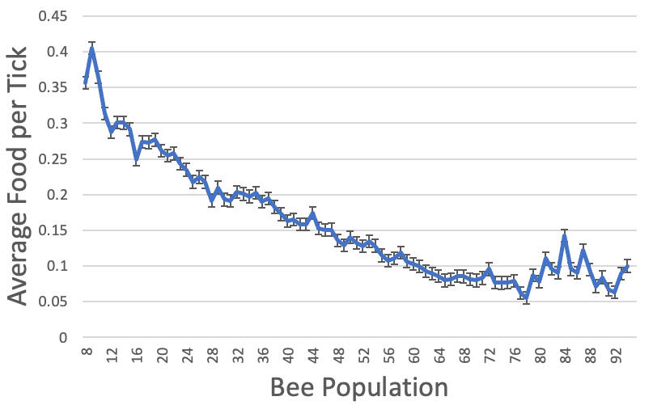

Figure 5: Average food collection rate of a colony at each population level using the default parameters. The x-axis is the bee population count, and the y-axis has the food collection rate of the colony at a given population count.
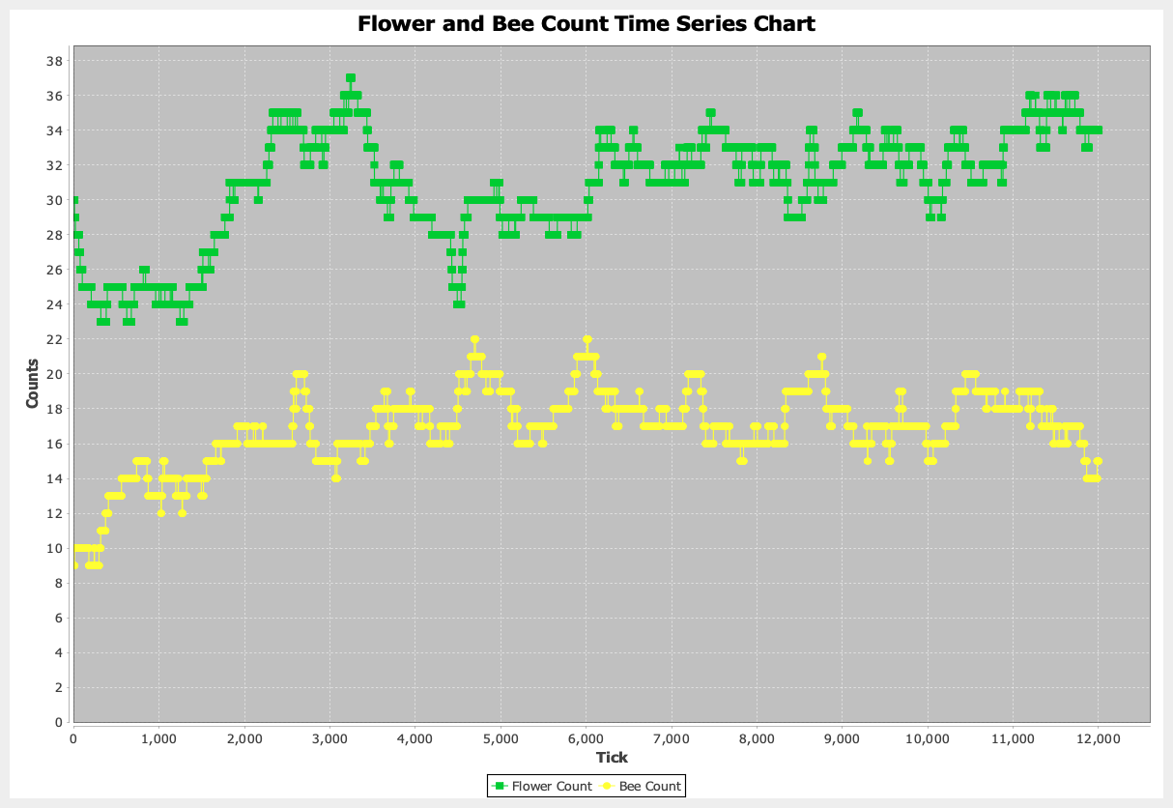
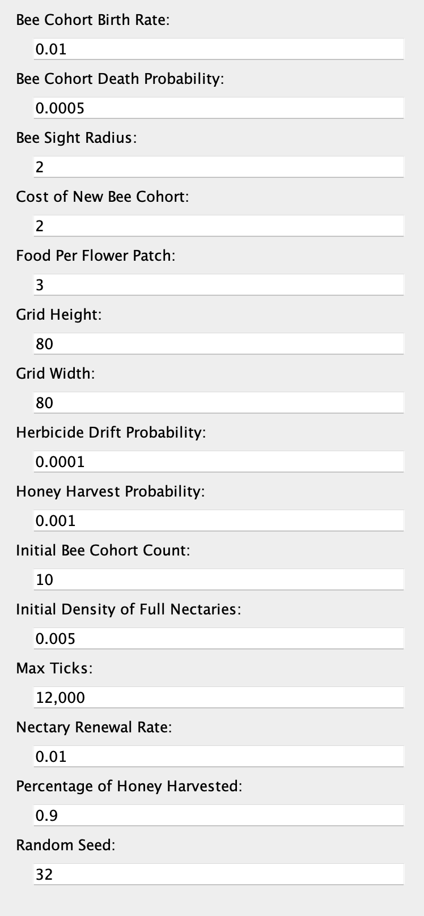

(a) (b)

Figure 6: Bee and flower populations over time (a) from running the simulation using the listed parameters (b). The green line represents the flower population at every tick and the yellow line indicates the bee population at every tick. This chart suggests that the bees effectively exploited the flowers because the bee population maintained a steady increase as time progressed.

Simulation Tutorial
- Confirm that you have Java version 8 or higher (https://www.java.com) installed on your computer. This is required to run the simulation. See https://www.java.com/en/download/help/version_manual.html on how to check your Java version.
- Download and install the latest version of Repast Simphony from the website: https://repast.github.io/download.html
- Download the latest version of DA³-BES (https://github.com/benwingerter/bee-simulation/releases). This is available under the Assets dropdown at the link. Choose the file labeled Source Code (zip).
- Unzip the downloaded file.
- Launch Repast simphony.
- Click File -> Import -> General -> Existing Projects into Workspace.
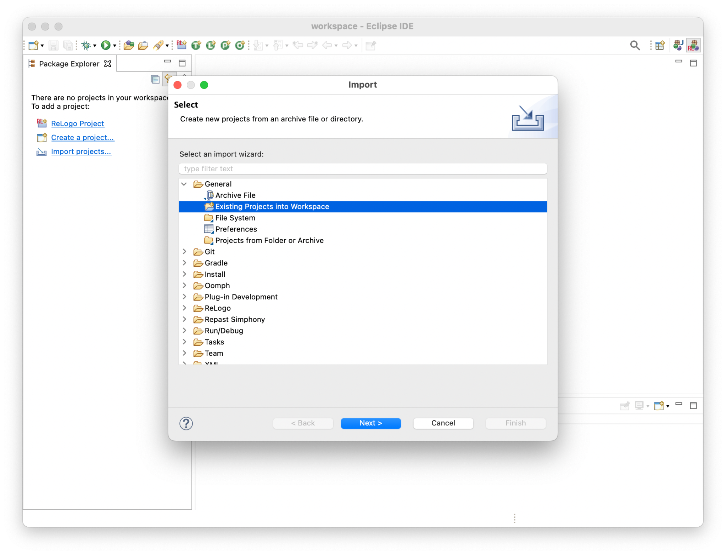
- Select Select Root Directory and click Browse.
- Navigate and open the unzipped folder containing the downloaded simulation.
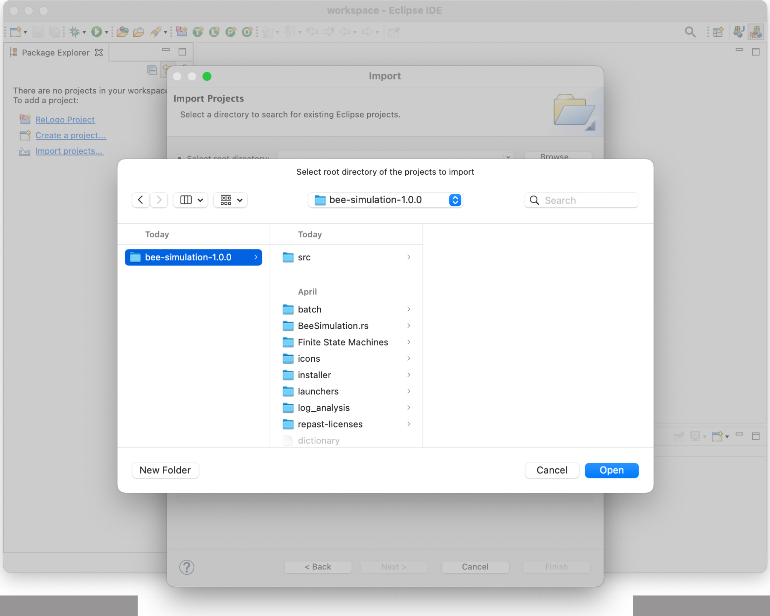
- Click Finish.
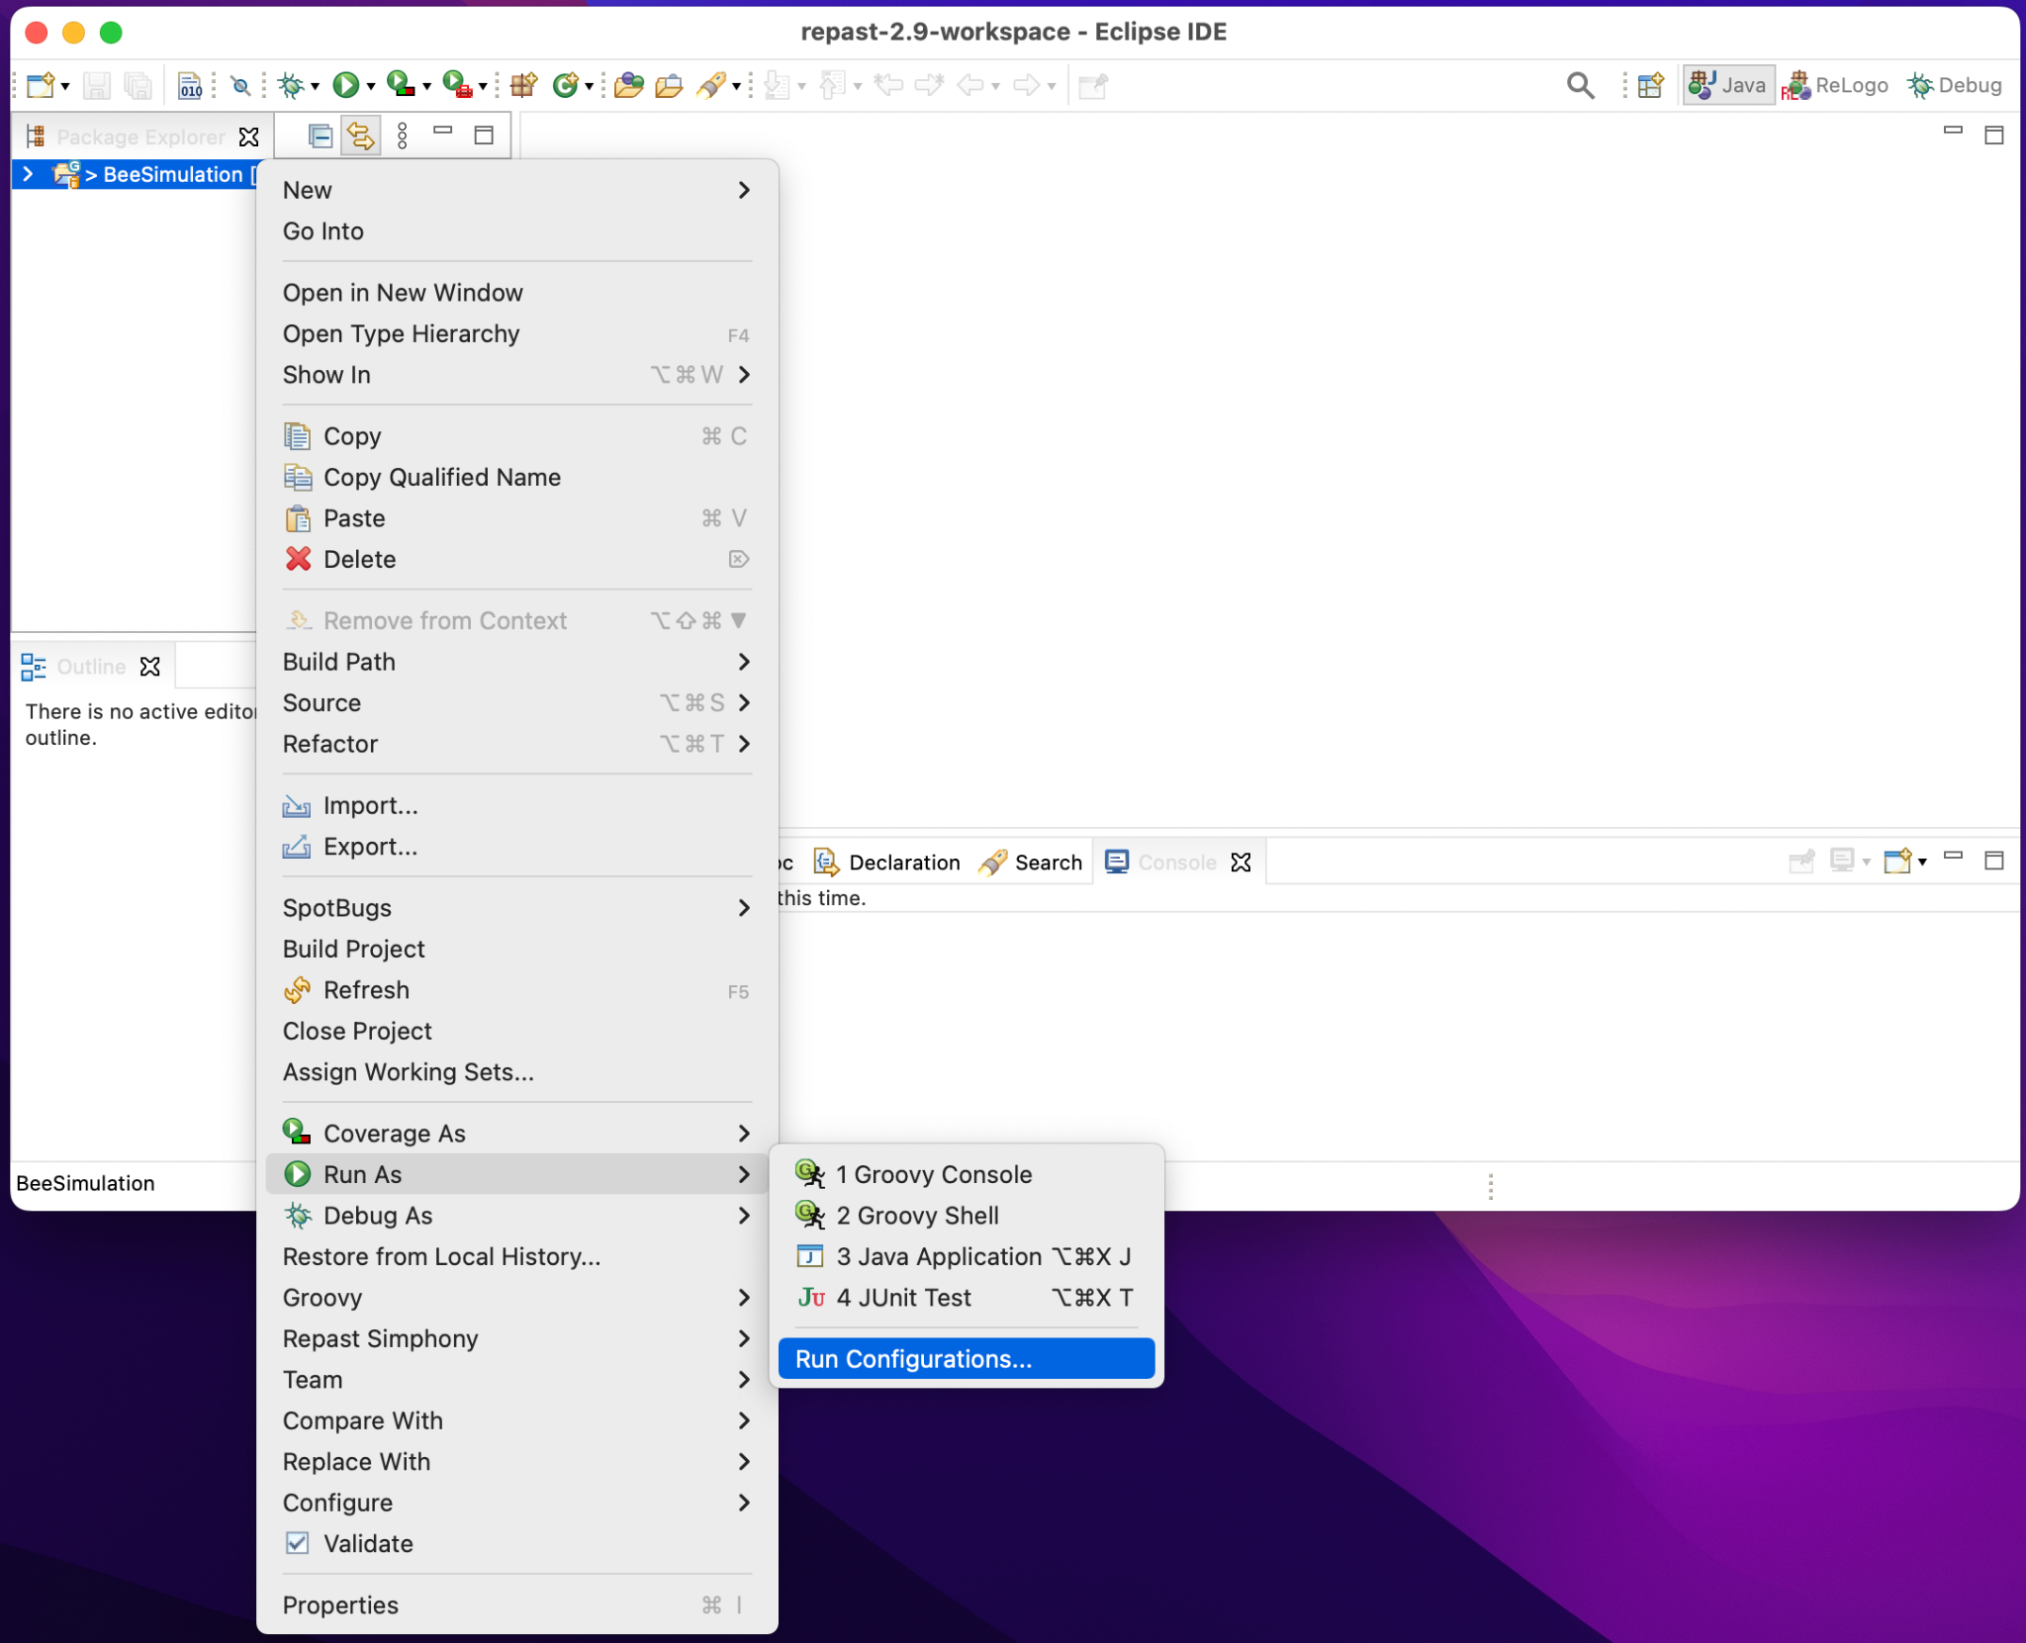
- Right click on BeeSimulation on the left of the window, click Run As -> Run Configurations…

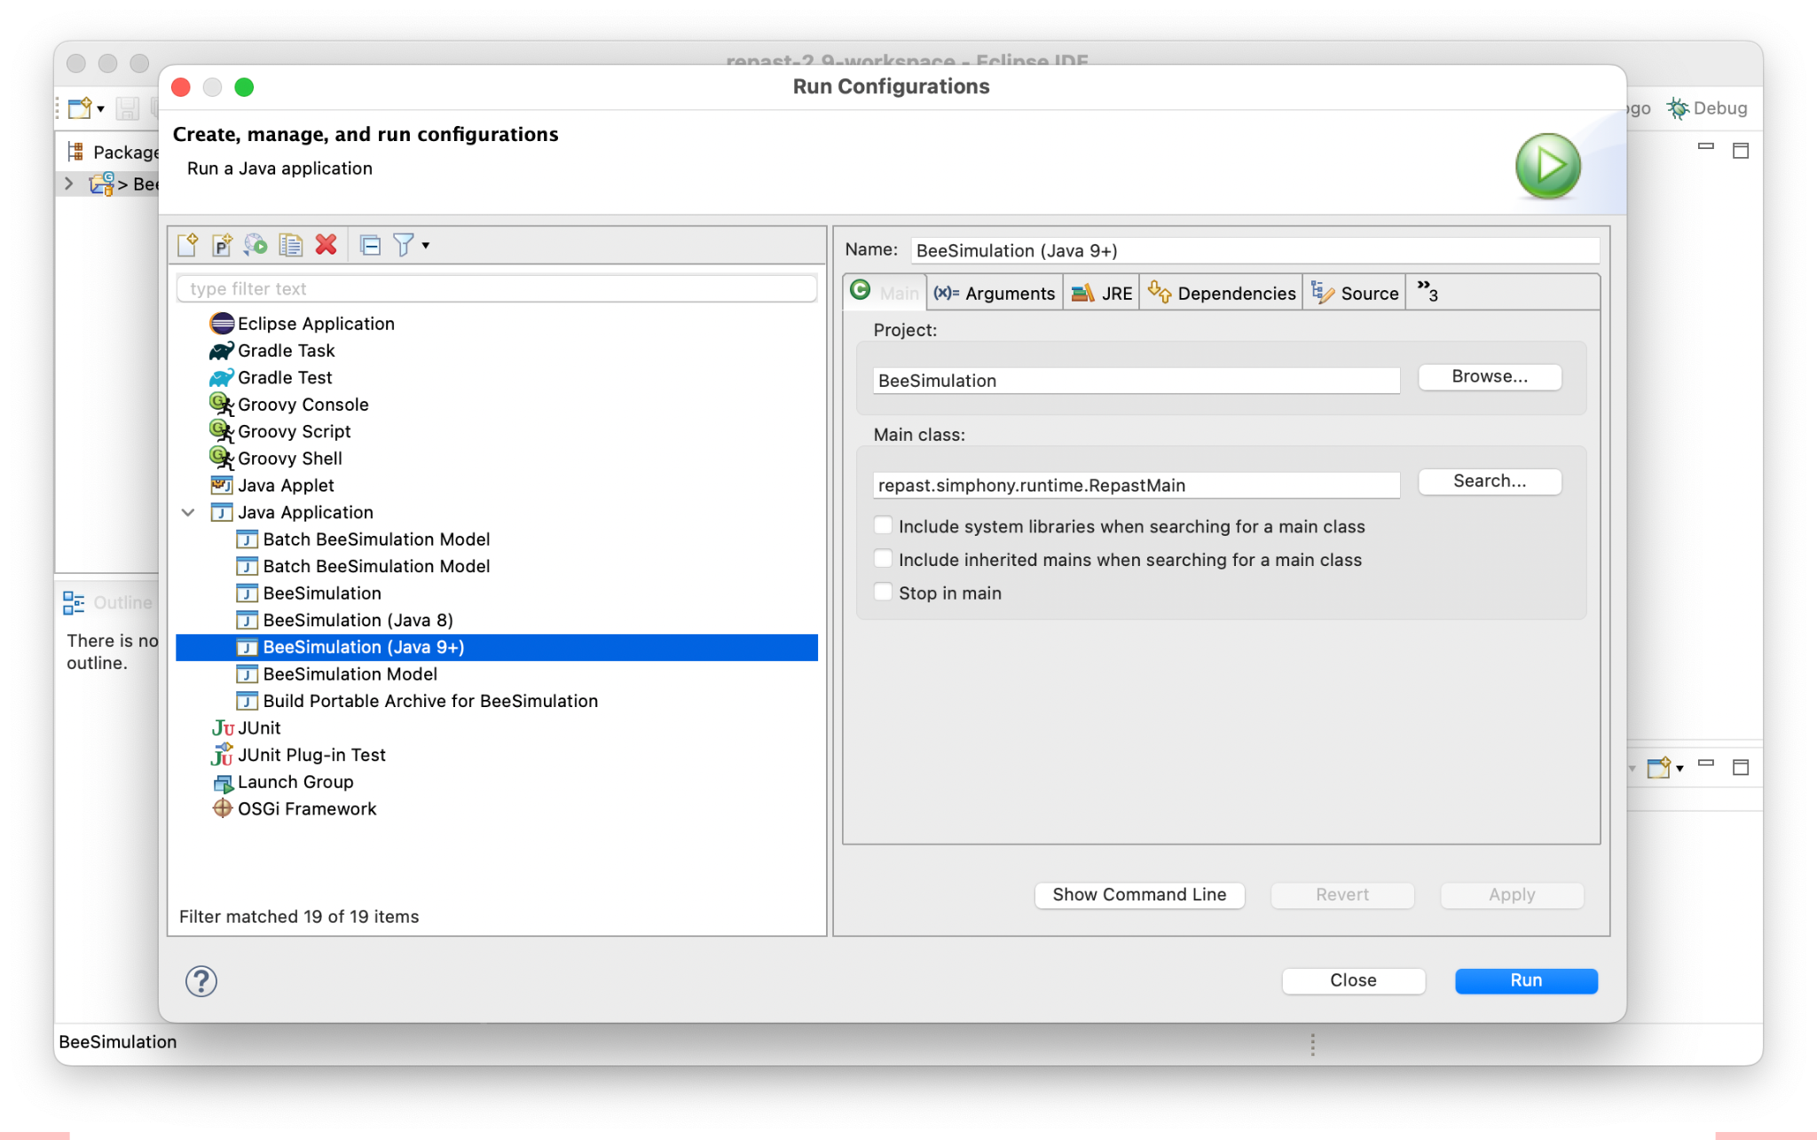
- Expand Java Application, select either Bee Simulation (Java 8) or Bee Simulation (Java 9+) depending on your Java version, then click Run.

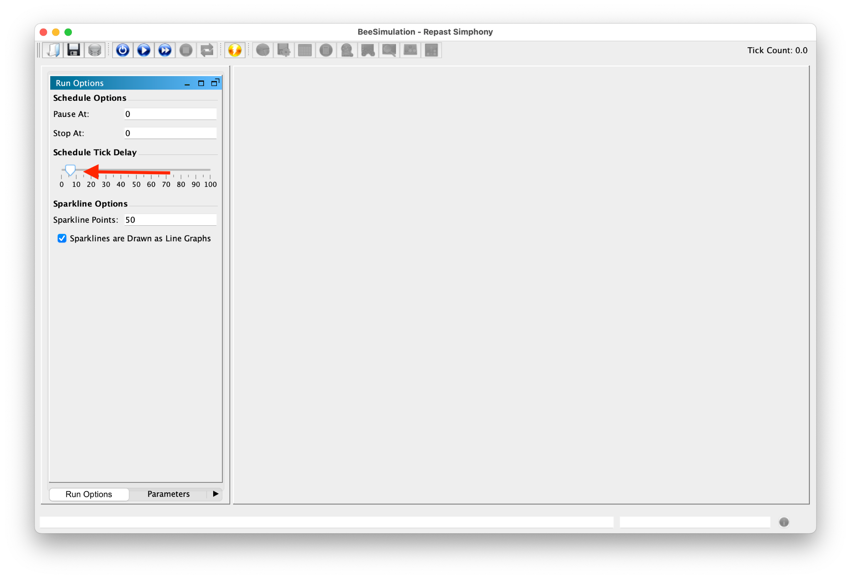
- In the Run Options Tab on the bottom right, set the Schedule Tick Delay to 10 to slow down the model and visualize the movements of the bee cohorts.
- In the Parameters Tab on the bottom right, change the default random seed to a random integer between 1 and 100.
- Click the Initialize button near the top of the window to set up the simulation. Note that parameter adjustments in the Parameters option pane must be completed before initializing to have an effect.
- In the User Panel tab on the bottom right, click the honey harvest button. Notice the list of honey harvest occurrences available to view.
- Click the start button on the top to launch the simulation.
- Click the stop button to stop or pause the simulation.
- Click the reset button to reset the simulation. Parameters are reset to their default values every time the simulation is reset.

Exporting Data to Excel: When a simulation run has completed, you have the option of exporting data to an Excel spreadsheet to visualize simulation behavior. When the simulation has finished, click the spreadsheet button on the top of the simulation window to export the data to a spreadsheet that includes bee count, flower count, and food collected at every tick.

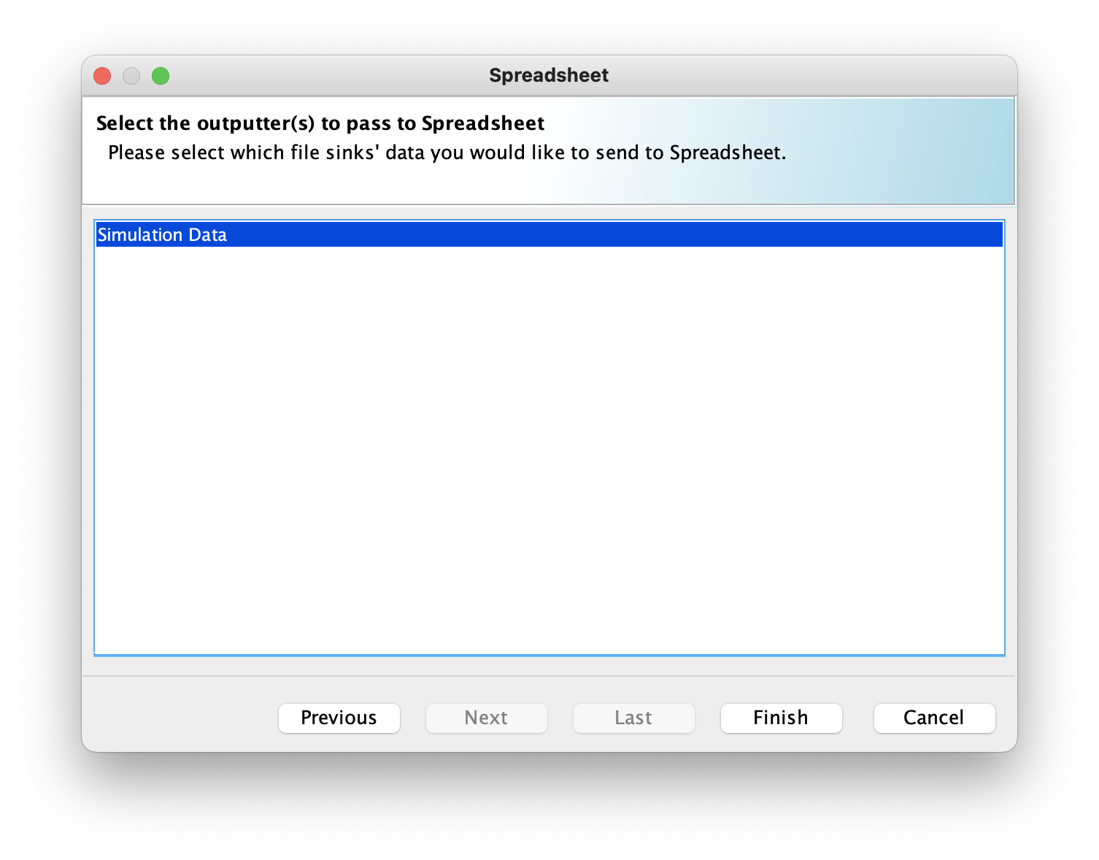

Select Simulation Data and click Finish. The program will then confirm the installation location of Excel and then open the results in Excel. Once Excel has opened, select File, Save As, then select File Format as Excel Workbook (.xlsx). Excel will open the file in an Excel Workbook format instead of a comma separated value (CSV) format which allows you to run calculations on the data.
Questions for Further Thought and Discussion:

Hypothesis Questions

These questions are meant to be answered BEFORE running the simulation. Take your best guess.
- How might the rate of flower patch generation affect the rate of food collection?
- How might the rate of food collection be correlated with bee population size?
- Is there a Bee Sight radius or radii where the rate of food collection might slow?
- What potential parameters could force the simulation to not achieve convergence (i.e., have all honey bees die)?
- How would a bee colony simulation resemble a complex adaptive system?

Analytical Questions

Use the graphs generated by the multi-agent simulation to quantify your answer for the following questions.
- How does the rate of flower patch generation affect the rate of food collection?
- How are the rate of food collection and bee population correlated? This question requires computation of the rates using the data from the Excel sheets.
- Is there a Bee Sight radius or radii where the rate of food collection slows?
- Provide a parameter combination that causes the bees to die out.

Additional Computer Science Questions
- What aspects does the simulation (code and logic) need to contain in order for the environment to be considered resilient?
- Would the degree of coordination amongst the different agent types affect convergence?
- How many tasks should be allocated to an agent before considering creating a new agent type to handle some of the overloaded tasks?
- Twiston-Davies et al. (2021) provide an example of another simulation regarding honey bee colonies (https://besjournals.onlinelibrary.wiley.com/doi/epdf/10.1111/2041-210X.13673). This simulation is more detailed than ours and includes a variety of other parameters. Choose two parameters from that paper and discuss how they might be incorporated into this simulation? How do you think these parameters would impact the colonies?
- How are the dynamics of a real-world bee colony different?
- What environmental aspects in the simulation impacted the resilience of bee colonies the most?
- How could this simulation be modified to account for differences in age and JH in bees? How would this impact the colony dynamics? Refer to Mortensen et al. (2019) for further information about JH and age (https://edis.ifas.ufl.edu/publication/IN1102).
References

Becher, M. A., V. Grimm, P. Thorbek, J. Horn, P. J. Kennedy, and J. L.Osborne. 2014. BEEHAVE: a systems model of honeybee colony dynamics and foraging to explore multifactorial causes of colony failure. Journal of Applied Ecology, 51:470-482.

Clement, W., K. Prudic, and J. Oliver. 2019. Exploring how climate will impact plant-insect distributions and interactions using open data and informatics. Ecological Society of America, QUBES Educational Resources. https://doi.org/10.25334/Q41T9B

Dorigo, M., M. Birattari, and T. Stützle. 2006. Ant Colony Optimization: Artificial ants as a computational intelligence technique. IEEE Comput. Intell. 1:28-39.

EFSA Scientific Committee, S. More, V. Bampidis, D. Benford, C. Bragard, T. Halldorsson, A. Hernández-Jerez, S. H. Bennekou, K. Koutsoumanis, K. Machera, and H. Naegeli. 2021. A systems-based approach to the environmental risk assessment of multiple stressors in honey bees. EFSA Journal 19:e06607.

Elekonich, M. M., D. J. Schulz, G. Bloch, and G. E. Robinson. 2001. Juvenile hormone levels in honey bee (Apis mellifera L.) foragers: foraging experience and diurnal variation. Journal of Insect Physiology 47:1119–1125. https://doi.org/10.1016/s0022-1910(01)00090-7

Holland, J. 1995. Hidden order: how adaptation builds complexity. Addison-Wesley, Reading, Massachusetts, USA.

Hung, K. J., J. M. Kingston, M. Albrecht, D. A. Holway, and J. R. Kohn. 2018. The worldwide importance of honey bees as pollinators in natural habitats. Proceedings of the Royal Society B: Biological Sciences 285:20172140. https://doi.org/10.1098/rspb.2017.2140

LaMorte, W. 2022. P-Values. [online] Sphweb.bumc.bu.edu. Available at: https://sphweb.bumc.bu.edu/otlt/MPH-Modules/PH717-QuantCore/PH717-Module7-T-tests/PH717-Module7-T-tests3.html

Lemmens, N., S. De Jong, K. Tuyls, and A. Nowé. 2007. Bee behaviour in multi-agent systems: A bee foraging algorithm. Pages 126-138 In Proceedings of the 7th ALAMAS Symposium.

Levin, S. A. 1998. Ecosystems and the biosphere as complex adaptive systems. Ecosystems 1:431-436. http://dx.doi.org/10.1007/s100219900037

Miller, J. H. and S. E. Page. 2007. Complex Adaptive Systems: An Introduction to Computational Models of Social Life. Princeton University Press. Princeton, NJ, USA.

Mortensen, A. N., B. Smith, and J. D. Ellis. 2019. The social organization of honeybees. UF/IFAS Extension.

North, M. J., N. T. Collier, J. Ozik, E. R. Tatara, C. M. Macal, M. Bragen, and P. Sydelko. 2013. Complex adaptive systems modeling with Repast Simphony. Complex adaptive systems modeling 1:1-26.

Office of the Press Secretary. 2014. Fact Sheet: The Economic Challenge Posed by Declining Pollinator Populations. Obama White House Archives. https://obamawhitehouse.archives.gov/the-press-office/2014/06/20/fact-sheet-economic-challenge-posed-declining-pollinator-populations

Parry, H. R., A. J. Evans, and D. Morgan. 2006. Aphid population response to agricultural landscape change: a spatially explicit, individual-based model. Ecological Modelling 199:451-463.

Russell, A. E. and J. K. Dailey. 2020. Gaming Ag Nitrogen Cycling. Teaching Issues and Experiments in Ecology 16: Experiment #2. https://tiee.esa.org/vol/v16/experiments/russell/abstract.html

Scriven, L. A., M. J. Sweet, and G. R. Port. 2013. Flower density is more important than habitat type for increasing flower visiting insect diversity. International Journal of Ecology 2013:1-12.

​​Twiston-Davies, G., M. A. Becher, and J. L. Osborne. 2021. BEE-STEWARD: A research and decision-support software for effective land management to promote bumblebee populations. Methods in Ecology and Evolution 12:1809-1815. https://doi.org/10.1111/2041-210X.13673

Tools for Assessment of Student Learning Outcomes:

Students will be assessed on the basis of their participation, the accuracy of their answers to the analytical questions, and the demonstration of critical thinking in their answers to the hypothesis questions and questions for future thought and discussion. Students will turn in written responses to three sets of questions after completing the simulation. Questions to be answered by students can be found above in the Hypothesis Questions, Analytical Questions, and Questions for Further Thought and Discussion sections. Because of the transferability of this exercise to classrooms of varying sizes and formats, instructors are encouraged to adapt this evaluation guide to best suit the aspects of their own classrooms.

 | Poor | Satisfactory | Exceptional
Analytical Questions | Little to no correct or reasonable answers to analytical questions | Reasonable and accurate answers to most analytical questions | Accurate answers to all analytical questions
Hypothesis Questions and Questions for Future Thought and Discussion | Student provides low-quality responses to questions; demonstrates no understanding of the exercise | Student provides reasonable answers and constructive dialogue to discussion; demonstrates adequate understanding of exercise | Student’s responses are high-level and detailed, adding new insights and connections in discussion; demonstrates strong and translational understanding of the exercise
Participation | Student is unengaged; does not address multiple questions | Student answers all questions with adequate effort | Student provides detailed and complete answers with notable effort

NOTES TO FACULTY

Challenges to Anticipate and Solve
- Java Not Installing. Some institutions may block installing Oracle Java on their computers due to licensing restrictions. An alternative distribution of Java with an open license is Adoptium (https://adoptium.net/).
- Simulation Freezes on Launching. The simulation program may rarely freeze upon clicking the start button. This is a problem in the underlying Repast Simphony toolkit. When this happens, use Task Manager on Windows or Force Quit on MacOS to shut down the simulation. Then launch the simulation again as you launched it the first time.
Comments on Introducing the Experiment to Your Students:

Complexity is a high-level concept with a rich theoretical background. Students do not need to understand all of the technical details and history of the field. Focus on what designates a system as complex (as opposed to complicated) and what the implications of complexity in ecological systems mean for adaptation.

Comments on the Data Collection and Analysis Methods:
We recommend that faculty download all resources and become familiar with running the simulation prior to using it in a course. Students should record the results of simulations, such as changed parameters and collection rates, to help answer the questions. This exercise is designed for students to experiment with different parameter combinations to understand simulation interactions.
Comments on Questions for Further Thought:

Additional Computer Science Questions
- What aspects does the simulation (code and logic) need to contain in order for the environment to be considered resilient?

Resiliency is the ability to respond and adapt to changes or disturbances in the environment. A simulation could have multiple states of equilibrium (i.e., not just bouncing back to one state). You may expect answers that involves the bees’ relationship to herbicide. Advanced answers may discuss possible features to include that could test the resiliency of the bees.
- Would the degree of coordination amongst the different agent types affect convergence?

There’s no perfect answer for this question. We look for reasoning and depth of thought. It ultimately depends on how the coordination is defined, and possible answers would mention:
- More coordination could lead to convergence more quickly.
- More coordination may lead to socially optimal convergence.
- More coordination may lead to unsustainable resource exploitation.
- What kind of tasks should be allocated to an agent before considering creating a new agent type to handle some of the overloaded tasks?

Agent types in this simulation–bees, flowers, and colonies–represent types of agents in the real world. If an agent is programmed to do a task that would belong to another plant, animal, or object in the real world, then it is time to assign that task to another agent type.
- Twiston-Davies et al. (2021) provide an example of another simulation regarding honeybee colonies (https://besjournals.onlinelibrary.wiley.com/doi/epdf/10.1111/2041-210X.13673). This simulation is more detailed than ours and includes a variety of other parameters. Choose two parameters from that paper and discuss how they might be incorporated into this simulation. How do you think these parameters would impact the colonies?

Answers will vary.
- How are the dynamics of a real-world bee colony different?

Bees are sensitive to more than just the environmental and spatial factors coded into the simulation. Individual differences among bees, including age, may lead to less predictable results.
- What environmental aspects in the simulation impacted the resilience of bee colonies the most?

Bees are able to adapt and change to continue persisting as a colony in the face of disturbance. Perseverance is impacted by a number of parameters; more resilient colonies are those that can continue surviving and functioning when faced with challenges.
- How could this simulation be modified to account for differences in age and JH in bees? How would this impact the colony dynamics? Refer to Mortensen et al. (2019) for further information about JH and age (https://edis.ifas.ufl.edu/publication/IN1102).
Bee age can be represented through ticks - bees that are older could exhibit more foraging behavior than those that are younger.
Comments on the Assessment of Student Learning Outcomes:
The assessment guidance provided earlier is a loose suggestion. Specific evaluation formats will be needed depending on the classroom and course context.
Comments on Formative Evaluation of this Experiment:

Our experiment instructions and details, like all of our teaching materials, are developed with guidance and feedback from education researchers at our institution. We consulted educational models, including Bloom’s Taxonomy, to craft targeted and appropriate learning objectives. We collected feedback from students who have used our education materials and incorporated their responses as we edit the materials. We encourage instructors who use this activity to collect and report feedback from their students, as well.
Comments on Translating the Activity to Other Institutional Scales or Locations:
- This activity translates well to smaller schools, as it can be worked on individually or in small groups.
- Because it is a computer simulation, this activity can be used anywhere with internet access.
- DA³-BES is not optimized to support users with disability constraints; the instructor should decide if the activity is appropriate for their students with disabilities and identify alternative activities if appropriate.
- Because of the advanced nature of the topic of the activity, it is most likely not suitable for K-12 education.

