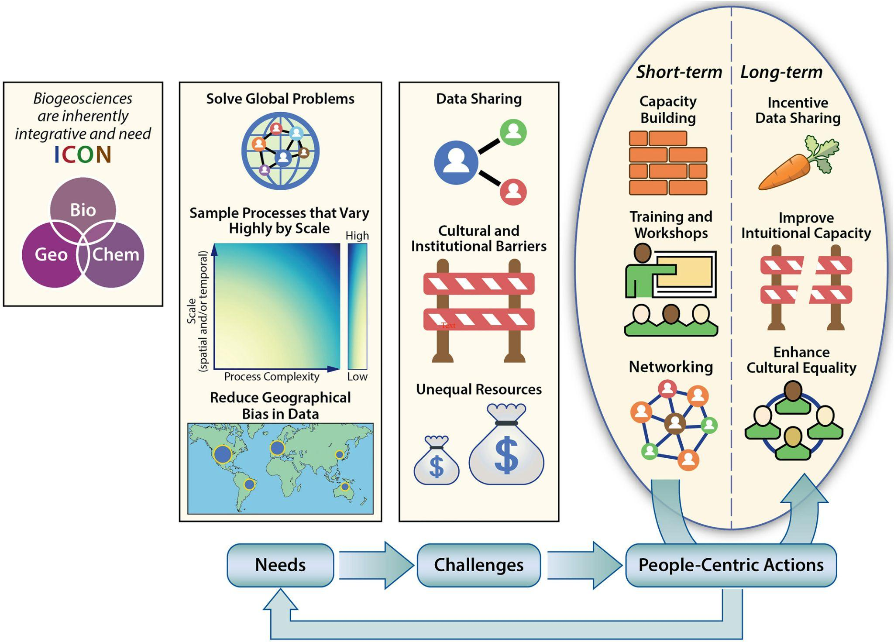

Figure 3: Conceptual overview of needs, challenges and required actions to advance biogeosciences. Geographical bias in data and unequal access to resources are identified as important issues. Source: Dwivedi et al. (2022); licensed under CC BY 4.0.

