# ISSUES: DATA SET Investigating mammal activity patterns using camera trap observations

Emily K. Prince, Robert T. Kelley, and Elizabeth A. McDonald

Department of Biology, Lander University, Greenwood, SC 29649

Corresponding author: Emily K. Prince ([eprince@lander.edu](mailto:eprince@lander.edu))

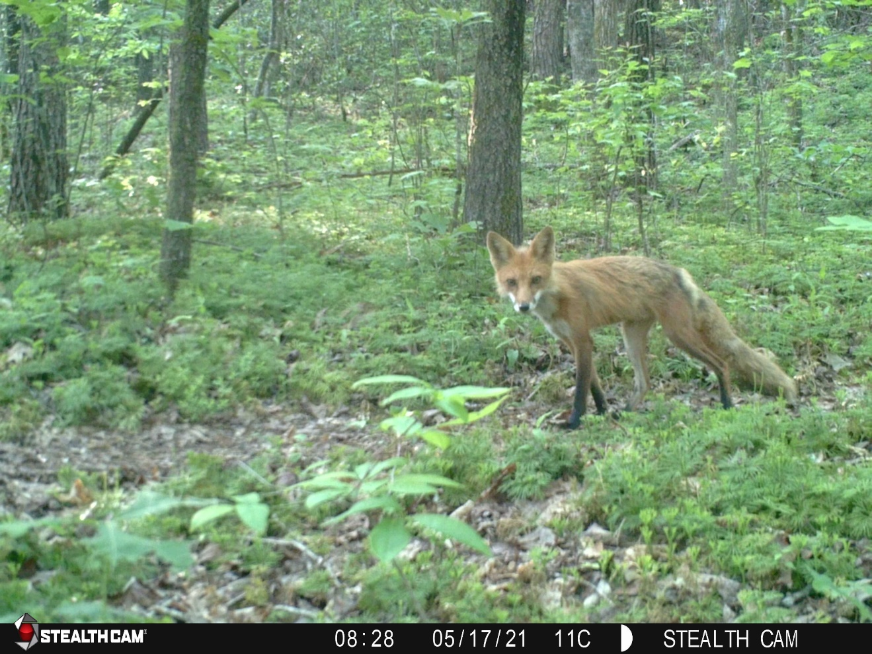

Observation of a red fox, *Vulpes vulpes*, captured by a camera trap in a forested habitat in Pickens County, SC

**THE ECOLOGICAL QUESTION:**

How do mammal activity and community composition change with habitat and human disturbance?

**FOUR DIMENSIONAL ECOLOGY EDUCATION (4DEE) FRAMEWORK**

* **Core Ecological Concepts:**
  + Community
    - Habitat types
    - Competition
    - Behavioral ecology
  + Ecosystems
    - Trophic levels
    - Predation
* **Ecology Practices:**
  + Quantitative reasoning and computational thinking
    - Statistics
    - Data skills – inputting and data-mining /data visualization
    - Computer skills: spreadsheets, "R"
    - Data analysis and interpretation
  + Working collaboratively
  + Communicating and applying ecology
* **Human-Environment Interactions:**
  + Human accelerated environmental change
    - Anthropogenic impacts, intentional and unintentional
  + How humans shape and manage resources/ecosystem/the environment
    - Urban ecosystems
* **Cross-cutting Themes:**
  + Systems
  + Spatial & Temporal
    - Scales

**WHAT STUDENTS DO:**

Students will work in pairs or small groups to generate questions that can be answered from the camera trap data set. Questions may focus on how different types of human disturbance affect mammal behavior, niche overlap between species, or predator-prey interactions. Students will use Microsoft Excel or Google Sheets to create PivotTables and to display data graphically. Students will analyze their results statistically using a Fisher’s exact test to compare proportions of observations between different categories.

**STUDENT-ACTIVE APPROACHES:**

Open-ended inquiry, cooperative learning, quantitative learning, problem-based learning

**STUDENT ASSESSMENTS:**

* Student-generated research questions and hypotheses
* PivotTables and bar graphs summarizing data
* Statistical output from Fisher’s exact tests and post-hoc tests
* Written interpretation of findings and their relationship to the hypotheses

**CLASS TIME:**

As written, this exercise requires approximately one 2.75-hour lab period. Most students can complete the exercise, from brainstorming to data interpretation, within the time period.

**COURSE CONTEXT:**

This exercise is currently used for an upper-level undergraduate Ecology course containing students ranging from sophomores to seniors.

**SOURCES**:

This data file was generated from Lander University’s Mammal Ecology Lab (led by McDonald and Prince).

**ACKNOWLEDGEMENTS:**

We are grateful to the Lander University College of Science and Mathematics as well as for a Lander University President’s Grant for funding for the camera trap project. We would also like to thank all of the individuals who provided access to camera trap sites: Kevin Cartee and the Fellowship Camp and Conference Center, Ann Butler and the Greenwood Parks and Trails Foundation, Kenneth Rogers, Fayette Yenny and Lake Greenwood State Park, Lander University, Paul Pridmore and the Greenwood Genetics Center, and Ken Forrester and the South Carolina Department of Natural Resources. Many Lander research students sorted through thousands of images to identify mammal species. We are grateful to Hunter Merrill, Ravon House, Cayla Smith, Haley Sherbert, Zachary Woods, Abigail Wills, Zachrey Swartzentruber, Elisa Howansky, Robert Chandler Russian, Sam Williams, Drew Bruton, Kimberly Sipanela, Hannah Nathe, and Georgia Spann. Finally, we are grateful to Dr. Prince’s BIOL 306 classes for testing this activity and providing feedback.

**OVERVIEW OF THE ECOLOGICAL BACKGROUND**

Mammals can be extremely difficult to observe directly in the wild. Camera traps, remote motion-activated cameras with infrared sensors, can help researchers document mammal activity in a relatively inexpensive and non-intrusive way (Burton et al. 2015). Camera traps are used extensively in ecological research and have been used to answer questions about the distribution, abundance, and behavior of populations as well as to address questions about the biodiversity and community structure of mammals (Trolliet et al. 2014).

In this exercise, students will use a data set generated from 26 cameras in Upstate South Carolina. The camera trap sites vary by habitat (classified here as open, edge, and forest), levels of temporary human disturbance (measured by different types of disturbances captured in images), and lasting human disturbance (as determined by total road length and building area surrounding cameras). This exercise includes data collected between May 2018 and August 2022. The Excel file includes two sheets. The first, “Camera Images,” contains information about each of the images, including the camera station, date, time, species identified, and number of individuals. The second, “Station Information,” contains information about each of the research sites and camera stations, including the level of human disturbance and habitat type.

Students will need access to a computer with Microsoft Excel or Google Sheets to complete this exercise. We recommend that they work in pairs. Students can investigate any research question that can be answered by analyzing the data. In the past, we have had students ask a variety of questions, including the effect of lasting or temporary human disturbance on mammal diel activity patterns, the relationship between habitat openness and group formation, whether niche partitioning occurs between species with similar ecological roles, and if the presence of large predators changes community composition.

**References**

Burton AC, Neilson E, Moreira D, Ladle A, Steenweg R, Fisher JT, Bayne E, Boutin S. 2015. Wildlife camera trapping: A review and recommendations for linking surveys to ecological processes. The Journal of Applied Ecology. 52:675-685.

Trolliet F, Huynen M, Vermeulen C, Hambuckers A. 2014. Use of camera traps for wildlife studies. A review. Biotechnologie, Agronomie, Société Et Environnement. 18:446-454.

**LEARNING OBJECTIVES:**

1. Students will formulate hypotheses about ecological questions, including
   1. how human disturbance at different scales affects the spatial and temporal distribution of mammals.
   2. how habitat structure affects the behavior of mammals of different trophic levels.
   3. how competition and predation structure the composition of mammal communities.
2. Students will test their hypotheses by extracting relevant information from large data sets and then using statistics to analyze the data.
3. Students will create unique data visualizations to communicate findings related to their hypotheses.
4. Students will evaluate the effects of human disturbance, habitat structure, or interspecific interactions on mammal behavior or community diversity by writing a paragraph interpreting their results.

**DATA SETS AND RELATED FILES**

For Faculty:

* [CameraData_Faculty.xlsx](https://tiee.esa.org/vol/v19/issues/data_sets/prince/resources/CameraData_Faculty.xlsx): This Microsoft Excel file contains the data set and description of camera sites provided for students, as well as several example PivotTables.
* [StudentWorksheetSolutions.docx](https://tiee.esa.org/vol/v19/issues/data_sets/prince/resources/StudentWorksheetSolutions.docx): This Microsoft Word file contains example answers for the worksheet provided to students.

For Students:

* [CameraData_Student.xlsx](https://tiee.esa.org/vol/v19/issues/data_sets/prince/resources/CameraData_Student.xlsx): This Microsoft Excel file contains a data set with information for about 13,900 images of mammals captured at 6 sites in Upstate South Carolina. It also contains a description of the habitat type and human disturbance level at 26 different camera stations.
* [StudentWorksheet.docx](https://tiee.esa.org/vol/v19/issues/data_sets/prince/resources/StudentWorksheet.docx): Students fill out this Microsoft Word file as they complete the assignment. Instructors then use this sheet for assessment.
* [StudentIntructionsGoogleSheets.docx](https://tiee.esa.org/vol/v19/issues/data_sets/prince/resources/StudentInstructionsGoogleSheets.docx): (Optional). The student instructions given below rewritten for Google Sheets instead of Microsoft Excel. Instructors can use this file if they prefer Sheets or do not have access to Excel.

**STUDENT INSTRUCTIONS**

**Background Information:**

Mammals can be extremely difficult to observe directly in the wild because they may inhabit dangerous or inaccessible terrain, be active primarily at night, or actively avoid researchers. Camera traps, remote motion-activated cameras with infrared sensors, can help researchers document mammal activity in a relatively inexpensive and non-intrusive way (Burton et al. 2015). Camera traps are used extensively in ecological research and have been used to answer questions about the distribution, abundance, and behavior of populations as well as to address questions about biodiversity and community structure of mammals (Trolliet et al. 2014).

A variety of factors influence patterns of mammal abundance and activity. Habitat choice is species-specific. Some species are more common in forested areas, while others select open areas. For example, in a study of mesocarnivores in Illinois, Lesmeister et al. (2015) found that bobcats avoided agricultural areas, coyotes were common in forested areas, and red and gray foxes preferred spatially complex habitats. Within a species, habitat choice depends upon a variety of factors, including foraging or hunting access as well the ability to avoid predators (e.g., Fattebert et al. 2019).

Human disturbance also influences the spatial distribution of mammals. As a consequence of habitat fragmentation and direct removal, large predators are usually less common in areas with high human footprints (Lesmeister et al. 2015; Nickel et al. 2020; Ritchie & Johnson 2009). Other mammals, like raccoons, are less affected by urban environments (e.g., Mims et al. 2022). In fact, raccoons may benefit from the removal of predators and from using human food waste as a resource (Bozek et al. 2007). The presence of both red foxes and striped skunks has been reported to be positively associated with human disturbance in landscapes as well (Lesmeister et al. 2015).

Different species of mammals have different diel activity patterns, meaning that they are more active at some times of day than others. Some, like raccoons, are nocturnal, meaning they are mostly active at night. Others, like squirrels, are diurnal, meaning they are primarily active during the day (Ikeda et al. 2016). Bobcats are crepuscular, or active during dawn and dusk (Lesmeister et al. 2015). Red foxes have no clear diel pattern; instead, they tend to be cathemeral, or sporadically active during the day and night (Ikeda et al. 2016). However, even in mammals with clear diel patterns, temporal activity may shift depending on specific conditions. For example, red deer are active during the day in some habitats but during the night in others, presumably in an effort to avoid different predators (Fattebert et al. 2019).

Human disturbance also alters diel activity patterns. Gaynor et al. (2018) reported a worldwide shift of wildlife towards nocturnality in response to human disturbance. Specifically, red foxes (Lovell et al. 2022) and nine-banded armadillos (DeGregorio et al. 2021) are more nocturnal in urban than rural environments. Even when human infrastructure does not alter the landscape, the temporary presence of humans in the environment has been linked to increased nocturnal activity in predators such as bobcats, coyotes, and pumas (Nickle et al. 2020). This effect is not universal because some mammals, such as the European badger, may not exhibit plasticity in diel activity (Lovell et al. 2022).

Beginning in late spring 2018, the members of Lander University’s Mammal Ecology Lab set up camera traps in Upstate South Carolina. Each camera is motion activated and records the date and time when each photograph is taken. We began with five camera stations, but we established additional stations over the next few years. Occasionally, we stop monitoring at particular camera stations because cameras that are frequently vandalized or stolen must be relocated. Currently, we have data from 26 cameras in Greenwood, Laurens, and Pickens Counties in South Carolina. The cameras are in six different sites: Grace Street Park in Greenwood County, on the campus of the Greenwood Genetics Center in Greenwood County, at Fellowship Camp and Conference Center in Laurens County, at Lake Greenwood State Park in Greenwood County, in undeveloped land near Table Rock State Park in Pickens County, and in the Jocassee Gorges Wilderness Area in Pickens County (Figure 1).

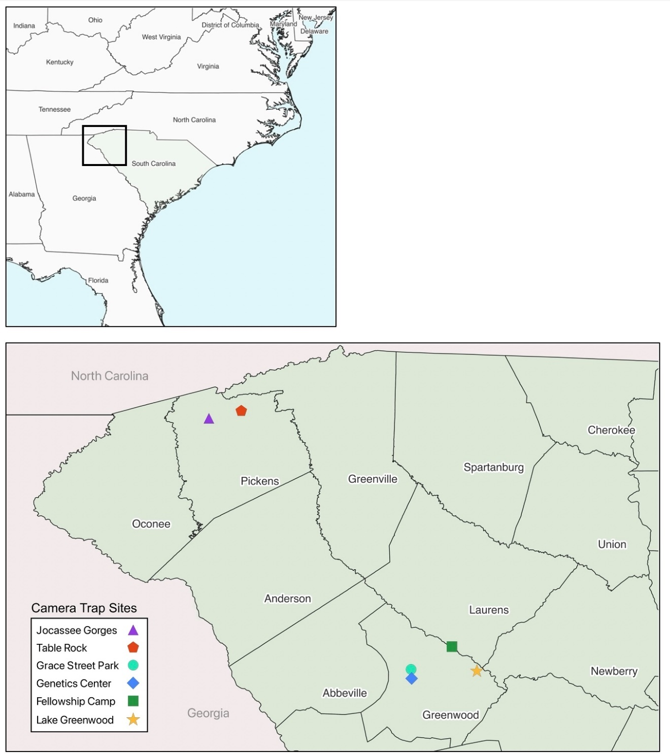

**Figure 1:** Map of camera trap locations. Top: Location of Upstate South Carolina within the Eastern United States. Bottom: Camera trap site locations in Greenwood, Laurens, and Pickens counties.

Figure 2 shows examples of photographs captured by our camera traps. The locations of the cameras encompass several different types of habitats. Some are in forested areas with substantial tree canopy overhead. Some are in open fields. Other cameras are along the edge of habitats and are positioned in locations where forests transition to fields or to open water. We use the area directly surrounding the camera to classify each habitat type as either forest, edge, or open.

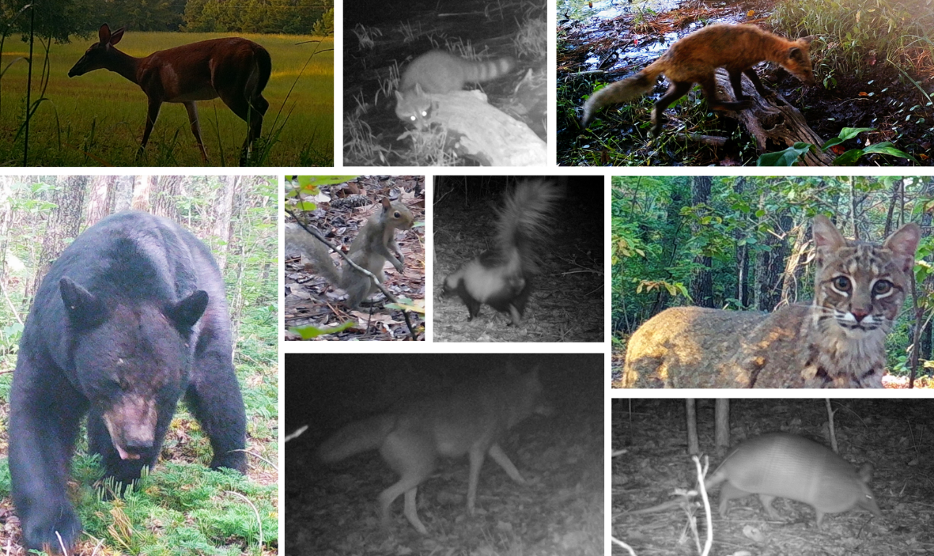

**Figure 2:** Example camera trap images. Note the differences in species, habitat type, and time of day. Top row: white-tailed deer, raccoon, red fox. Lower left: black bear. Remaining pictures (clockwise from upper left): gray squirrel, striped skunk, bobcat, armadillo, and coyote. Pictures have been cropped to fit.

The cameras also differ in the amount of human disturbance that occurs near them. Some sites are in urban areas with extensive landscape-level disturbance in the form of human infrastructure such as roads and bridges. Other sites are in relatively undeveloped land. We used the total length of roads and area of buildings within 1 km of the site to classify the lasting human disturbance (LHD) as high or low. Because urban areas often have lots of artificial light, even at night, we also classified each station as having high or low artificial light at night (ALAN). The stations also differ in the intensity of temporary human activity captured by each camera. Some cameras capture no human activity. Others record the occasional hiker or dog-walker. However, some cameras record frequent human disturbance, which may include people, dogs, farm animals, bicycles, cars, lawn mowers, and industrial vehicles. We used the frequency of images capturing disturbance, weighted by the intensity and duration of the disturbance, to classify each station as having either high, low, or no temporary human disturbance (THD).

You have received an Excel file with the records of each photograph taken from May 2018 until August 2022. Each row represents a single image, and includes the camera site, station, habitat, THD level, LHD level, and ALAN level. The row also includes which species was identified, that species’ trophic level, the number of individuals in the image, and whether the animals were part of a group. Finally, each row includes information about when the image was taken, including the date, the season, the time, and whether the picture was taken during the day or at night. To characterize cathemeral activity, each row also includes information about the time the image was taken divided up into four categories; day, night, dawn, and dusk.

**Instructions:**

**Planning your experiment**

1. Read the background information and open the Excel file, CameraData_Student.xlsx, provided. The sheet labeled “Camera Images” contains more than 13,900 observations of mammal activity. The other sheet, “Station Information,” provides information about the site, habitat type, deployment time, and human disturbance at each camera station.
2. Once you have looked through the file, make notes about what variables might predict mammal activity on the student worksheet. For example, you might be interested in the effect of habitat type on diel activity, or whether mammals form groups more often in areas with higher human disturbance. You might also be interested in comparing different species or trophic levels to one another. For example, do animals with similar diets, such as raccoons and opossums, live in the same habitat types? You can use these examples, or you can come up with questions of your own. Once you decide on your topic, you need to determine which variables included in the data set will be best to use to test your hypotheses. For example, if you decide that you are interested in the effects of human disturbance on the diel activity patterns of mammals, you must choose which measure of human disturbance to use. You will also need to decide which information provides the best measure of diel activity. Finally, you must consider which observations to include. Are you interested in all mammals? In a single trophic level or species? You could also decide to focus on a single season or habitat type. Discuss your notes with your partner and develop a research question that interests both of you.
3. After you and your partner have decided on a question, write out your research question, hypothesis, and a biological explanation on the student worksheet. Use the example provided as a guide, but do not use this exact question. Have your instructor check your plan before proceeding to the next step.

**Example:**

Research Question: How does habitat type influence diel activity patterns in red foxes?

Hypothesis: Red foxes will be more diurnal in forest habitats than other habitats, but more nocturnal in open habitats than other habitats.

Explanation: Foxes are more visible to prey, predators, and humans in open habitats than in forested habitats, so they will be more active at night in open habitats when they can hide under the cover of darkness. When foxes are less visible, such as in forest habitats, they will be more diurnal.

1. To determine if your hypothesis is supported, you will need a way to compare and analyze the number of observations in different categories. For example, we might find that most images of red foxes are captured at night in open habitats but during the day in forested habitats. We will use a Fisher’s exact test to determine if two variables (in our example, habitat type and time of day) are associated with one another. If the two variables are associated, it means that the proportions of observations are different between the different categories. In our case, it would mean that the proportion of observations during the night are different between the different habitats. The first step in this type of analysis is to make a contingency table. An example contingency table is provided in Table 1.

Using the example as a guide, set up a contingency table for your research question. Fill out the blank table in your worksheet with your variables, levels, and descriptions of data that belong in each cell (not the actual values). You may not need all the rows and columns provided, but you should not need any additional squares.

**Example:**

Our research question is whether habitat type influences diel activity in red foxes, so our statistical test will be used to determine if habitat type and time of day are associated with one another. We completed the contingency table below with descriptions of which data belongs in each of the cells.

**Table 1:** Example of how a contingency table should be constructed. One variable should be recorded next to the rows (i.e., habitat type) and the other variable (i.e., time of day) should be recorded above the columns. The different levels of each variable (i.e., day and night for time of day and forest, open, and edge for habitat type) should be labeled, as well. Finally, each cell should be filled with a description of the data that belongs in it.

|  |  |  |  |  |
| --- | --- | --- | --- | --- |
|  |  | **Time of day** | |  |
|  |  | Day | Night | **Row Totals** |
| **Habitat type** | Forest | Number of red fox observations in forest habitats during the day | Number of red fox observations in forest habitats at night | Total red fox observations in forest habitats |
| Edge | Number of red fox observations in edge habitats during the day | Number of red fox observations in edge habitats at night | Total red fox observations in edge habitats |
| Open | Number of red fox observations in open habitats during the day | Number of red fox observations in open habitats at night | Total red fox observations in open habitats |
|  | **Column Totals** | Total red fox observations during the day | Total red fox observations at night | Grand total of all observations |

1. Next, write a pair of statistical hypotheses for your test. For a Fisher’s exact test, your null hypothesis is that there is no association between the two variables you are investigating. Your alternative hypothesis is that there is an association. Statistical hypotheses for our example are provided in the following box.
2. Using the example statistical hypotheses, write your null and alternative hypotheses on the student worksheet. Have your instructor check your contingency table and statistical hypotheses before proceeding to the next step.

**Example:**

Statistical hypotheses:

*Ho*: there is no association between habitat type and diel activity for red foxes

*Ha*: there is an association between habitat type and diel activity for red foxes.

Interpretation:

If our alternative hypothesis is supported, that will mean that red foxes have different patterns of activity during the day and at night depending on the type of habitat.

**Collecting your data**

1. Now that you have a plan for how your contingency table will be set up, the next step is to collect the data. Because the Excel file that you have been given has more than 13,900 observations, it would be extremely tedious to tally each category by hand. You would also probably make a lot of mistakes. Fortunately, Excel can do all the addition for you, and even create the table you need. The PivotTable tool in Excel can summarize complex data sets in a manageable way. Use the following instructions to create a PivotTable.
   1. Graphical user interface, application

      Description automatically generatedClick on any cell within the data you want to analyze. Then go to the “Insert” tab at the top of the page. Click on PivotTable (it should be on the left, see Figure 3).

**Figure 3:** Excel menu with the option to create a PivotTable circled.

* 1. A gray box labeled “Create PivotTable” should pop up. Make sure the selected Table/Range includes all of the cells containing your observations, choose to place your PivotTable in a new worksheet, and click OK.
  2. Next, you will set up your PivotTable using the contingency table that you made previously as a guide.
  3. Begin to set up your PivotTable, adding the correct columns of data from the PivotTable fields to the “Rows,” “Columns,” and “Values” sections. Use the example to guide your choices (see Figure 4).

|  |
| --- |
| **Example:**  Creating a PivotTable:  In our example contingency table, the rows were habitat type. This means we will click on “habitat” in the PivotTable fields and drag it to the “Rows” section.  Our columns were day and night, so we move the field “day_night” to the “Columns” section. See Figure 4 for the field settings for this example.  At this point your PivotTable should start to look like an empty version of your contingency table.  The “Values” section will include the numbers that you want in your table. In this case, that is the “number_indiv” field. When you drag it into the “Values” section, the PivotTable should now contain the correct data.  **Figure 4:** PivotTable Fields settings. |

* 1. After you add the correct fields and data to your PivotTable, you may still have a bit of work to do. This will depend on your research question. Look over the example below and decide if you need to add a filter to your PivotTable and whether you want to change the order of your rows or columns.
  2. Now you have made a PivotTable in Excel. Use this to fill out the second contingency table on the student worksheet, but this time add the numbers from your PivotTable.

**Example:**

Modifying your PivotTable (adding a filter, changing row and column order)

The PivotTable created for our example provides the information for all animals, but we are only interested in red foxes.

To focus on red foxes, we need to drag the “species” field to the “Filters” category (see Figure 4). The filter will appear above the PivotTable. Initially it says “(All),” but we can click the down arrow and choose to filter by any species we choose.

You might be interested in one particular trophic level, or in one particular season. Regardless, the filter works the same way.

We wanted to rearrange the order of our row labels, so we right-clicked on one of the labels and selected “Move.” We rearranged our row labels so that the categories proceed from the least to the most open, rather than alphabetically (Figure 5). You can rearrange column labels using the same method.

**Figure 5**: PivotTable created to match the contingency table described in Table 1.

**Analyzing, interpreting, and visualizing your data**

1. After you have made your contingency table, you will complete a Fisher’s exact test. Put the numbers from your contingency table into the web application available at <http://statist.icu/>. You can adjust the number of rows and columns for your specific research question. Leave any unused rows and columns blank. Our example data entry, analysis, and interpretation are shown in Figure 6.

|  |
| --- |
| **Example:**  Graphical user interface  Description automatically generated  Using the web application for our data analysis, we find that *p* = 2.59359018526833e-10. Typically, this value is written in scientific notation as *p* = 2.59 x 10-10; however, very tiny *p-*values are not usually reported. Instead, we will simply report that *p* < 0.0001.  Remember that when *p* is less than or equal to 0.05, you can reject the null hypothesis.  In this case, *p* is much less than 0.05, so we do reject our null hypothesis.  This means that there is an association between diel activity and habitat type.  Text  Description automatically generated  **Figure 6**: Contingency table and statistical test results using the web application. Notice that the column headers, row headers, and observation numbers match the PivotTable in Figure 5. |

1. Using the example as a guide, complete your statistical test and report your statistical results on the student worksheet.
2. If you reject your null hypothesis, you may still need to determine which categories are associated with each other. To figure this out, we need to do a post-hoc test. If your analysis involved a contingency table bigger than 2x2 and you have an overall *p*-value < 0.05, then you will too.
3. If you need a post-hoc test to interpret your results, use the example as a guide. If you have made a large contingency table, the results can be somewhat difficult to interpret. Please note that a significant *p*-value does not always mean that your experimental hypothesis is supported. To check this, consider the percent of observations, rather than the number of observations, in each category. Look at the example, and then make these changes to your own data.

**Example:**

Completing a post-hoc test

While we know that habitat type is associated with diel activity overall, we do not know which habitat types are different from one another. This means that we need to complete a post-hoc test.

When *p* < 0.05, the web app will automatically conduct a post-hoc test. For our example, the output from our post-hoc analysis is shown in Figure 7.

These results tell us that red fox nocturnality is different between forest and edge habitats (because *p* < .05 for that comparison) but not between forest and open or edge and open habitats (because *p* > .05 for each of those comparisons).

**Figure 7:** Example post-hoc test results for the Fisher’s exact test.

1. Once you understand what your results mean, you need to figure out how to graph your findings. In most cases, a simple bar chart will be sufficient. While you can automatically generate a PivotChart, these graphs can be difficult to manipulate. Instead, you should copy your data from the PivotTable to another sheet in your Excel file and use that to make a figure.

**Example:**

Changing display to show percent of observations

We wanted to know what percent of observations were during the day and during the night for each habitat. Fortunately, that is quite easy to do with a PivotTable. Simply right click on one of the numbers in the PivotTable. Choose “Show Values As” and then “% of Row Total” (Figure 8).

**Figure 8:** The steps for changing the display from numbers of observations to percent of observations for each category in a PivotTable.

Now when we look at our data (Figure 9), we can see that red foxes are approximately twice as likely to be active during the day in forest habitats as they are in open habitats and four times more likely to be active during the day in forest habitats as they are in edge habitats.

**Figure 9**: Example PivotTable showing the percent of red fox observations occurring during the day and night for each habitat type.

1. The default graphs generated by Excel should be modified to improve clarity and appearance. At a minimum, add a solid Y-axis to your graph and delete the title and gridlines. You should also make sure that your graph includes labels for the X-axis and the Y-axis, a series legend if required, and an indication of which categories are significantly different from which other categories. Finally, include a descriptive figure caption with your graph. An example figure and figure caption are shown in Figure 10. Once you have completed your graph and figure caption, take a screenshot of it and paste it into the student worksheet.

**Example:**

Graphing your results

Because we were interested in determining which habitats had the highest red fox nocturnality, we decided to make a graph (Figure 10) showing the percent of observations during the day and at night in each habitat. Notice that there are no error bars here. That is because these values are percentages, not means.



**Figure 10:** Red fox observations during the day and night in three different habitat types. Red fox diel activity is significantly different between habitats labeled with different letters. Red foxes were less nocturnal in forest habitats than edge habitats (*p* < 0.0001), but nocturnality did not differ between forest and open habitats or edge and open habitats.

**Asking a follow-up research question**

1. When you have finished making your graphs, you may have additional questions. For example, looking at our example research question and results made us wonder if gray fox nocturnality patterns are similar to those of red foxes. We also wondered if human disturbance had a similar effect on habitat selection. Try to come up with a follow-up question for your data. Record a second research question, hypothesis, and explanation on the student worksheet.
2. Repeat the process by generating a PivotTable, analyzing your data statistically, and graphing (include a caption) and interpreting your results for your second question. You do not need to write out a contingency table or explicitly determine your null and alternate statistical hypotheses.
3. After you have finished graphing and interpreting the results for your second question, write a paragraph summarizing your results and conclusions in the student worksheet. To receive full credit, make sure that you include whether your experimental hypotheses were supported, what conclusions you can draw about mammal activity patterns, and the possible biological explanations for your results. Keep in mind that sometimes results can be statistically significant but not support your hypothesis. For example, our hypothesis was only partly supported. Red foxes are more diurnal in forest habitats than edge habitats, but the proportion of observations in open habitats was not significantly different from the other two habitats. Looking at our contingency table, we think this is likely because very few of the observations were in open habitats, suggesting that red foxes avoid these areas altogether. Incorporate your findings from both analyses into your paragraph.

**Notes to Faculty**

Comments on implementing exercise

As written, this exercise has been used as a lab in a 300-level ecology course. However, faculty can modify this exercise to fit the course or time available. For example, going through the exercise one time (i.e., through step 12) can be completed in a 75-minute class period for students who are familiar with Excel. If students address more than one research question or are less comfortable with spreadsheets, the exercise could be completed during a subsequent class, in a lab period, or assigned for homework. To expand the exercise, faculty can have students ask multiple related questions. For example, students might investigate the effects of temporary human disturbance on each of the four different trophic levels by creating four different PivotTables and completing four different statistical tests.

The student instructions assume that students have a basic familiarity with Excel, but that students are unfamiliar with PivotTables. Students who are wholly unfamiliar with spreadsheets may wish to complete the HHMI spreadsheet tutorials (<https://www.biointeractive.org/planning-tools/resource-playlists/teaching-statistics-and-math-using-spreadsheet-tutorials-and>) before beginning this exercise.

As a default, Excel uses “Sum of number_indiv” as the value in the PivotTable. In this case, when multiple animals are captured in a single image, all are included as observations. If faculty or students would prefer to count all images as single observations, the value field settings can be changed to “Count of number_indiv.” Either setting is appropriate, and the choice may depend on the question that is asked. For example, students investigating group formation may use “Count of number_indiv” so that each group is a single observation.

      Most students and some faculty are likely unfamiliar with Fisher’s exact tests. This test is similar to a Chi-square test for association, in that it allows researchers to determine whether two variables are associated with one another. For example, either test would allow researchers to determine, for example, whether habitat type is associated with group formation. A *p-*value ≤ 0.05 indicates that the two variables are associated, meaning that the proportion of observations containing groups differs between the habitat types. In contrast, when *p* > 0.05, the two variables are not associated and the proportion of observations containing groups is not different between different habitat types. The advantages of using Fisher’s exact test instead of a Chi-square test for association are that Fisher’s is more accurate for small sample sizes (i.e., a total sample size of <1000) and that a post-hoc test can be easily performed to determine which categories are associated with one another (McDonald 2014). In the example above, the post-hoc test would allow students to determine whether group formation differed between forest and edge, forest and open, or open and edge habitats.

This exercise is written to be completed with Microsoft Excel, but faculty can modify it for use with Excel for the web instead. Faculty without access to Excel or who prefer Google Sheets can also use the modified student instructions with the images and examples from Google Sheets instead. Additionally, we have created a web application using the R package Shiny (Chang et al. 2022) to conduct the Fisher’s exact test and post-hoc test. However, if students are comfortable using R (R Core Team 2021), the analysis can be conducted there instead with the package RVAideMemoire (Hervé 2021). The R code for the example used in this exercise is provided below.

if(!require(RVAideMemoire)){

install.packages('RVAideMemoire')

library(RVAideMemoire)

}

redFoxNocturnalHabitat <- matrix(c(83,13,4,109,112,17), nrow=3)

colnames(redFoxNocturnalHabitat) <- c("day", "night")

rownames(redFoxNocturnalHabitat) <- c("forest", "edge", "open")

redFoxNocturnalHabitat

fisher.test(redFoxNocturnalHabitat)

fisher.multcomp(redFoxNocturnalHabitat)

The output of the web application will also provide the R code to generate the statistical results. Students or faculty can paste the code into the console of R or Rstudio to generate the same results. The code generated by the application creates contingency table names based on the titles used for rows and columns. Students who do not include titles or those who use the same titles for multiple data sets will want to create unique contingency table names to avoid confusion.

if(!require(RVAideMemoire)){

install.packages('RVAideMemoire')

library(RVAideMemoire)

}

df.ForEdgOpe_DayNig <- matrix(c(83,109,13,112,4,17), nrow=2)

colnames(df.ForEdgOpe_DayNig) <- c("Forest", "Edge", "Open")

rownames(df.ForEdgOpe_DayNig) <- c("Day", "Night")

fisher.test(df.ForEdgOpe_DayNig)

fisher.multcomp(df.ForEdgOpe_DayNig)

During the exercise, students complete the provided student worksheet. After the exercise, the student worksheet can be used to assess students on a variety of skills including:

* Writing testable research questions and hypotheses (numbers 2, 3, 4, and 10; learning objective 1).
* Creating statistical hypotheses and interpretation of statistical results (numbers 6, 8, and 11; learning objective 2).
* Determining what data should be collected to address a research question (by correctly labeling the contingency table, number 5; learning objective 2).
* Generating PivotTables to summarize large data sets (number 7; learning objective 2).
* Creating figures that accurately and effectively summarize findings (numbers 9 and 12; learning objective 3).
* Analyzing the results of the data analysis and evaluating how those results fit into a larger scientific context (number 13; learning objective 4).

Faculty may want to have students write a full laboratory report or address discussion questions in addition to, or instead of, the paragraph suggested in the student instructions and student worksheet. The reference list at the end of this document is a useful place to start if students are investigating the primary literature on the use of camera trapping in ecological research.

A list of potential discussion questions is provided below. Note that the research questions that each pair of students chooses will determine which of these discussion questions are appropriate.

Potential discussion questions

1. Based on your findings, do all species across all trophic levels respond to human disturbance in the same way? If not, propose an explanation for the differences you observed.
2. Would you expect lasting human disturbance to have the same effect as temporary human disturbance? Why or why not? Think about this question both in terms of species richness and behavior (i.e., diel activity, group formation).
3. This data set was generated from a relatively small number of camera stations and collected over only a few years. What are the limitations of these data? If you could set up cameras to add to this data set, where would you establish them and why?
4. This data set was generated from an ongoing project. What additional questions could be answered if cameras remain in the field for many years or decades?
5. Only one of these sites, Jocassee Gorges, allows hunting. Do humans still pose a threat to the animals in the other sites? Explain why or why not. What differences would you expect to observe among sites where hunting is allowed, in sites like Fellowship Camp that are adjacent to land where hunting is permitted, and in sites like the Genetics Center where hunting is not allowed nearby?
6. Mammals might be found in groups for a variety of reasons: finding a mate, raising offspring, responding to predators, or searching for food. How could you use this data set to distinguish between these different reasons?
7. Observations of domestic dogs are characterized as a temporary human disturbance and are incorporated into the THD score. In contrast, feral cats are included as members of the mammal community, and observations are included in the “Camera Images” sheet. Why do you think this is? Would you characterize the data in the same way? Why or why not?
8. Assigning mammal species to different trophic levels was a somewhat subjective task. For example, black bears are omnivores, but were assigned as apex predators because they are not at risk of predation from other species. Was this classification appropriate? Would you change any of the designations we made for this data set?
9. Between 1693 and 1790, the top predators in South Carolina were systematically eliminated (Charleston County Public Library 2021). Before that time, wolves and panthers lived in the state (although inconsistencies in the literature of the time makes it difficult to know exactly which species were present). What effects do you think the extirpation of these apex predators had on the mammal community?
10. Coyotes were not observed in South Carolina until the 1970s (Butfiloski and Baker 2020), and armadillo sightings were first reported in South Carolina the early 2000s (Taulman and Robbins 2014). What impacts might these new species have had on prey, predators, or competitors?

Challenges for students

Students may have difficulty developing questions that can be addressed with the data set. Because the cameras were not all set up at the same time and because of vandalism, mechanical failure, or other issues, gaps in the data exist. Additionally, we do not have the same number of cameras across habitat types or human disturbance levels. Ultimately, this means that camera trap days (i.e., the sum of the number of days a camera was recording) vary across habitat types, human disturbance levels, and seasons. Students can account for the different numbers of cameras and active time in different habitat types or disturbance levels by using the number of cameras in each category and time each was active (i.e., camera trap days) in the “Station Information” worksheet. However, providing information about which of each of the 26 cameras was active during which dates would complicate this data set immensely.

This limits the questions that can be asked. For example, a student might hypothesize that red foxes are more likely to be observed in the spring than during other times of the year. Unfortunately, because the camera trap days are not evenly distributed across the seasons, that question cannot be addressed with this data set. In contrast, students can compare certain behaviors of one mammal to another mammal or how mammal behavior changes across seasons. For example, students can use the data set to determine whether red foxes are more likely to be observed in the spring than gray foxes. They could also determine whether red foxes are more likely to be found in a group in the spring than in other seasons.

In our experience, students often have trouble determining whether their statistical results support their experimental hypothesis. Sometimes students create experimental hypotheses that are supported when there is no association between variables. For example, students may hypothesize that raccoons and opossums have the same diel activity patterns. In that case, a significant *p*-value would indicate an association between the species and observations in the day or night, and it would mean that the two species do not have the same diel activity pattern. Students may also have significant results that indicate the opposite of what they hypothesized. For example, students could hypothesize that white-tailed deer are more nocturnal in forest habitats than other habitats, when they are actually more nocturnal in open habitats. In both cases, we find it useful to review the difference between experimental (or research) hypotheses and statistical hypotheses. We also find that having students sketch a graph of what their data would look like if their experimental hypothesis were supported can help us identify students who are struggling to connect their hypothesis to the data they have generated.

Students may also have a difficult time interpreting results if they have made a contingency table that is too complicated and includes too many comparisons. We have found that if both variables have more than 2 categories, the results are extremely difficult to parse. For example, if a student hypothesizes that observations of lower trophic levels will be more common in the spring and summer, while observations of higher trophic levels are more common in the fall and winter, they may choose to set up a 4 by 4 contingency table. The resulting post-hoc test will involve 36 different comparisons, and it will be extremely difficult to interpret. Faculty can encourage students to limit the comparisons made (e.g., only consider summer and winter) or group categories together (e.g., combine meso and apex predators) to make the results easier to interpret. Generally, students should be discouraged from creating anything larger than a 4 by 2 contingency table.

Our students often have trouble generating appropriate figures for their data. PivotCharts can be made automatically from PivotTables, but this can lead to a number of mistakes which will make the figure difficult to interpret. For example, observations of raccoons are much more common than observations of opossums. If students are comparing the diel activity patterns of these two mammals, students may generate a PivotChart of the total observations that leads to the incorrect conclusion that raccoons are more active in the day and the night (Figure 11A). Although the statistical test must be conducted on the number of observations, the graph should show the percent of observations of each species during the day and the night. However, this figure may still be difficult to interpret, as in Figure 11B. Because both species are nocturnal, including the percent of nighttime observations makes it difficult to compare the proportion of observations occurring during the day. Additionally, PivotCharts cannot be easily manipulated to improve clarity and legibility.

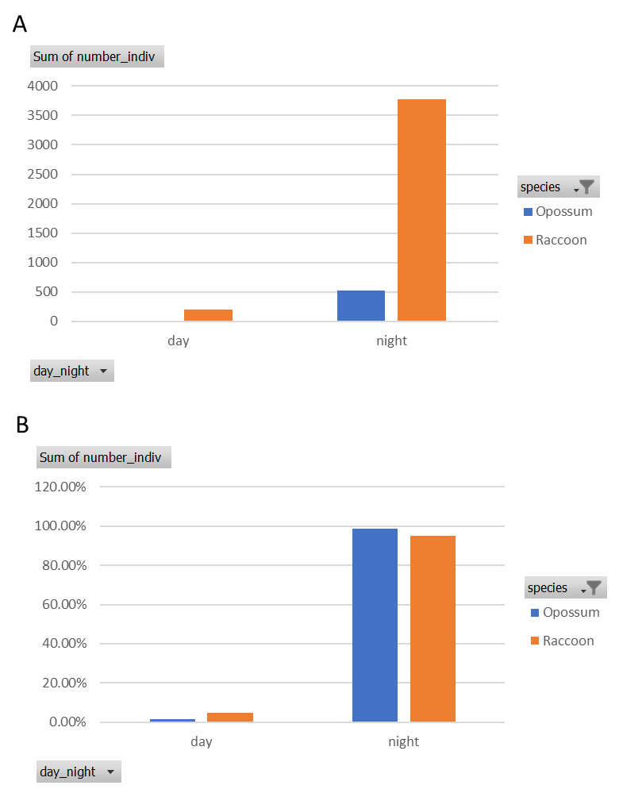

**Figure 11:** Automatically generated PivotChart showing (A) the number of observations in each category or (B) the percent of day and night observations for each species. The percent of raccoon observations during the day is nearly four times higher than the percent of opossum observations during the day, but that is not clear in either panel.

To avoid the many problems associated with PivotCharts, and to encourage students to think carefully about the best way to present data, we require our students to paste data elsewhere in Excel to make a graph that appropriately shows their data (Figure 12).

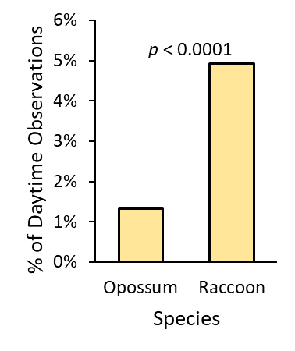

**Figure 12:** The percent of observations of opossums and raccoons that occur during the day.

Note that because the graphs generated in this exercise are from proportions, not means, error bars should not be included in the figures.

Description of Excel columns

*station*: letters indicate a camera site and numbers indicate a particular camera station within the site. The camera sites are described below.

|  |  |
| --- | --- |
| **Site Name** | **Site Description** |
| cf | Fellowship Camp and Conference Center on Lake Greenwood, Laurens County, SC |
| gsp | Grace Street Park and private property adjacent to the park, inside the City of Greenwood, Greenwood County, SC |
| lg | Lake Greenwood State Park, Greenwood County, SC |
| ltr | Undeveloped land near Table Rock State Park in Pickens County, SC |
| gc | Undeveloped area owned by the Greenwood Genetics Center inside the City of Greenwood, Greenwood County, SC |
| jg | Jocassee Gorges Wilderness area maintained by the SCDNR in Pickens County, SC |

*habitat*: indicates the habitat type 10m in front of the camera.

|  |  |
| --- | --- |
| **Habitat Classification** | **Habitat Description** |
| forest | extensive canopy cover from trees in front of camera |
| open | minimal canopy cover in the area in front of the camera |
| edge | transition between habitats in front of camera, e.g., forest to open, forest to lake, forest to road |

*THD*: indicates a temporary human disturbance score for each site, calculated by dividing the sum of disturbances captured by each camera by the number of days that camera was deployed. Longer lasting or more disruptive disturbances were weighted more heavily using the multipliers below. To simplify analysis, the resulting THD scores were grouped into one of three categories, but the THD score for each station is available on the station information sheet.

|  |  |
| --- | --- |
| **Disturbance** | **Multiplier** |
| Human | 1 |
| on-leash dog | 0.5 |
| off-leash dog | 1 |
| farm animal | 1 |
| passenger vehicle | 2 |
| industrial vehicle | 3 |
| mower | 4 |

|  |  |
| --- | --- |
| **THD Score** | **THD Category** |
| < 0.1 | None |
| ≥ 0.1, ≤ 1 | Low |
| > 1 | High |

*LHD*: indicates a lasting human disturbance score for each camera station calculated by using GIS to create a 1 km buffer around each camera station. We determined the total length of highways (*LHW*) (SC DOT 2023a), total length of other roads (*LOR*) (SC DOT 2023b), and total building area (*BA*) (SC DOT 2018) within each buffer. The score for each station was calculated by dividing the values for each individual station by the mean value of all stations for the category, then adding the scores for all categories together (shown in the following formula). To simplify analysis, the resulting *LHD* scores were grouped into one of two categories, but the *LHD* score for each station is available on the station information sheet.

$$LHD Score= \frac{LHW}{Mean LHW}+\frac{LOR}{Mean LOR}+\frac{BA}{Mean BA}$$

|  |  |
| --- | --- |
| **LHD Score** | **LHD Category** |
| < 4 | Low |
| ≥ 4 | High |

*ALAN*: indicates the level of artificial light at night at each camera station. ALAN was calculated using a GIS layer of radiance at each site (Román et al. 2018). The radiance score is reported in nanowatts per square centimeter per steradian [$\frac{nW}{{cm}^{2}×sr}$]. To simplify analysis, the resulting ALAN scores were grouped into one of two categories, but the ALAN score for each station is available on the station information sheet.

|  |  |
| --- | --- |
| **ALAN Score** | **ALAN Category** |
| ≤ 25 | Low |
| > 25 | High |

*species*: indicates the species identified in each camera trap image. Corresponding common and scientific names are provided below.

|  |  |  |
| --- | --- | --- |
| **Name in File** | **Common Name(s)** | **Scientific Name** |
| armadillo | Nine-banded Armadillo | *Dasypus novemcinctus* |
| beaver | American Beaver | *Castor canadensis* |
| black bear | American Black Bear | *Ursus americanus* |
| bobcat | Bobcat | *Lynx rufus* |
| chipmunk | Eastern Chipmunk | *Tamias striatus* |
| coyote | Coyote | *Canis latrans* |
| deer | White-tailed Deer | *Odocoileus virginianus* |
| feral cat | Domestic Cat | *Felis catus* |
| feral pig | Wild Boar | *Sus scrofa* |
| gray fox | Gray Fox | *Urocyon cinereoargenteus* |
| gray squirrel | Eastern Gray Squirrel | *Sciurus carolinensis* |
| groundhog | Woodchuck | *Marmota monax* |
| muskrat | Common Muskrat | *Ondatra zibethicus* |
| opossum | Virginia Opossum | *Didelphis virginiana* |
| otter | North American River Otter | *Lontra canadensis* |
| rabbit | Eastern Cottontail | *Sylvilagus floridanus* |
| raccoon | Raccoon | *Procyon lotor* |
| red fox | Red Fox | *Vulpes vulpes* |
| striped skunk | Striped Skunk | *Mephitis mephitis* |

*trophic_level*: indicates the trophic level of the species in each image. When the category was in doubt, species were assigned based on their risk of predation from other species rather than their diets. For example, black bears are omnivores, but are classified as apex predators here because they are extremely unlikely to be threatened by any of the species detected (with the exception of humans).

|  |  |  |
| --- | --- | --- |
| **Species**  **Name in File** | **Common Name(s)** | **Trophic Level** |
| armadillo | Nine-banded Armadillo | omnivore |
| beaver | American Beaver | herbivore |
| black bear | American Black Bear | apex predator |
| bobcat | Bobcat | apex predator |
| chipmunk | Eastern Chipmunk | herbivore |
| coyote | Coyote | apex predator |
| deer | White-tailed Deer | herbivore |
| feral cat | Domestic Cat | mesopredator |
| feral pig | Wild Boar | mesopredator |
| gray fox | Gray Fox | mesopredator |
| gray squirrel | Eastern Gray Squirrel | herbivore |
| groundhog | Woodchuck | herbivore |
| muskrat | Common Muskrat | omnivore |
| opossum | Virginia Opossum | omnivore |
| otter | North American River Otter | omnivore |
| rabbit | Eastern Cottontail | herbivore |
| raccoon | Raccoon | omnivore |
| red fox | Red Fox | mesopredator |
| striped skunk | Striped Skunk | omnivore |

*date*: indicates the date on which the image was captured.

*day*: indicates the day of the month on which the image was captured.

*month*: indicates the month during which the image was captured.

*year*: indicates the year during which the image was captured.

*season*: indicates the season during which each of the observations was made. Seasons were determined by downloading the monthly average high temperature using data from May 2018 until April 2022 from the [NOAA National Centers for Environmental Information](https://www.ncei.noaa.gov/) (Greenwood airport station). Months with an average high temperature ≥ 25°C were classified as summer. Months with an average high > 15°C and < 25°C were classified as either spring or fall, and months with an average high temperature of ≤ 15°C were classified as winter.

|  |  |  |
| --- | --- | --- |
| **Month** | **Avg Max High Temp (°C)** | **Season** |
| May | 27.4 | summer |
| June | 30.0 | summer |
| July | 31.7 | summer |
| August | 31.3 | summer |
| September | 29.7 | summer |
| October | 24.4 | fall |
| November | 16.8 | fall |
| December | 14.3 | winter |
| January | 12.1 | winter |
| February | 15.0 | winter |
| March | 19.4 | spring |
| April | 23.1 | spring |

*time*: indicates the time of day using a 24-hour clock during which each image was captured. To simplify the data, all cameras were set to show daylight saving time (DST) all year.

*day_night*: indicates whether the image was captured during the day or night. NOAA’s sunrise and sunset times on the first day of each month for the Greenwood airport station (<https://gml.noaa.gov/grad/solcalc>) were used for the entire month. Because sunrise and sunset times are largely consistent between years, the 2019 times were used for all data. Images captured between sunrise and sunset were classified as day. Other images were classified as night. Because the cameras always use DST, the table below reflects the sunrise and sunset times in DST, regardless of the month.

|  |  |  |
| --- | --- | --- |
| **Month** | **Sunrise** | **Sunset** |
| Jan | 8:35 | 18:30 |
| Feb | 8:26 | 18:59 |
| Mar | 7:58 | 19:25 |
| Apr | 7:16 | 19:49 |
| May | 6:39 | 20:13 |
| Jun | 6:18 | 20:35 |
| Jul | 6:20 | 20:45 |
| Aug | 6:39 | 20:30 |
| Sep | 7:02 | 19:55 |
| Oct | 7:23 | 19:13 |
| Nov | 7:48 | 19:36 |
| Dec | 8:16 | 18:19 |

*d_n_da_du*: indicates whether each image was captured during the day, night, dawn, or dusk. Dawn and dusk were classified as the time one hour before and one hour after sunrise (dawn) or sunset (dusk) using the *day_night* sunrise and sunset times.

*number_indiv*: indicates the number of individuals captured in each image.

*group*: indicates whether the animals in the image were in a group. Images containing ≥ 2 mammals of the same species were classified as belonging to a group (indicated as yes). Images containing only 1 mammal from a species were classified as not belonging to a group (indicated as no).

*CameraTrapDays*: indicates the number of days each particular camera was active and recording data. This column is only available in the station information worksheet.

**References**

Bozek CK, Prange S, and Gehrt SD. 2007. The influence of anthropogenic resources on multi-scale habitat selection by raccoons. Urban Ecosystems. 10:413-425.

Burton AC, Neilson E, Moreira D, Ladle A, Steenweg R, Fisher JT, Bayne E, and Boutin S. 2015. Wildlife camera trapping: A review and recommendations for linking surveys to ecological processes. The Journal of Applied Ecology. 52:675-685.

Butfiloski J and Baker B. 2020. Coyote biology and control in South Carolina. South Carolina Department of Natural Resources. <https://www.dnr.sc.gov/wildlife/coyote/coyoteinfo.pdf>

Charleston County Public Library. 2021. South Carolina's war against beasts of prey, 1693–1790. Charleston Time Machine. Retrieved June 22, 2022, from <https://www.ccpl.org/charleston-time-machine/south-carolinas-war-against-beasts-prey-1693-1790>

Chang W, Cheng J, Allaire J, Sievert C, Schloerke B, Xie Y, Allen J, McPherson J, Dipert A, and Borges B. 2022. shiny: Web Application Framework for R. R package version 1.7.4. <https://CRAN.R-project.org/package=shiny>

DeGregorio BA, Gale C, Lassiter EV, Massey A, Roberts CP, and Veon JT. 2021. Nine‐banded armadillo (*Dasypus novemcinctus*) activity patterns are influenced by human activity. Ecology and Evolution. 11:15874-15881.

Fattebert J, Morelle K, Jurkiewicz J, Ukalska J, and Borkowski J. 2019. Safety first: Seasonal and diel habitat selection patterns by red deer in a contrasted landscape. Journal of Zoology. 308:111-120.

Gaynor KM, Hojnowski CE, Carter NH, and Brashares JS. 2018. The influence of human disturbance on wildlife nocturnality. Science. 360:1232-1235.

Hervé M. 2021. RVAideMemoire: Testing and Plotting Procedures for Biostatistics. R package version 0.9-79. <https://CRAN.R-project.org/package=RVAideMemoire>

Ikeda T, Uchida K, Matsuura Y, Takahashi H, Yoshida T, Kaji K, and Koizumi I. 2016. Seasonal and diel activity patterns of eight sympatric mammals in northern Japan revealed by an intensive camera-trap survey. PLoS One. 11:e0163602.

Lesmeister DB, Nielsen CK, Schauber EM, and Hellgren EC. 2015. Spatial and temporal structure of a mesocarnivore guild in midwestern North America. Wildlife Monographs. 191:1-61.

Lovell C, Li S, Turner J, and Carbone C. 2022. The effect of habitat and human disturbance on the spatiotemporal activity of two urban carnivores: The results of an intensive camera trap study. Ecology and Evolution. 12:e8746.

McDonald JH. 2014. Handbook of Biological Statistics. 3rd ed. Baltimore, Maryland: Sparky House Publishing.

Mims DM, Yasuda SA, and Jordan MJ. 2022. Contrasting activity times between raccoons (*Procyon lotor*) and Virginia opossums (*Didelphis virginiana*) in urban green spaces. Northwestern Naturalist. 103:63-75.

Nickel BA, Suraci JP, Allen ML, and Wilmers CC. 2020. Human presence and human footprint have non-equivalent effects on wildlife spatiotemporal habitat use. Biological Conservation. 241:108383.

R Core Team. 2021. R: A language and environment for statistical computing. R Foundation for Statistical Computing. Vienna, Austria. Available from: <https://www.R-project.org/>

Ritchie EG, Johnson CN. 2009. Predator interactions, mesopredator release and biodiversity conservation. Ecology Letters. 12:982-998.

Román MO, Wang Z, Sun Q, Kalb V, Miller SD, Molthan A, Schultz L, Bell J, Stokes EC, Pandey B, Seto KC, et al. 2018. NASA's Black Marble nighttime lights product suite. Remote Sensing of Environment 210:113-143.

SC DOT. 2018. South Carolina Building Footprints – Statewide. Distributed by Koordinates [cited 2023 Jan 19] from <https://koordinates.com/layer/96990-south-carolina-building-footprints-statewide>

SC DOT. 2023a. *Statewide Highways*, Distributed by South Carolina Department of Transportation Downloadable GIS Data [cited 2023 Jan 19] from <http://info2.scdot.org/GISMapping/Pages/GIS.aspx>

SC DOT. 2023b. *Statewide Other Roads*, Distributed by South Carolina Department of Transportation Downloadable GIS Data [cited 2023 Jan 19] from <http://info2.scdot.org/GISMapping/Pages/GIS.aspx>

Taulman JF and Robbins LW. 2014. Range expansion and distributional limits of the nine-banded armadillo in the United States: An update of Taulman & Robbins (1996). Journal of Biogeography. 41:1626-1630.

Trolliet F, Huynen M, Vermeulen C, Hambuckers A. 2014. Use of camera traps for wildlife studies. A review. Biotechnologie, Agronomie, Société Et Environnement. 18:446-454.