# ISSUES: FIGURE SET Community interactions of army ants

Emily Rauschert

Department of Biological, Geological and Environmental Sciences, Cleveland State University, Cleveland, OH 44115

Corresponding author: Emily Rauschert ([e.rauschert@csuohio.edu](mailto:e.rauschert@csuohio.edu))

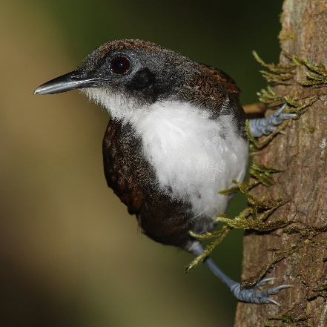

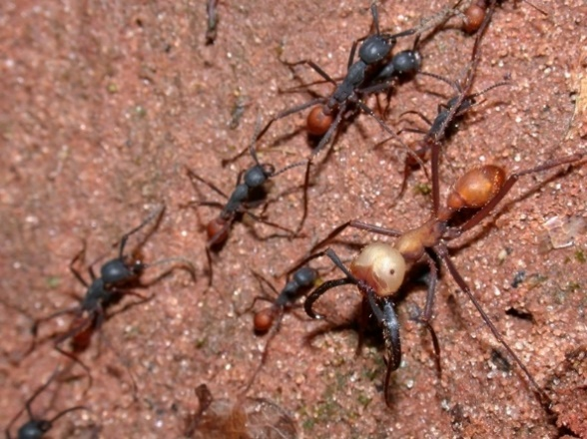

Army ants, *Eciton burchellii*, (left, photo by Alex Wild, <https://commons.wikimedia.org/wiki/File:Eciton_burchellii_army_ants.jpg>) and a common ant-following bird, the Bicolored Ant Bird *Gymnopithys leucaspis* (photo by Matt Deres, <https://en.wikipedia.org/wiki/File:Gymnopithys-leucaspis-001_edit2.jpg>). [CC BY 3.0](https://creativecommons.org/licenses/by/3.0)

**THE ISSUE:**

Species interactions can be positive, negative, and neutral, and it’s not always obvious which of these are occurring, especially with smaller species like ants. How could this be tested experimentally, and what kind of data would need to be gathered? How do these interactions occur in undisturbed settings, and how might human activities influence the types of interactions?

**FOUR DIMENSIONAL ECOLOGY EDUCATION (4DEE) FRAMEWORK**

* **Core Ecological Concepts:**
  + Communities
    - Mutualisms
    - Exploitation
    - Competition
    - Predation
    - Stability
  + Biomes
    - Rainforests
* **Ecology Practices:**
  + Quantitative skills
    - Data visualization
    - Data analysis and interpretation
  + Designing and critiquing investigations
* **Human-Environment Interactions:**
  + Human-accelerated environmental change
    - there is no pristine ecosystem nor total equilibrium
    - Anthropogenic impacts
    - intentional and unintentional
* **Cross-cutting Themes:**
  + Biogeography
    - alien/invasive species

**STUDENT-ACTIVE APPROACHES:**

Think-pair share, small-group discussion, large-group discussion

**STUDENT ASSESSMENTS:**

**Formative**: small group work and discussion. **Summative**: graph interpretation questions on assignments or exams, experimental design questions on exams

**CLASS TIME:**

90 minutes, likely divided over two class periods

**COURSE CONTEXT:**

This figure set is suitable for an introductory biology course, a nonmajors course, or a basic ecology course.

**ACKNOWLEDGEMENTS:**

This is an adaptation of a figure set originally developed by Mark Kuhlmann in 2006 (Teaching Issues and Experiments in Ecology, Vol. 4: Issues Figure Set #1 [online]. <https://tiee.esa.org/vol/v4/issues/figure_sets/army_ants/abstract.html>), based on a research paper by Peter Wrege and colleagues "Antbirds Parasitize Foraging Army Ants." Ecology, 86(3), 2005, pp. 555–559. This Figure Set was developed as a part of the Teaching with Figures Faculty Mentoring Network, which was supported by ESA's Transforming Ecology Education to 4D (TEE) Project with funding from the National Science Foundation (DBI-2120678).

**OVERVIEW**

**WHAT IS THE ECOLOGICAL ISSUE?**

A massive swarm-raid by an army ant colony is one of the most impressive behaviors by social insects. Thousands of ants advance in a swarm, scouring the forest for food. Foraging workers carrying off small insects and gang up on and overwhelm larger animals by sheer numbers. Many insects and other animals flee ahead of the advancing swarm. Workers use their bodies to create living bridges to overcome obstacles, and at night, form a living shelter for the queen and brood.

As these huge colonies move through the forest, they are often accompanied by a community of other species, including birds, other insects, lizards, and even mammals (Schneirla 1971). But what exactly is the nature of the relationship between the ants and their followers? Do they help or hinder the ants?

"Army ant" is both a taxonomic designation and a description of a lifestyle. Most army ants are in one of two genera: Dorylus (paleotropics) and Eciton (neotropics), the focus of this figure set. An army ant colony typically cycles between two behavioral phases: nomadic and statary (Schneirla 1971). During the nomadic phase, a colony moves daily, housing the queen and brood in a temporary bivouac, and conducts large foraging raids. During the statary phase, the colony stays in one place for several weeks and conducts small-scale raids during the day. The main prey of a raiding army ant colony are leaf-litter invertebrates and the brood of other social hymenoptera (ants, bees, and wasps). Workers usually aggregate on prey, collectively subduing and dismembering it (Gotwald 1995). As a result, army ants can capture prey many times larger than an individual worker. Army ants will attack almost anything, and many animals flee the oncoming swarm. After an army ant swarm raid has passed, arthropod densities in the leaf litter may be reduced by as much as 50% (Gotwald 1995). Because of their large colony sizes (up to 1.5 x 106 ants/colony) and mobility (raids cover >1000 m2 of forest per day), army ants have a significant impact on tropical forest communities.

Army ants also have indirect effects by supporting a community of ant followers, especially birds. In the New World topics, over 50 bird species regularly follow army ant raids, many getting >50% of their food at army ant swarms. Common ant-following birds include members of the antbird family (Formicariidae) as well as woodcreepers, cuckoos, and tanagers. The number of birds following a particular ant swarm varies considerably from day to day, but large colonies of regularly swarming army ants are frequently accompanied by flocks of over 20 individuals of several bird species (Willis and Oniki 1978).

Ant-following birds stay just ahead of the advancing army ant swarm or perch on branches just above it, capturing animals, mostly larger arthropods and small vertebrates, disturbed by and fleeing from the army ant raid. Although they may occasionally incidentally consume army ant workers that are attached to something else they are eating, studies reveal that the birds do not deliberately eat army ant workers (Willis and Oniki 1978). By getting food that they otherwise would not, the birds clearly benefit from the association. Early studies suggested that the birds might flush prey back to the ants, making the relationship mutualistic (Willis and Oniki 1978). However, later studies do not specifically describe the nature of the interaction, and it is possible that birds remove prey that the army ants would otherwise capture (Wrege et al. 2005). The balance between mutualism, commensalism, and parasitism is often a fine one, and determining the exact nature of this type of interspecific relationship often takes careful measurement of the costs and benefits to each species.

**FIGURE SETS TABLE**

|  |  |  |
| --- | --- | --- |
| **Figure Set** | **Student-active Approach** | **Cognitive Skill** |
| Part I: Designing an experiment and describing evidence supporting a hypothesis | Pairs or small group worksheet and discussion, followed by large-group discussion | Creation – Students design experiment, generate hypotheses and draw graphs that support or do not support their hypothesis. |
| Part II: Identifying the relationship between army ants and ant-following birds | Pairs or small group worksheet and discussion, followed by large-group discussion | Analysis: Interpretation of graphs |
| Part III: Ant-following bird interactions | Pairs or small group worksheet and discussion, followed by large-group discussion | Analysis: Interpretation of graphs, experimental design |

**Part I: Designing an experiment and describing evidence supporting a hypothesis**

**Learning Objectives:**

Students will be able to

* + Describe elements of good experimental design
  + Design an experiment to test what type of species interaction is present
  + Draw a hypothetical graph of evidence that would support or refute a hypothesis
  + Describe possible interactions with people that may influence the ability to carry out an experiment
  + Discuss how a system might change following introduction of a new species

**Student Assessment:**

* + Formative small group discussions are important, as students work in groups to design experiments and interpret results. Students complete worksheet questions, and they have the opportunity to revise them following class discussion
  + Summative assessment could take the form of additional assignment questions or exam questions focused on experimental design and graphical evidence.

**FIGURE SET BACKGROUND**

Army ant swarms are one of the most dramatic sights in tropical forests and observers are impressed by the array of species that follow these swarms. It has long been assumed that some bird species have a mutualistic relationship with army ants because these birds often follow swarms and catch animals escaping from the advancing ants. It was further assumed that the birds chased some escaping animals back toward the swarm. Like many apparent mutualisms, the true effects of the ant-following birds on the ants had never been closely examined.

Peter Wrege, from Cornell University, and his colleagues wanted to find out if ant-following birds had a positive, neutral, or negative effect on the prey capture rate of a swarm-raiding army ant species. How would you go about testing the hypothesis that ants benefit from the presence of ant-following birds by capturing more prey? What sort of evidence would convince you about the nature of their interaction?

**STUDENT INSTRUCTIONS**

B

Part I: Investigating interactions in the Army Ant system

*Please work together in groups of 2 or 3. Only turn in one per group.*

Army ant swarms are one of the most dramatic sights in tropical forests and observers are impressed by the array of species that follow these swarms. Hundreds of thousands of army ants work together during raids, capturing up to 3000 prey per hour. Army ants can capture prey as large as birds and snakes, and many potential prey flee as army ants approach. It has long been assumed that some bird species have a mutualistic relationship with army ants because these birds often follow swarms and catch animals escaping from the advancing ants. It was further assumed that the birds chased some escaping animals back toward the swarm. Like many apparent mutualisms, the true effects of the ant-following birds on the ants had never been closely examined.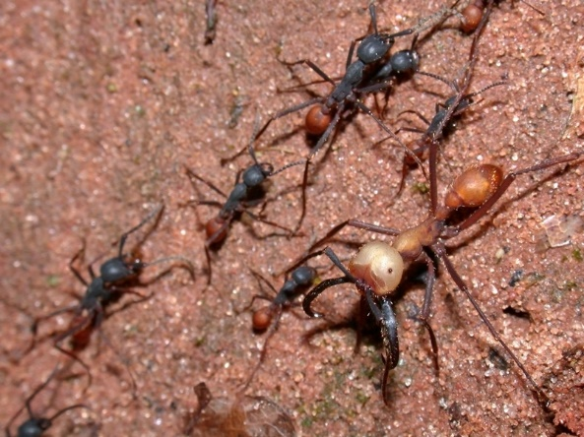

Figure 1: Army ants, *Eciton burchellii*, (left, photo by Alex Wild, <https://commons.wikimedia.org/wiki/File:Eciton_burchellii_army_ants.jpg>) and a common ant-following bird, the Bicolored Ant Bird *Gymnopithys leucaspis* (photo by Matt Deres, <https://en.wikipedia.org/wiki/File:Gymnopithys-leucaspis-001_edit2.jpg>). [CC BY 3.0](https://creativecommons.org/licenses/by/3.0)

Peter Wrege, from Cornell University, and his colleagues wanted to find out if ant-following birds had a positive, neutral, or negative effect on the prey capture rate of a swarm-raiding army ant species. How would you go about testing the hypothesis that ants benefit from the presence of ant-following birds by capturing more prey?

With the other students in your group, you will use the questions below to design an experiment to test the hypothesis that ants benefit from the presence of ant-following birds by capturing more prey. A hint: the researchers figured out that aggregations (clusters) of some of the army ant workers always indicated the capture of some sort of prey by the ants.

1. You have been assigned to study the army ant system to determine the nature of the interaction between army ants and ant-following birds. Write down a general research question about the interactions of army ants and ant-following birds, and one or two hypotheses you could actually test.
2. What ecological concepts are related to your hypothesis?
3. List at least three qualities of a good experimental design. Why are these important? To what extent might these be difficult to achieve in the army ant system?
4. Describe an actual experiment that could test your research question. Please be specific about how this experiment would be conducted, including how many times it will be repeated. Clearly state what variables you intend to measure to gather the data you need to assess your hypothesis.
5. What are the limitations to your design? For example, how confident are you in your measurements?
6. Draw some sample graphs that would shed light on your hypothesis that you could make using the variables you are collecting in your experiment. Show one graph that would support your hypothesis, and one graph that would refute your hypothesis. Clearly label all parts of the graph, including the axes, and write a sentence about your interpretation of each graph. Hint: one of the easiest graphs to understand would have your response variable on the y axis, and your treatments on the x axis.

**Graph supporting the hypothesis**

**Graph refuting the hypothesis**

1. Consider potential difficulties in conducting this research. Actually carrying out experiments can be tricky, especially because other people may come by your site who may not be interested in your experiments. Think about potential problems involving people that might make it more difficult to conduct your experiment and list some things you might do to resolve these, if possible.

**NOTES TO FACULTY**

Before working on this exercise, students should get some introduction to the biology and ecology of army ants, either presented by the instructor, watching a video, or by reading the background material. Some nice pictures that support the background material are available in Gotwald (1995), Willis and Oniki (1978), and the web references listed in the Resources section includes links to general information.

In addition, students need some knowledge of the elements of a well-designed experiment. For this activity, a rubric could be given to each group for students to discuss before they develop their experimental designs.

Many students can confidently design an experiment to test a hypothesis but do not have a clear vision of what data will be collected, or what data would look like that actually supported their hypothesis. While the worksheet directions do suggest a possible response variable (Y axis variable) that is measured, students will likely struggle with what might be represented on the X axis. Many students will instinctively draw a time-series graph because these are the most intuitive to them. However, here some sort of contrast between groups is likely needed, depending on their experimental design. It may be useful to briefly check in with the whole group after about ten minutes of small group work, to nudge all students in an appropriate direction. As much as possible, instructors and teaching assistants will need to circulate and take a look at groups’ graphs, to guide students toward reasonable graphs.

A class discussion of the experiments, hypotheses and graphs developed by the student groups (as described in the Student Instructions) with comments encouraged from other groups can be very useful. Students will need clear instructions for reporting (e.g., select one person in the group to be the reporter, know there is limited time available for reporting per group, etc.). The instructor and students should help point out good points and flaws of different groups' experiments, helping to introduce or reinforce key elements of experimental design. Each group can turn in a revised written description of their experiment for assessment. The student handout will help students organize this assignment. Students can fill the form out together in class and hand it in as a group or do this individually as homework. Students can fill the form out together in class and hand it in as a group or do this individually as homework.

As an alternative, students could be given the experimental design from the Wrege et al. (2005) study, to critique and to explain in a step-by-step fashion. Students could also be given hypothetical graphs of resulting data and asked to determine whether this would support or refute the hypotheses.

**Part II: Identifying the relationship between army ants and ant-following birds**

**Learning Objectives:**

Students will be able to

* + Identify the parts of a boxplot
  + Interpret graphical information (a boxplot) about species interaction
  + Evaluate the strength of empirical evidence and suggest improvements to experimental design

**Student Assessment:**

* + Formative small group discussions are a focus here, as students work in groups to design experiments and interpret results. Students complete worksheet questions, and they have the opportunity to revise them following class discussion
  + Summative assessment could take the form of exam questions focused on experimental design and graphical evidence. Application-based questions could prompt students to determine how interactions might change if new species arrive or other species are lost.

**FIGURE SET BACKGROUND**

Ant-following birds clearly benefit from army ants by capturing prey they otherwise would not. The effect of the birds on the army ants is less obvious. Wrege et al. (2005) conducted an experiment designed to quantify the effect of ant-following birds on the army ant Eciton burchellii in Panama. Their experiment consisted of paired 10-minute trials replicated on 18 army ant swarms. For each swarm, observers first counted the number of ant aggregations (indications of the capture of large prey, see photo) during 10 minutes when ant-following birds (6.1 ± 2.2 birds per swarm, mean ± 1 SD) were present.

They then chased away the birds by waving their arms or, if a bird was extremely persistent, by squirting it with a water gun. They then again counted the number of aggregations during the next 10 minutes. Thus, their experiment had a control treatment (birds present) and exclusion treatment (birds absent). Unfortunately, they could not randomize the order of these treatments (that is, they always did the control treatment first) because some birds would not return quickly after being chased away.

The researchers visualized this dataset using box plots, sometimes called box and whiskers plots. Box plots visually represent the dispersion of data and are therefore a graphical summary of the data. Quartiles are used to divide the data into four groups, each containing 25% of the values. The box contains the "middle" 50% of the data, and the horizontal line within the box indicates the median point. If there are no outliers, each “whisker” shows 25% of the data and therefore the extremities of the whiskers are the minimum and maximum values. If outliers are present, the whiskers typically extend to the smallest and largest non-outlying values.

**STUDENT INSTRUCTIONS**

Part II: Interpreting data in the army ant: ant-following bird interactions

*Please work together in groups of 2 or 3. Only turn in one per group.*

Ant-following birds clearly benefit from army ants by capturing prey they otherwise would not. The effect of the birds on the army ants is less obvious. Wrege et al. (2005) conducted an experiment designed to quantify the effect of ant-following birds on the army ant *Eciton burchellii* in Panama. Their experiment consisted of paired 10-minute trials replicated on 18 army ant swarms. For each swarm, observers first counted the number of ant aggregations (indications of the capture of large prey, see photo) during 10 minutes when ant-following birds (6.1 ± 2.2 birds per swarm, mean ± 1 SD) were present.

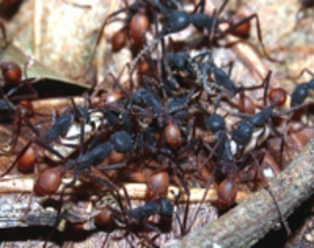They then chased away the birds by waving their arms or, if a bird was extremely persistent, by squirting it with a water gun. They then again counted the number of aggregations during the next 10 minutes. Thus, their experiment had a control treatment (birds present) and exclusion treatment (birds absent). Unfortunately, they could not randomize the order of these treatments (that is, they always did the control treatment first) because some birds would not return quickly after being chased away.

Army ant workers (*Eciton burchellii*) clustered around a captured insect.

Photo by Alex Wild, used with permission.

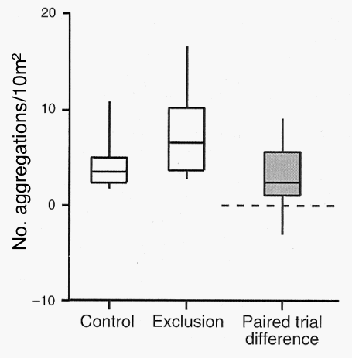The researchers chose to visualize their results using boxplots. Box plots visually represent the dispersion of data and are therefore a graphical summary of the data. They help researchers see both the variability of the data encountered, and the middle of observed results. Quartiles are used to divide the data into four groups, each containing 25% of the values. The box contains the "middle" 50% of the data, and the horizontal line within the box indicates the median point. If there are no outliers, each “whisker” shows 25% of the data and therefore the extremities of the whiskers are the minimum and maximum values. If outliers are present, the whiskers typically extend to the smallest and largest non-outlying values.

Figure 2. The effect of ant-following birds on the foraging success of the army ant Eciton burchellii in Panama. The standardized number of ant aggregations observed in each area of 18 paired trials (open boxes) and the difference between paired exclusion and control areas (shaded box) are displayed. In the box plots, the horizontal line is the median (middle observation), the boxes show the interquartile range (25% of data points above and below the median), and the vertical bars show the range. The differences (shaded box) were significantly greater than zero (dashed horizontal line, t17 = 3.8, P = 0.0014). From Wrege et al. (2005).

1. Describe the graph and what it shows. Make sure you understand how the figure is set up, what the axes show, and what information is depicted. **Carefully describe the overall patterns in the data.**

2. Interpret the data. What do they tell you about the type of relationship between birds and army ants?

3. In this experiment the researchers always ran the control first, followed by the exclusion. What is the significance of the control treatment always being first in their paired trials? Is this the best design of an experiment? How does it affect your interpretation of their results?

**NOTES TO FACULTY**

Students should read the background material and then work in pairs or small groups to interpret the figure. They should be able to figure out that the graph shows that the number of aggregations (feeding rate on large prey) was (significantly) higher where birds were excluded than where they were present. Thus, the birds steal food the ants would otherwise get, making the relationship parasitic.

The "paired difference" in the figure shows essentially the same thing as comparing the means from the control and exclusion treatments but is more representative of what the statistical analysis (a paired t-test) was testing and is a better visualization of this dataset. Depending on student abilities and learning objectives, instructors may want to highlight why graphing paired differences is more statistically correct.

Students may not be familiar with box and whisker plots. If they are not, explain that box plots are designed to visually represent the dispersion of data and is therefore a graphical summary of the data. Quartiles are used to divide the data into four groups, each containing 25% of the values. The box contains the "middle" 50% of the data, and the vertical line within the box indicates the median point. Each “whisker” shows 25% of the data and therefore the extremities of the whiskers are the minimum and maximum values. Outliers are usually shown as additional points on the boxplot; while this figure does not have any outliers, the next figure in Part III does. Depending upon learning objectives, instructors may want to describe how outliers are determined.

Students generally have no difficulty determining the nature of the relationship from the figure. Questions about the experimental design, such as the one suggested for assessment, pose more difficulty. Some students may frame their answers in terms of "realism" of the experiment, rather than the statistical or logical appropriateness of the design. For example, in nature, "birds don't suddenly depart from an ant swarm," or "birds aren't always present first, then absent." Class responses to this question can be used as an opportunity to discuss the significance of randomization and independence in experimental design. It is also useful to discuss the sample size of the study with the students.

**Part III: Ant Following Bird Interactions**

**Learning Objectives:**

Students will be able to

* + Identify the parts of a boxplot
  + Interpret graphical information (a boxplot) about species interaction
  + Evaluate the strength of empirical evidence and suggest improvements
  + Predict what impacts might occur when a novel species invades

**Student Assessment:**

* + Formative small group discussions are key here, as students work in groups to design experiments and interpret results
  + Summative assessment could take the form of exam questions focused on experimental design and graphical evidence. Application-based questions could prompt students to determine how interactions might change if new species arrive or other species are lost.

**FIGURE SET BACKGROUND**

Ant-following bird assemblages can be quite diverse, containing many different species of birds. Often when multiple species are utilizing the same resource, they can have negative impacts on each other, leading to interspecific competition. Sean O’Donnell and colleagues Anjali Kumar, and Corina Logan were wondering whether there was competition between resident ant birds, who are present near round (residents), and migratory ant bird species (migrants), who are only present part of the year while they overwinter. To investigate this question, they conducted field surveys at Tilarán Mountains in Costa Rica during times with (29 raids) and without migratory birds (19 raids), and they recorded the number of resident birds present at raids with and without migratory birds.

**STUDENT INSTRUCTIONS**

**Part III: Ant-following bird interactions between residents and migrants**

*Please work together in groups of 2 or 3. Only turn in one per group.*

Ant-following bird assemblages can be quite diverse, containing many different species of birds. Often when multiple species are utilizing the same resource, they can have negative impacts on each other, leading to interspecific competition. Sean O’Donnell and colleagues, Anjali Kumar and Corina Logan, were wondering whether there was competition between resident ant-following birds, who are present year-round (residents), and migratory ant-following bird species (migrants), who are only present part of the year while they overwinter. To investigate this question, they conducted field surveys at Tilarán Mountains in Costa Rica during times with (29 raids) and without migratory birds (19 raids), and they recorded the number of resident birds present at raids with and without migratory birds.

Draw a graph of what you would expect to see if migratory birds are having a negative effect (competition) on the resident birds, at raids with and without migratory birds.

Examine the graphs below, which look at the number of resident birds present at ant raids. The first panel (A) contrasts when migrants are present and absent, at different seasons. The lower panel (B) displays data only from when migrants were present, contrasting raids where migrants were present and absent.

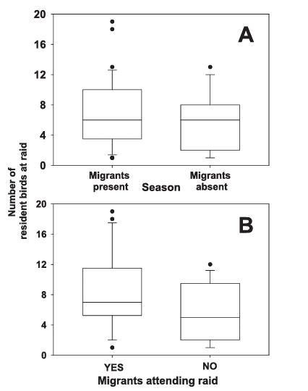

Figure 3. The number of resident birds present during a raid. The upper panel (A) displays the number of resident ant-following birds present during different seasons, with migrant birds present and absent. The lower panel (B) focuses on data from when migrants are locally present, displaying the number of resident antbirds present as a function of whether migrants are attending the raid or not. In this boxplot, there are also outliers, unusually large or small values, represented by dots outside of the whiskers. Used with permission of the author.

**Questions**

1. In panel, A, what relationship do you see between the presence of migrants and the number of resident ant birds? Does it seem like migrants are inhibiting resident birds?

2. In panel B, how does the presence of migrant birds at a raid impact the number of residents in the raid? What does this tell you about the likely impact of migrants on resident birds?

3. Although some trends are visible in panels A and B, statistically, those results were not significantly different (for Panel A, F1,50 = 1.21, P = 0.28, and for Panel B, (F1,31 = 2.55, P = 0.12). What does it mean when we do not find statistically significant different? Overall, what might you conclude about the nature of the relationship between residents and migrants?

4. How strong is your evidence for your conclusion in 3? Design a study that might provide stronger evidence about the nature of the relationship between resident and migratory antbirds.

5. The invasive African ant, *Pheidole megacephala,* which was introduced to the Neotropics, has been observed to counterattack army ants, leading to their deaths. What impacts might this have on ant-following birds?

**NOTES TO FACULTY**

Have students complete the first side, where they are asked to describe what evidence for competition might look like, before looking at the actual results on the second side. Depending on your students, you may want to first hand out the first side, and then the actual results. Students will have an easier time realizing that there is no evidence of competition if they first tried to draw what evidence of competition would look like.

For these results (boxplots), it is important that students understand what the dots represent (outliers), and that there was considerable variation in the number of birds observed.

In the discussion of the strength of the support, discuss with students that this was an observational study, and not an experiment. This adds realism but does not necessarily prove causation. Students will also need help understanding the difference between being able to reject the null hypothesis (and having a clear answer) and failing to reject the null hypothesis despite a trend.

**ADDITIONAL** **RESOURCES**

*Army Ants*

Animal Diversity Web. University of Michigan’s Museum of Zoology. *Eciton burchelli.*

(<http://animaldiversity.ummz.umich.edu/site/accounts/information/Eciton_burchelli.html>)

Ant (and other creatures) photos by Alex Wild, Department of Entomology, University of California, Davis.

(<http://www.myrmecos.net/ants.html>)

Ants of Africa. Includes Antbird/Army ants images. Created by Brian Taylor, University of Nottingham (<https://antsofafrica.org/>)

New interaction with invasive ants

<https://pubmed.ncbi.nlm.nih.gov/25103833/>

Army ant video

<https://youtu.be/JsfiUR0ZzLw>

*Box plots*

<https://chartio.com/learn/charts/box-plot-complete-guide/>

**LITERATURE CITED**

Gotwald, W. H., Jr. 1995. *Army Ants: The Biology of Social Predation.* Cornell University Press, Ithaca, NY.

O’Donnell, S., A. Kumar, and C. J. Logan. 2014. Do Nearctic Migrant Birds Compete with Residents at Army Ant Raids? A Geographic and Seasonal Analysis. Wilson Journal of Ornithology 126. <https://doi.org/10.1676/13-109.1>.

Schneirla, T. C. 1971. *Army Ants: A Study of Social Organization.* W. H. Freeman and Company, San Francisco, CA.

Willis, E. O. and Y. Oniki. 1978. Birds and Army Ants. Annual Review of Ecology and Systematics 9:243-263.

Wrege, P. H., M. Wikelski, J. T. Mandel, T. Rassweiler, and I. D. Couzin. 2005. Antbirds parasitize foraging army ants. Ecology 86:555-559.