ISSUES: FIGURE SET
Impacts of high deer density on forest ecology and considerations for developing effective management solutions
Miranda Kearney^{1*}, Lynne Beaty^{2*}, and Shamili Ajgaonkar^{3*}
¹Biology Department, SUNY Oneonta, Oneonta, NY 13820
²Department of Biology, Penn State Erie, The Behrend College, Erie, PA 16563
³Department of Biology, College of DuPage, Glen Ellyn, IL 60137
*All authors contributed equally to this work.
Corresponding author: Miranda Kearney (Miranda.Kearney@oneonta.edu)
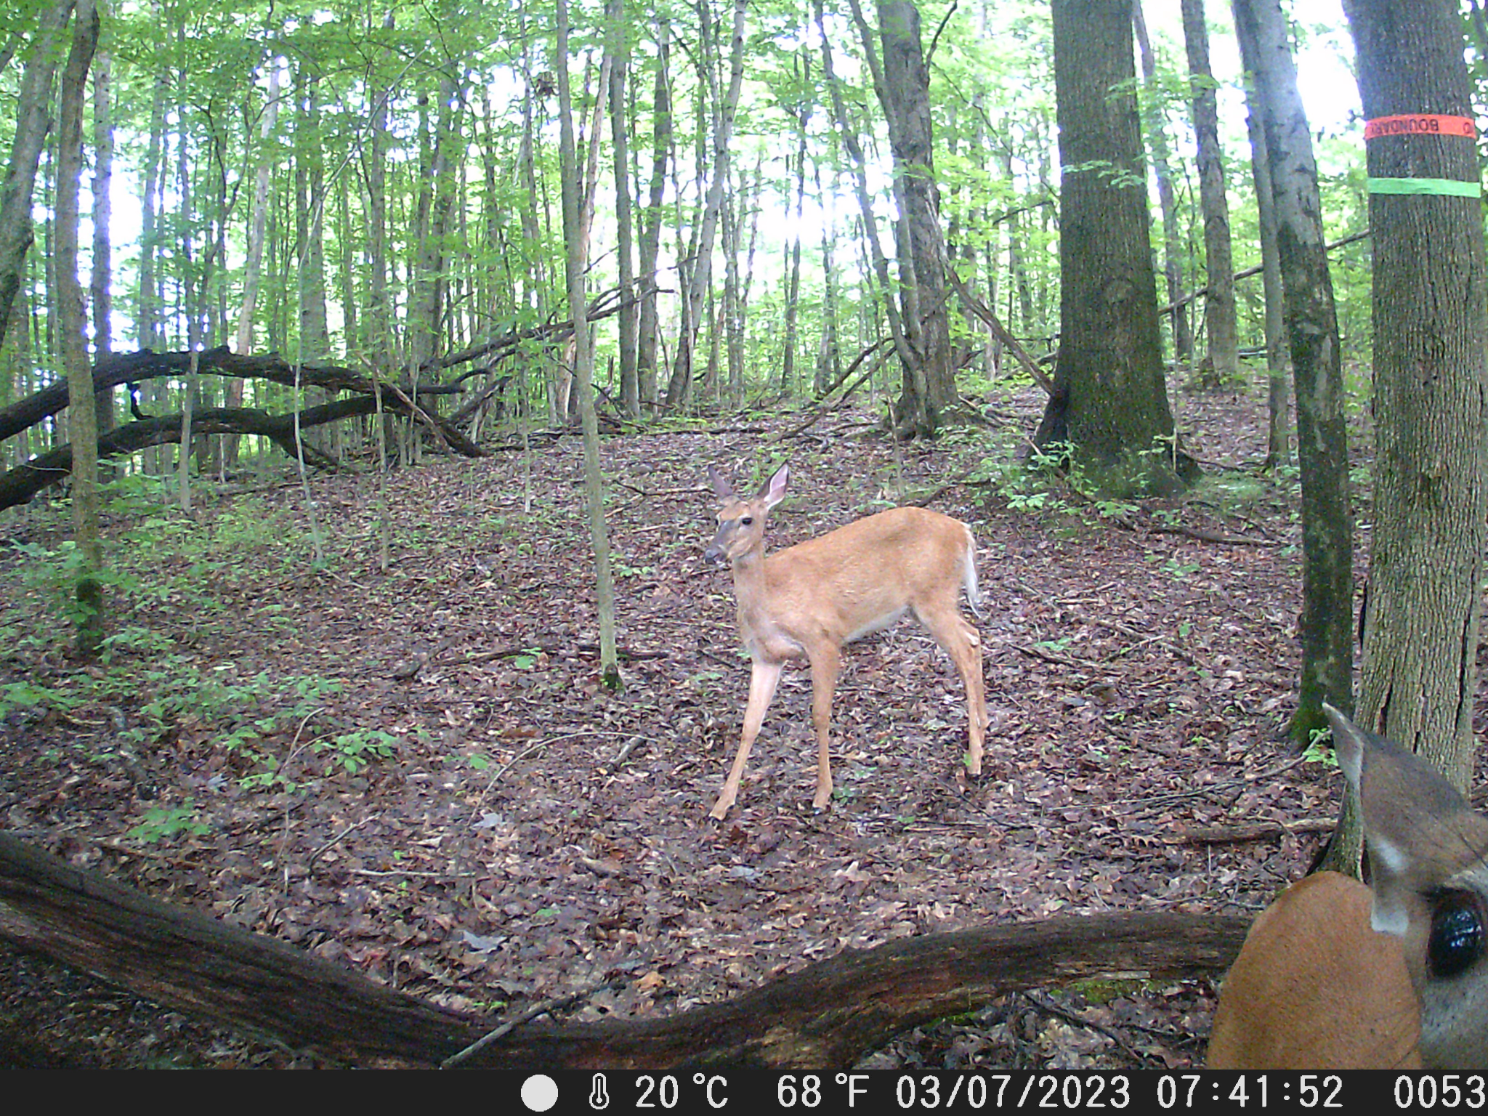

White-tailed deer (Odocoileus virginianus) (Photo by Lynne Beaty)

THE ISSUE:
Balancing the needs of wildlife and people has been—and continues to be—one of the more contentious topics at the public-science interface. This is especially true for game species whose population sizes are often augmented for recreational and economic reasons. This figure set focuses on the changing dynamics of forest ecosystems under increasing white-tailed deer (Odocoileus virginianus) populations and the challenges for wildlife management of this popular game species.

FOUR DIMENSIONAL ECOLOGY EDUCATION (4DEE) FRAMEWORK
- Core Ecological Concepts:
  - Population dispersion
    - Exponential and logistic growth – cycles
  - Community
    - Succession
    - Stability – resistance – resilience – disturbance – steady-state – fluctuate
  - Ecosystems
    - Predation: predator-prey – herbivore – carnivores
    - Regulators – control from below/above – trophic cascades
  - Biosphere
    - Global climate change
- Ecology Practices:
  - Quantitative reasoning and computational thinking
    - Data skills – inputting and data-mining / meta-analysis/ data visualization
    - Modeling and simulation
  - Working collaboratively
- Human-Environment Interactions:
  - Human accelerated environmental change – there is no pristine ecosystem nor total equilibrium
    - Anthropogenic impacts, intentional and unintentional
  - How humans shape and manage resources/ecosystems/the environment
    - Ecological stewardship
    - Natural resource management
    - Conservation Biology
  - Ethics
    - Environmental ethics
- Cross-cutting Themes:
  - Systems
  - Spatial & Temporal
    - Scales

STUDENT-ACTIVE APPROACHES:
- Figure Set 1: turn-to-your-neighbor
- Figure Set 2: visual analysis, informal group work, making predictions
- Figure Set 3: citizen’s argument

STUDENT ASSESSMENTS:
Minute Paper, Concept Map, Reflective Essay

CLASS TIME:
One to two 50-minute lecture classes

COURSE CONTEXT:
First and second-year courses in Introductory Ecology, Introductory Environmental Science, or Conservation Biology for majors. Some portions of the figure set can be used across all of the above categories, while others (e.g. modeling, figure 3) may be more appropriate for a majors audience.

ACKNOWLEDGEMENTS:
Data and figures used in this issue were adopted or adapted from original papers in the following journals: Conservation Biology, Ecological Applications, Forest Ecology and Management, Journal of Wildlife Management, and the Wildlife Society Bulletin. This figure set is based on the "Ecological Impacts of High Deer Densities" figure set originally submitted and published by Tania Schusler in Teaching Issues and Experiments in Ecology. Thank you to Christopher Beck and colleagues in the Teaching with Figures in Ecology Faculty Mentoring Network (FMN) funded by the National Science Foundation (DBI 2120678) for their thoughtful input on the revisions to this figure set. Thank you also to the Ecological Society of America for their support of the FMN that led to the production of this work.

OVERVIEW
WHAT IS THE ECOLOGICAL ISSUE?
Management of white-tailed deer (Odocoileus virginianus) in the eastern and midwestern United States is a success story gone awry (McShea 2012). Once at the brink of extirpation throughout their range, deer populations have burgeoned over the last several decades (McCabe and McCabe 1997). While many people value the increased populations of deer for viewing, hunting, and as prey for other species, this has created unwelcome consequences for farmers, orchardists, homeowners, and motorists, including crop damage and increased incidences of vehicle accidents. Of concern to conservation biologists is the possibility that high deer densities might have detrimental effects on the forest ecosystem, from abiotic conditions to biotic structure, including the abundance and diversity of vegetation and wildlife. Several ideas for controlling the now-exploding deer populations have been proposed, but challenges remain in implementing solutions that consider concerns from a broad array of stakeholders (Leong et al. 2009; Ruggiero 2010; Warren 2011). Moreover, the successful management of deer populations is unique in that citizens have an active and pivotal role in implementing various population control options.
This Figure Set explores the dynamics of forest ecosystems under high population densities of a large herbivore, the white-tailed deer. Students will evaluate deer impacts on ecosystem structure and function, propose multidimensional solutions, and assess the pros and cons of different control options. Specifically, they will first consider the ecological data showing the effect of high deer density on biotic (tree and bird diversity) and abiotic (soil pH and moisture) forest factors. Students will then review data related to forest ecosystem services and dynamics in forests that have effectively managed deer population sizes. Finally, students will be asked to propose a solution that considers both conflicting human opinions on deer management approaches and the relative impact of different approaches on deer population size.

Background
By the end of the 19th century, market and subsistence hunting had decimated deer populations throughout their range. In 1896, the U.S. Supreme Court declared wild animals property of the state. Regulations required hunters to obtain licenses and abide by hunting seasons, bag limits, and sex restrictions (i.e., do not kill female deer [does] and fawns and concentrate on male deer [bucks]) to help deer populations recover. Successful wildlife management through the regulation of hunting was a key factor in the rebound of deer herds. Other factors have also contributed to expanding deer numbers. Human elimination of wolves and mountain lions removed natural predators throughout much of white-tailed deer’s range. Human manipulation of land for agriculture and silviculture also improved and expanded habitat for deer, an “edge species” with an affinity for forested landscapes fragmented by open fields. In addition, private landowner decisions to prohibit hunting limited hunter access to many areas, allowing deer populations to grow. Today, the problem of too few deer has in numerous cases become one of too many deer, posing new challenges for natural resource managers.

Ecological Effects of High Deer Densities
A growing body of ecological studies (see Waller and Alverson 1997, Russell et al. 2001, and Côté et al. 2004 for academic reviews or Ness 2003 for a popular review) suggests that high deer density directly affects the composition of woody and herbaceous vegetation and indirectly impacts wildlife. Tree species especially palatable to deer, such as economically valuable oaks, are not regenerating while other species resistant to deer browse, like beech, flourish. The toll on herbaceous plants is also substantial. Local disappearances of numerous plants, such as orchids and lilies, have been documented in woodlands with abundant deer across the East and Midwest. These concerns are especially crucial in protected areas (e.g., nature preserves and national parks) where managers are often attempting to support a particular vegetative community.
Beyond the impact on specific trees or other plants, deer can significantly influence wildlife habitat by altering the forest’s composition and structure. For example, in a forest where the understory has been largely eaten by deer, habitat for birds requiring a thick understory will decline. On the other hand, birds that prefer an open understory will benefit. Some ecologists have argued that white-tailed deer are a keystone herbivore because they have such large impacts on forest communities (Waller and Alverson 1997). Waller and Alverson (1997:218) define a keystone species as one that: “(1) affects the distribution or abundance of many other species, (2) can affect community structure by strongly modifying patterns of relative abundance among competing species, or (3) affects community structure by affecting the abundance of species at multiple trophic levels.” It can be argued that deer fit this description because they affect trees, shrubs, herbaceous plants, birds, and small mammals when at high densities.
Although many people assume that deer densities today are far above historical norms, it is surprisingly difficult to know whether this is the case. Addressing this question, McShea et al. (1997) state that: “Deer populations are above densities that existed over large portions of the continent at the turn of the century …, when deer had been extirpated from many parts of their historical range. However, the hypothesis that deer are more abundant now than they were prior to European colonization is equivocal at best. It is extraordinarily difficult to obtain an accurate estimate of pre-colonial population sizes … There is intensive debate about how to obtain accurate counts of existing populations …, let alone how to determine numbers of deer from periods before the counting of deer had even begun.”

Anthropogenic Effects
While deer numbers might not exceed biological carrying capacity, in some places they have exceeded human tolerance for deer-related conflicts. In many rural and suburban areas, residents complain that deer damage crops, orchards, and home landscaping. Another complaint is the rise in deer-related vehicle accidents. People also fear increased risk of Lyme disease because deer are a host for black-legged or deer ticks (Ixodes scapularis), the disease vector. Therefore, while many people view deer positively, others perceive deer as a nuisance, like vermin or oversized rats. Finally, some take the perspective that it is not deer but humans that are the problem. For example, increased deer-related vehicle accidents (DRVA’s) could equally be blamed on rising numbers of cars driving on increasing miles of roads as on growing deer populations.

Management Challenges
Decision-making for deer management involves many challenges beyond insufficient data and an incomplete understanding of the role that deer play in complex ecosystem interactions. A major issue is that interpretation of deer numbers and impacts varies with scale: impacts over a wide spatial scale do not necessarily reflect what is happening at a finer scale. Thus broad-scale regional management strategies are unlikely to adequately address deer impacts within specific refuges. Unacceptable deer impacts on forest communities at a local scale, on the other hand, might be tolerable if species impacted are sufficiently protected on a regional scale. However, no “ideal” or “correct” deer density exists within a determined scale of focus. For one thing, flux and change are natural phenomena in forest ecosystems. Attempts to maintain a stable population of deer may be incongruent with goals to maintain ecosystem health.
Resource managers also face political challenges in identifying management alternatives acceptable to a wide range of stakeholders interested in deer. Without non-human predators, the main sources of deer mortality are winter die-offs, disease, such as chronic wasting disease (CWD) and Epizootic Hemorrhagic Disease, and hunting. Hunting, the traditional management tool for regulating deer populations, remains the most common management strategy. Regulations originally designed to help deer herds grow have been revised to reduce populations by harvesting more does. But the necessary changes in hunter behavior require education and time. In addition, in many locations where deer-related problems have been identified, local safety ordinances prohibit firearm use or private lands do not allow hunter access. Thus, in some cases, legal changes are necessary for hunting to be an effective management tool.
In suburban areas with intolerable deer-human conflicts, sharpshooting is often the most efficient method of deer control. Sharpshooting involves attracting deer with corn, for example, to a bait site where trained personnel selectively shoot animals to cull the herd. Ideally, the deer meat is then donated to a local food pantry. Like hunting, however, sharpshooting elicits moral objections from animal welfare and rights supporters. Other alternatives have demonstrated limited success. Trapping and relocating deer simply moves the problem to another location and stresses the animals. Contraception can help control isolated populations but is expensive and requires repeated treatments for the maintenance of deer infertility over time. Researchers and residents have also experimented with various repellents to deter deer from home landscaping.
In this Figure Set, students will think critically about the ecological impacts of deer, as well as the impacts and trade-offs of deer management alternatives.

FIGURE SETS TABLE

Figure Set | Student-active Approach | Cognitive Skill
1. Ecological effects of high deer density on biotic and abiotic forest factors. (Rooney et al. 2000; McShea and Rappole 2000; Woods et al. 2019) | Turn-to-your-neighbor | Comprehension, interpretation, application, analysis
2. Outcomes of deer management | Visual analysis, informal group work, making predictions | Comprehension, interpretation, analysis, synthesis
3. Management choices (Chase et al. 2002; Merrill et al. 2006; Peters et al. 2020) | Citizen’s argument | Comprehension, interpretation, application, analysis

Part 1: Ecological effects of high deer density on forests
Learning objectives:
- Students will identify data visualization (graph) types, describe the rationale for their use, and propose alternatives.
- Students will use data visualizations to demonstrate how high deer density affects the abiotic conditions and biotic structure of forest ecosystems.
- Students will formulate hypotheses about how deer-induced changes might impact the long-term structure and stability of forest ecosystems.

Student Assessment: minute paper, concept mapping

Part 2. Outcomes of deer management
Learning objectives:
- Students will interpret and analyze the graphs and describe the rationale for their use.
- Students will use data visualizations to evaluate how deer management affects seedling survival and the biotic structure of forest ecosystems.
- Students will brainstorm opportunities and challenges related to the long-term recovery of forest ecosystems.

Student Assessment: brainstorming, concept mapping

Part 3. Management choices
Learning objectives:
- Students will construct hypotheses about how different deer population control options will impact deer population size.
- Students will use data visualizations to evaluate hypotheses about different deer control methods.
- Students will use data visualizations to demonstrate how human perspectives shape the management of wild populations.

Student Assessment: reflective essay
Figure Set Background:
This figure set is in three parts. In Part 1, students will consider the structural and functional consequences of high deer density on forests by evaluating data related to biotic (tree and bird diversity) and abiotic (soil pH and moisture) forest factors. In Part 2, they will review information related to forest dynamics in forests that have effectively managed deer population sizes. In Part 3, students will be asked to critically consider the trade-offs between deer management alternatives and the effectiveness of management alternatives in a citizen’s argument.

STUDENT INSTRUCTIONS:

Part 1: Ecological effects of high deer density on forests
Across the three studies presented in part 1, researchers evaluated the impacts of deer on biotic and abiotic forest factors. For Figure 1a, Rooney and colleagues (2000) examined whether deer browse might be a factor affecting the regeneration of eastern hemlock (Tsuga canadensis). A long-lived, shade-tolerant conifer occurring on moist, acidic soils, eastern hemlock once dominated much of the forest in upper Wisconsin and Michigan. Heavily cut over by the 1920s, hemlock-northern hardwood forests were replaced by second-growth hardwoods and have yet to rebound. Today, hemlock remains a common community element in the few remaining primary forests and has partially rebounded in some lowland and riparian areas. Hemlock remains uncommon, however, in previously logged, upland stands and occupies only 0.5% of the upland landscape in the northern Great Lakes region.
Restoration of hemlock-dominated landscape elements is being considered by federal land management agencies but significant barriers exist. Even in forest stands where hemlock does compose a substantial portion of the canopy, hemlock seedlings and saplings are conspicuously absent. A variety of hypotheses could explain this mystery. Seedling establishment may be limited by the availability of appropriate microsite conditions, such as moss beds, nurse logs, or bare mineral soil. Or, moisture availability, soil characteristics, or other habitat characteristics may limit hemlock seedlings. Because they grow slowly and provide winter browse, hemlock seedlings are also sensitive to herbivory by white-tailed deer, as demonstrated in several other studies.
Rooney and colleagues studied 100 hemlock stands in northern Wisconsin and western upper Michigan. The sites included land in county, state, and national forests, national lakeshore, Indian reservations, and private ownership. At each study site, researchers counted the number of hemlocks in each of four size classes (seedlings, small saplings, medium saplings, large saplings) and collected data on several factors suspected behind poor hemlock regeneration. These were seed input, leaf litter type, leaf litter depth, light availability, habitat type, and deer browsing intensity. Browsing intensity was measured using the sugar maple browse index, which is the ratio of browsed sugar maple twigs to total sugar maple twigs counted in an area. It was measured by counting the number of browsed and unbrowsed terminal twigs 30-200 cm above the ground and provided a measure of deer browsing intensity on a scale from 0 to 1. It is assumed that the higher the sugar maple browse index for an area, the higher the intensity of deer browse for other species, including hemlock, which is also palatable to deer. They then conducted statistical analyses to assess which of these factors contributed to variation in hemlock density between sites.

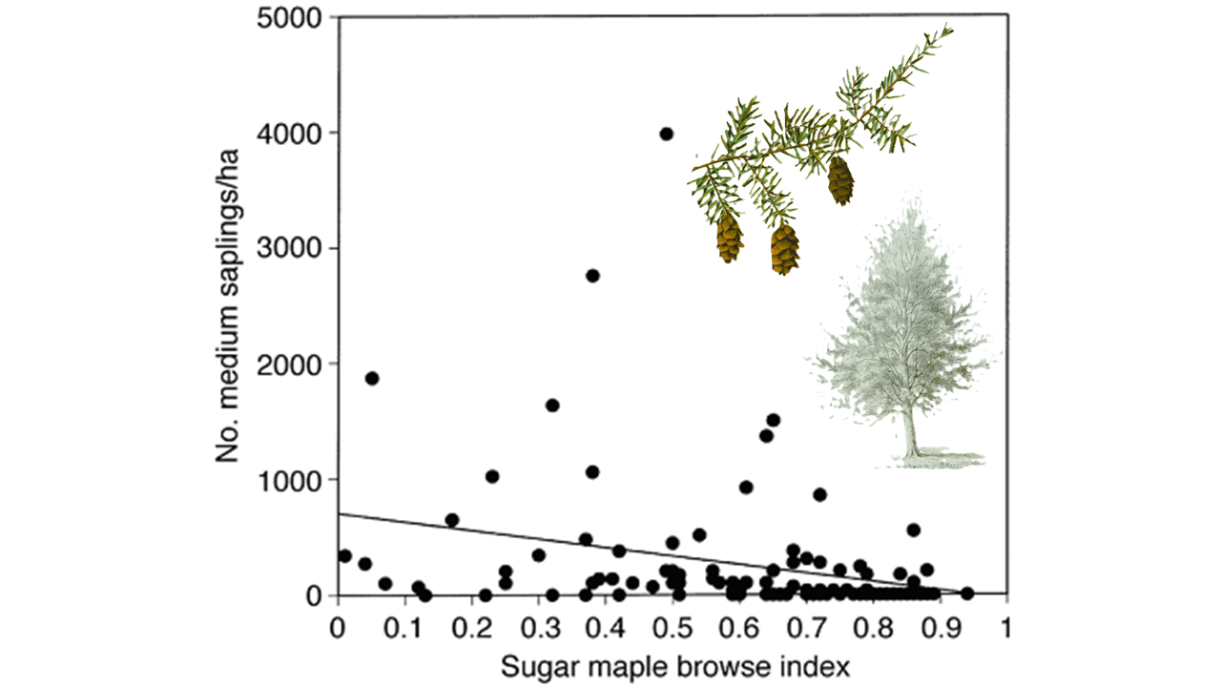
Figure 1a. The number of medium-sized hemlock saplings per hectare as a function of the sugar maple browsing index. The sugar maple browsing index is an indicator of deer browse intensity. The intercept and slope are both significant (ln(saplings) = 2.06—1.58(browse); df = 1, 98; r² = 0.083; P = 0.004). (From Rooney, T. P., McCormick, R. J., Solheim, S. L. and D. M. Waller. 2000. Regional variation in recruitment of hemlock seedlings and saplings in the Upper Great Lakes, USA. Ecological Applications 10(4):1119-1132.) Hemlock image source: http://www.plantillustrations.org/illustration.php?id_illustration=83050
https://corescholar.libraries.wright.edu/cgi/viewcontent.cgi?referer=&httpsredir=1&article=1073&context=biology
Figure 1a Questions:
Examine Figure 1a. Turn to your neighbor and first describe and then analyze Figure 1a. Take your time and make sure you understand the axes and the variables plotted.
- What conclusion do you draw regarding the relationship between medium-sized hemlock saplings and deer browse?
- What consequences might this have for succession in forests and restoration of forests with high deer densities?

Figure 1b shows the results from a study by McShea and Rappole (2000). These researchers examined changes in vegetation and bird populations on 8 forested sites in northern Virginia over 9 years. Four sites were fenced to exclude deer. The other 4 served as controls. McShea and Rappole wanted to see how reducing the number of deer in a protected forest affected the abundance (number) of birds and diversity (variety) of bird species.
To do this, the researchers measured vegetation by counting and identifying to species all woody plants >1m in height and <4cm in diameter within three 24x24m quadrats at each site. The researchers captured birds by mist-netting. Every year at each site, they strung 25 fine mesh nets between trees for 3 days during the month of June. Each day at dawn and dusk, researchers removed birds caught in the nets; recorded their species, sex, and reproductive condition; and then released them. They recorded data for 25 bird species of which 3 are reported in Figure 1b.
With a partner, examine Figure 1b and the additional information provided below. Then discuss the questions that follow. With your partner, be prepared to share your analysis of Figure 1b during full class discussion.

Results of Vegetation Monitoring
McShea and Rappole found that excluding deer over the 9-year period increased the density of understory woody shrubs relative to control sites. Species richness of understory woody plants also increased within the exclosure areas over the course of the study. In other words, researchers found more shrubs and more different species of shrubs in the sites excluding deer than in the control sites.

About the Bird Species
Chipping Sparrows prefer open understory. They breed in open woodlands with grass, along river and lake shorelines, orchards, farms, and in urban and suburban parks. They winter in similar areas. They forage primarily on the ground and eat grass and other small seeds, small fruits, and insects. The Chipping Sparrow’s nest is a loosely woven open cup of rootlets, grasses, and other fine materials placed in a small tree or shrub (Cornell Lab of Ornithology. 2003. All About Birds. http://birds.cornell.edu/programs/AllAboutBirds/BirdGuide/Chipping_Sparrow_dtl.html)
Indigo Buntings prefer dense herbaceous ground cover, such as brushy vegetation, saplings, and weeds. They eat seeds. The Indigo Bunting’s nest consists of grasses, leaves, and weed stems. Nests are found in trees or tangles. (Conservation Commission of Missouri. 1995-2002. Missouri Breeding Birds Atlas. http://www.conservation.state.mo.us/nathis/birds/birdatlas/maintext/0400015.htm)

Ovenbirds prefer a dense, woody understory. They breed in mature deciduous and mixed deciduous and coniferous forests. They winter in primary and second growth forests. They eat forest insects by picking them off leaf litter on the forest floor. The Ovenbird’s nest is a woven domed coup of dead leaves and plant stems, with the entrance on the side, placed on the ground. (Cornell Lab of Ornithology. 2003. All About Birds. http://birds.cornell.edu/programs/AllAboutBirds/BirdGuide/Ovenbird.html)

Graph Interpretation
Note that the hatched bars represent the exclosure sites (i.e., no deer) and the solid bars represent the control sites (i.e., deer present). On the Y-axis, you will find the number of birds recorded for each species. (Note that the scale on the top graph differs from the other two.) On the X-axis, you will find each of the 9 years during which the study was conducted. Look for patterns in the number of each bird species over time. Compare and contrast the exclosure and control sites and answer the questions below the figure.

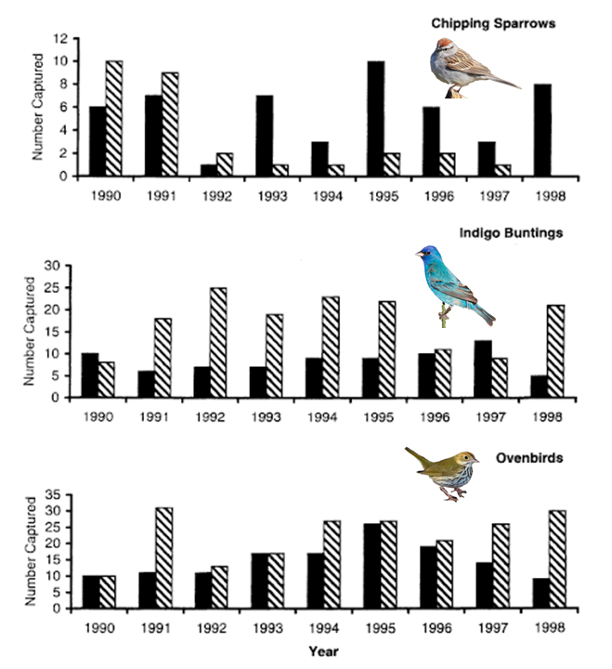
Figure 1b. Abundance of three representative bird species at four deer exclosure sites (hatched bars) and four control sites (solid bars). Deer exclosure sites were fenced in early 1991. (Figure modified from McShea, W. J. and J. H. Rappole. 2000. Managing the abundance and diversity of breeding bird populations through manipulation of deer populations. Conservation Biology 14(4):1161-1170.) Bird Image sources: https://commons.wikimedia.org/wiki/File:Indigo_Bunting_by_Dan_Pancamo_4.jpg
https://commons.wikimedia.org/wiki/File:Spizella-passerina-015_edit.jpg
https://commons.wikimedia.org/wiki/File:Ovenbird_(90497).jpg

https://rustyblackbird.org/wp-content/uploads/Managing-Populations-the-Abundance-through-and-Diversity-of-Breeding-Bird-Manipulation-of-Deer.pdf

Figure 1b Questions
- How would you describe the changes over time in the number of Chipping Sparrows, Indigo Buntings, and Ovenbirds in sites with deer (solid bars) and without deer (hatched bars)?
- Is there another graph type that might also be used to display this data?
- Is the response of each species consistent with its known biology (see “About the bird species” above)? What plausible explanations can you offer for the changes in relative abundance of these species over time?
- Based on the information in the “About the bird species”section, what consequences might these changes in bird species richness have on other aspects of the forest?

Figure 1c shows the results of research performed by Woods and colleagues (2019) that examined soil pH and soil moisture in areas where deer are present (No fence) or absent (Fence). To do this study, the researchers used three paired (6 total) 9 m x 3m deer exclosures to manipulate white-tailed deer access to the study sites. They collected soil cores from the paired deer exclosure and deer access plots and measured a number of parameters including pH and moisture.
Many plant species are adapted to specific soil pH and moisture ranges and microbial communities are also regulated, in part, by soil physicochemical properties including pH and moisture levels. Thus, important soil functions, like nutrient cycling and carbon sequestration can be affected by changes to soil pH and moisture. Generally speaking, drier soils tend to increase nutrient cycling and reduce soil carbon, as drier conditions promote microbial decomposition. Changes to soil pH can likewise impact nutrient cycling, potentially increasing or decreasing cycling rates depending on the intensity and directionality (increase or decrease) of the change relative to the original soil condition. With the same neighbors you have been working with, describe and analyze Figure 1c and answer the questions below the figure.

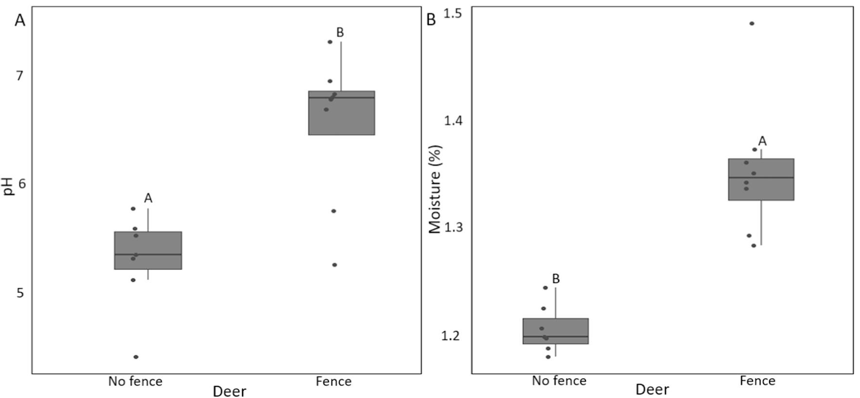
Figure 1c. Box and whisker plot of soil pH (A) and percent soil moisture (B) with bars representing a 95% confidence interval where deer are present (No fence) or absent (Fence) superimposed on the raw data values. Letters indicate the difference between averages in treatments based on Tukey’s post hoc comparison (P < 0.05). (Figure modified from: Woods M.J., Roberson E., Cipollini D., Rua M.A., 2019. White-tailed deer and an invasive shrub facilitate faster carbon cycling in a forest ecosystem. Forest Ecology and Management. 448, 104-111.)

https://www.sciencedirect.com/science/article/pii/S0378112719306395

Figure 1c Questions
- Why do you think the researchers chose to display this data with a box and whisker plot? Could they have used any other data visualizations?
- What conclusion can you draw regarding the effect of deer on soil physicochemical properties?
- What consequences might this have for forests with high deer densities?

Part 2: Outcomes of deer management
Prior to European settlement deer densities in North American forests ranged around 8-11 deer per square mile. In contrast, recent monitoring efforts have shown that deer densities in many eastern parks exceed 100 deer per square mile. Simultaneously, vegetation monitoring indicates a decline in tree seedling and sapling densities, which deer exclusion studies make plain is the result of deer browsing.
To recover from any type of disturbance, healthy forests require adequate tree seedlings and saplings to enable regeneration of the forest canopy. Contrary to this reality, many long-term datasets (such as the National Park Service Inventory and Monitoring network) indicate that decades of over browsing by white-tailed deer prevents tree regeneration in many eastern national parks. Logically, most of the preferred foods for deer are native plant and tree species, and herbivory pressure in areas of high deer-density results in non-native invasive species flourishing. Deer-dominated forest ecosystems tend to shift towards thickets of invasive shrubs as canopy trees decline from disturbances or age. The end result is that without deer management, parks are at risk of losing their forests. If a disturbance such as storm damage or insect infestation takes out mature trees, the forest will be unable to reestablish itself.
This section focuses on the results of deer management programs on seedling recovery in two parks – Gettysburg National Military Park in Pennsylvania and Catoctin Mountain Park in Maryland. The graphs presented here are from Case Studies in Deer Management StoryMap (Weinberg McClosky, ND) and are based on data from the National Park Service Resilient Forests Initiative for Eastern National Parks.

Gettysburg National Military Park: The landscape at Gettysburg National Military Park in south central Pennsylvania includes a combination of open fields, farmland, and woodlots that are dominated by white oak, ash, and hickory. In an effort to help visitors connect with historic events, the park endeavors to maintain the landscape as close to what it was when the battle was fought. Beginning in the 1970s and 1980s park staff observed an increase in the size of deer herds feeding in the park’s agricultural areas. At the same time, they also noticed a lack of young trees in the woodlots and speculated that the deer were browsing on the seedlings and saplings as well. Due to concerns about forest regeneration and the role that deer might play in it, they began a long-term vegetation and deer monitoring project.
What researchers from Gettysburg Park and Pennsylvania State University found was that by 1992 deer densities exceeded 100 per square mile. Simultaneously, vegetation monitoring showed that tree seedling and sapling densities were declining, and the comparisons of fenced [deer exclusion] and unfenced plots provided evidence that the declines were due to deer browsing. The conclusion from these studies was that deer density in Gettysburg would need to be reduced to 25 deer per forested square mile to allow for adequate seedlings and saplings survival to maintain the woodlots. In 1995 the park completed an environmental impact statement that specified lethal removal of deer as the best deer management pathway to achieve the recommended density, and the first removals began later that same year (NPS, 1995).

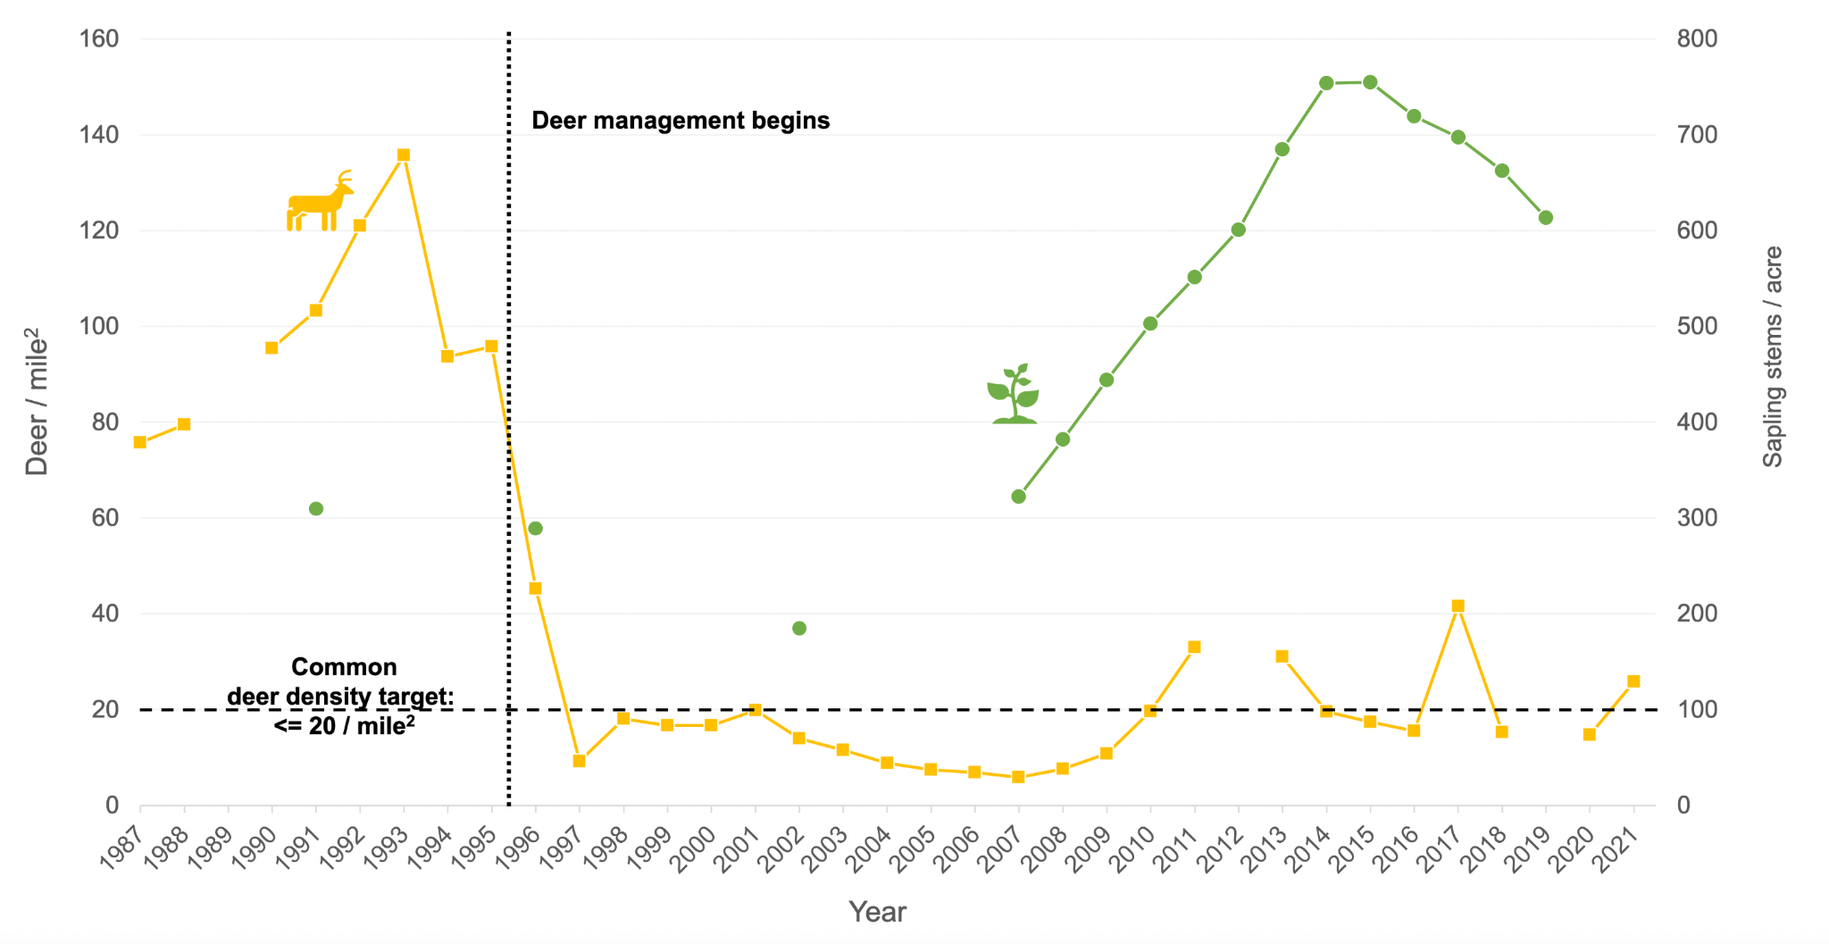
Figure 2a: The relationship between seedling numbers and deer population density in Gettysburg National Military Park. (Graph from Weinberg McClosky, Jessica. Case Studies in Deer Management: What’s worked to support forest regeneration in eastern national parks, what hasn’t, and what’s next? National Park Inventory & Monitoring ND. Retrieved July 16, 2023). https://storymaps.arcgis.com/stories/5b5fe3b82f664093ad435040724706ef

Catoctin Mountain Park: Established during the Great Depression, Catoctin Mountain Park in Maryland protects both natural areas and cultural resources. Though despoiled by industry and agriculture, the park’s forests have successfully recovered and today offer a wide range of outdoor recreation opportunities.
As the forests recovered, so did the deer population, and by the 1980s, park staff were concerned about the impact of deer herds on the forest ecosystem. Young trees as well as understory plants and wildlife all seemed to be impacted, and the state-threatened greater purple-fringed orchid needed the protection of deer exclusion fencing. Thus, in 2009, based on long-term studies validating the undesirable effects of a large deer population, the park finalized an environmental impact statement that included the use of fencing, repellents, as well as the lethal removal of deer to maintain a winter population of 15–20 deer per square mile. At the time the EIS (NPS, 2009) was finalized, the deer numbered over 120 per square mile in the park. Since then, park staff survey the deer population each November and determine the deer management plan that will achieve the target density of 15-20 deer per square mile.

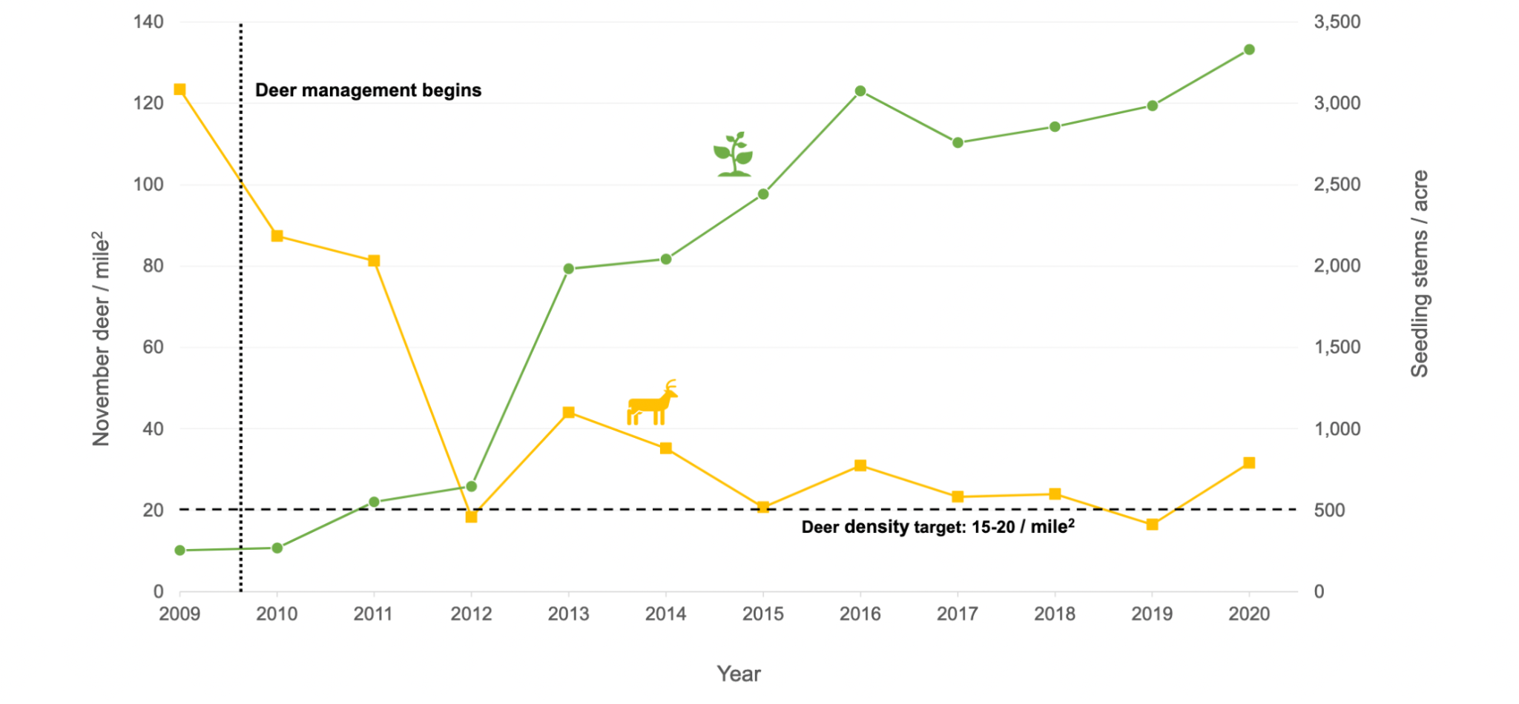
Figure 2b: The relationship between seedling numbers and deer population density in Catoctin Mountain Park. (Graph from Weinberg McClosky, Jessica. Case Studies in Deer Management: What’s worked to support forest regeneration in eastern national parks, what hasn’t, and what’s next? National Park Inventory & Monitoring ND. Retrieved July 16, 2023).
https://storymaps.arcgis.com/stories/5b5fe3b82f664093ad435040724706ef

Examine Figures 2a and 2b. In small groups, describe and analyze Figure 2a and 2b and be prepared to share your responses to the following questions in a full class discussion:

1. Describe the two graphs. How are they similar? How are they different?
2. What conclusion can you draw regarding the effect of deer management on seedling number?
3. What predictions would you make about sustainable forest regeneration in the future in these two forests? Brainstorm challenges that could potentially impact forest regeneration. What information would you need to make a more informed conclusion?

Part 3: Management choices
Conflicts over the management of abundant wildlife have increased dramatically over the past decade. Large herbivores are a particular source of controversy in many suburban communities. For example, some residents enjoy the presence of deer (Odocoileus virginianus) in their neighborhoods, while others have become concerned about problems deer may cause, such as damage to landscaping and gardens, or the risk of vehicular accidents. In many communities, people’s tolerance for the negative impacts of deer has been exceeded. Wildlife agencies and communities face the challenge of managing deer in areas where the traditional management method of hunting is infeasible (e.g., it is unsafe to discharge firearms in areas with high human population density) or socially unacceptable (e.g., the general public will not enjoy watching deer die). At issue are not only the technical aspects of wildlife population control but also the regard for socially acceptable solutions and management of conflicts among community members with opposing viewpoints.
Part 3 focuses on the challenges faced by wildlife managers and community decision-makers in reducing the negative impacts associated with high deer densities. The first portion of part 3 uses the case study of Cayuga Heights, New York to illustrate the multiple stakeholders involved in deer management and trade-offs between management alternatives. It also uses data from Chase et al. (2002) on the public perspectives of various control techniques and models constructed by Peters et al. (2020) to evaluate the effectiveness of these different control techniques.
Cayuga Heights (population 3,738) is a relatively affluent residential suburb bordering the city of Ithaca in Tompkins County, New York. About 520 acres in size, Cayuga Heights is situated on hilly topography east of Cayuga Lake, one of the Finger Lakes in central New York. Deer find suitable habitat in the village’s numerous small woodlots covering side slopes and ravines unfavorable for home construction or maintenance as open lawns. Some Cayuga Heights residents conducted a petition drive in 1998 to document concerns about deer. In response, the mayor appointed a citizen committee to study the situation. Officially created in August 1998, the Cayuga Heights Deer Committee was charged with studying the “deer problem” and developing recommendations for the mayor and village trustees. The situation in Cayuga Heights is not unlike that in many suburban communities in the northeastern and mid-western U.S., where controversy over deer management has persisted over several decades. In many areas, like Cayuga Heights, traditional management methods, such as hunting, are likely to be infeasible or socially unacceptable; and community members hold diverse wildlife values.
While alternatives to hunting are available to control deer populations, these options differ in how well the community perceives them and how effective they are at meeting population management goals. To determine the relative effectiveness of different population control methods, researchers construct population models that reflect the dynamics of the population of interest and alter the parameters of the model based on the impacts of the different control options. In this way, they can see which control options have the largest relative impact on population size.
The type of population model that a researcher will use to evaluate control options will depend on the type of data available. If little data are available, then the researcher will construct a simpler population model; if more data are available, then the researcher will construct a more complex model. A common population model used to assess the relative impacts of control options is matrix models. Matrix models use data from the entire life cycle of a population to generate estimates of population growth. These models are especially valuable because they allow for additional analyses determining which parameter contributes the most to population growth.
For this activity, you and your classmates will play the roles of citizens participating on the Village of Cayuga Heights Deer Committee. Cayuga Heights’ elected officials have mandated your committee to study deer in the Village and recommend how the local government should proceed to reduce deer-related problems in the community. You are aware that numerous homeowners complain that deer ravage their landscaping, gardeners fight an ongoing battle to protect vegetables from decimation by deer, and motorists worry about the increasing likelihood of hitting a deer while driving. Yet many people — including some of those concerned about problems associated with deer — enjoy the presence of deer in their community.
The Deer Committee has worked closely with the New York Department of Environmental Conservation, which has the authority for managing deer. The state deer biologist has agreed to assist Cayuga Heights in managing its deer herd, but the Village (i.e., YOU as the citizen committee tasked with addressing deer issues) must decide which management alternative is most suitable for your community and recommend it for approval by the Village’s governing board. Your committee has been meeting monthly for two years. With assistance from wildlife biologists, you studied Cayuga Heights’ deer population and management methods. Below are four potential methods for managing deer that your committee is considering. A regular hunting season for deer is not an option because the village is almost entirely residential and has an ordinance to protect human safety that prohibits the discharge of firearms.
Method 1: Selectively Cull Deer
The deer population could be reduced by selectively shooting deer attracted to a carefully designed bait site. The meat from a deer cull can be donated to charitable organizations. Deer could be culled by professional sharpshooters or village police. Sharpshooters could use shotguns or archery equipment (bow and arrow) to shoot deer. The cost of this technique is estimated to be around $300 per deer. Wildlife scientists say this technique is effective for immediate reduction of deer numbers in small areas. However, this technique may be difficult in Cayuga Heights because of the density of buildings and houses and because of safety concerns. Sharpshooting is estimated to reduce adult and yearling deer survival by 54-76% (DiNicola and Williams 2008).
Method 2: Deer Contraception
Contraception, or birth control, for female deer, is still being perfected, so any decision to use contraception has to be part of a research project. The estimated cost of contraception is around $1,000 per deer to administer two treatments per year for two years. Contamination of the food chain and meat butchered by hunters is possible. Several contraceptives are used and generally administered to deer with a dart gun. If any darts miss their mark and go unrecovered, they could be hazardous to humans. The effectiveness of reducing population levels using this method is uncertain but estimated to result in 80-90% reduction in fawning for treated females.
Method 3: Surgically Sterilize Deer
Deciding to surgically sterilize female deer is another possible means to attempt to reduce the population of deer. The cost of this method is estimated to range between $400 and $600 per deer — depending on the success rate and the method used to capture deer — after an initial outlay of around $20,000 for equipment. The long-term effects of this method on deer behavior and genetics are unknown. Sterilization has been successful in over 90% of the cases, with successfully treated females becoming unable to have offspring. However, reproductive tissues have been observed to grow back in some individuals. Individual deer only need to be treated once, but it is difficult to capture all deer, especially when there is movement between deer populations. Previous studies have demonstrated that capturing 45->80% of female deer in a population is necessary for sterilization to be effective (Merrill et al. 2006, Denicola and Denicola 2021).
Method 4: Educate People About Reducing Deer-related Problems
One possible decision is to do nothing to reduce the deer population directly, but try to teach people to reduce problem interactions by changing their behavior or the behavior of deer. The village costs for this approach would depend on how much, if any, of an education campaign was funded by the village. Methods that could be promoted include: installing deer fencing, planting unpalatable landscape plants, using deer repellents, discouraging deer feeding, and hazing or frightening deer. Village ordinance prohibits installing fences over 4 feet in height within the first 15 feet of one’s property. Most methods of problem prevention have various, low levels of effectiveness, and none are considered fool-proof.
Working with wildlife biologists (Merrill et al. 2006, Peters et al. 2020), your committee collected the data necessary to construct a matrix model for the deer in Cayuga Heights. Population modeling like this is a valuable tool to rapidly and inexpensively assess the potential effectiveness of the control options that your committee is considering.
Your committee has crafted a female-based Lefkovitch matrix model (Lefkovitch 1965), meaning that the deer life cycle is broken into distinct stages instead of age-based classes. If age classes were to be used, the model would be considered a Leslie matrix model instead of a Lefkovitch model. You began your matrix models by drawing a life cycle diagram that showcased deer stages and the transition between them (see below). Your model has three life cycle stages: fawn, yearling, and adult. The transition between these stages takes a year, with the arrows representing annual survival probability (i.e., from fawn to yearling, yearling to adult, and adult to an older adult) or reproduction (i.e., yearling to fawn and adult to fawn).
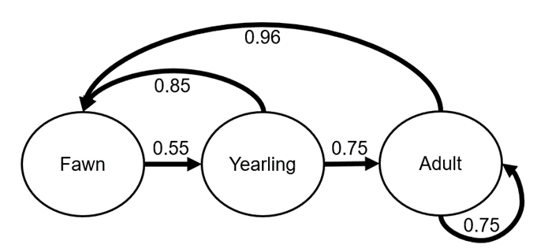
In Cayuga Heights, the probability that a fawn survives to be a yearling is 0.55, a yearling survives to adulthood is 0.75, and an adult continues to survive year after year is 0.75 (Merrill et al. 2006). In this population, female yearlings produce, on average, 0.85 female fawns, and adult females produce 0.96 female fawns (Merrill et al. 2006). However, these values are just average estimates and are known to vary over time. For this model, we are assuming that these values do not change over time.
Your committee then plugged these values into a matrix (hence the term matrix model) that you used as the basis for your population control method evaluation (see matrix below).
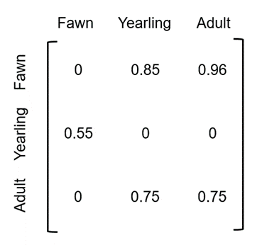
After working with wildlife biologists, you estimated Cayuga Heights to have ~217 female deer in their population, including 87 adults, 50 yearlings, and 80 fawns. Your committee first ran simulations to determine how the deer population would progress without any direct population control. These are referred to as “baseline” simulations—that is, they reflect the relative performance of the population if conditions were to remain unchanged from current conditions.
Then, your committee modified model parameters to reflect the three direct population control options: selective culling, contraception, and surgical sterilization. Public education was not included because it did not directly impact deer population size. To examine the impact of selective culling on the population, you conservatively reduced yearling and adult survival by 54% based on the results of previous studies (DiNicola and Williams 2008; yearling-to-adult survival = 0.437, adult-to-adult survival = 0.419). To determine how contraception would influence population size, you reduced the average number of fawns produced by yearlings and adults to 0.12 and 0.182, respectively. This reflected an 80% reduction in fawn production for both life stages. Lastly, surgical sterilization was implemented by reducing yearling and adult reproduction at two levels: low—a 45% reduction—and high—an 85% reduction in fawn production at both stages (yearling reproduction: low = 0.33, high = 0.09; adult reproduction: low = 0.5, high = 0.1365).
For each run of the population model, you projected 10 years in the future. Given that you started with the same population size for each model run (i.e., 217 female deer from different stages), the relative effectiveness of the different control methods can be examined by looking at the relative population trajectories over time.
Before looking at Figure 3, converse with your Deer Committee—which management approach do you think will have the largest impact on population size? Among your group, discuss why you think that your chosen management option will have the largest impact on population size.
With the other members of the Deer Committee, review the population simulation simulations that resulted from your committee’s work in Figure 3.
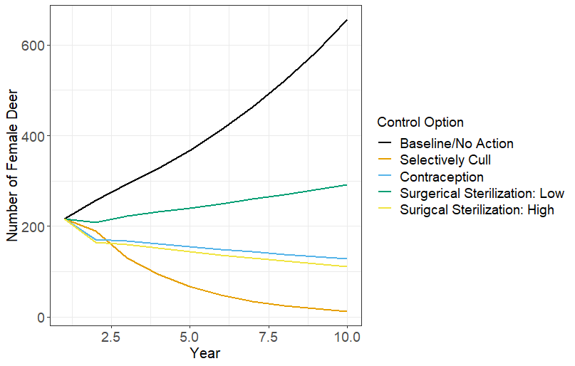
Figure 3: Ten years of simulated white-tailed deer (Odocoileus virginianus) populations in Cayuga Heights, New York, with and without population control methods. Control methods include selective culling, contraception, and surgical sterilization at low (45%) and high (85%) capture successes. The relative impact of no direct population control methods is indicated by “Baseline/No Action.” (Data from: Merrill, John A., Evan G. Cooch, and Paul D. Curtis. "Managing an overabundant deer population by sterilization: effects of immigration, stochasticity and the capture process." The Journal of Wildlife Management 70, no. 1 (2006): 268-277.; Model structure: Peters, Rebecca M., Michael J. Cherry, John C. Kilgo, Michael J. Chamberlain, and Karl V. Miller. "White‐tailed deer population dynamics following Louisiana black bear recovery." The Journal of Wildlife Management 84, no. 8 (2020): 1473-1482.)
Provide brief answers to the following questions:
1. Did the management approach you thought would be the most effective end up being the most effective? Why do you think you did or did not find support for your chosen management strategy?
2. What is the relative impact of non-action on the Cayuga Heights deer population? If you decide not to manage the population directly, is the population likely to increase, decrease, or stay the same?
3. Which control method had the largest relative impact on deer population size in the simulations?
4. Do you think that future deer populations will match the numbers in this figure? Why or why not?
With assistance from social science researchers (Chase et al. 2002), you also conducted a scientific survey to learn how people living in Cayuga Heights felt about deer. This survey was mailed to 550 of Cayuga Height’s ~3,600 residents and 81% of contacted residents completed the survey. The survey contained questions about interests, concerns, and attitudes towards deer management, opinions about stakeholder involvement in deer management, and preferences for personal involvement in deer management. To determine preferences for certain actions, the researchers calculated the percentage of respondents that chose each answer on the survey (Table 1).
Table 1. Factors important for understanding the context regarding deer management from a survey of residents in Cayuga Heights, New York, 1998 (n = 438). (From Chase, L. C., Siemer, W. F. and D. J. Decker. 2002. Designing stakeholder involvement strategies to resolve wildlife management controversies. Wildlife Society Bulletin 30(3):937-950.)
FACTORS | % respondents
Attitudes toward deer
Enjoy deer without reservations | 11%
Enjoy deer but worry about problem | 54%
Do not enjoy deer | 34%
Preferred change in population size
Decrease | 81%
No change | 12%
Increase | 3%
Acceptability of management actions
Deer reproduction control
Very acceptable | 55%
Not at all acceptable | 14%
Trap deer and move them to another area
Very acceptable | 41%
Not at all acceptable | 18%
Use sharpshooters to kill deer at bait sites
Very acceptable | 21%
Not at all acceptable | 50%
Educate people about living side by side with deer
Very acceptable | 33%
Not at all acceptable | 25%
Restrict development to preserve habitat for deer
Very acceptable | 19%
Not at all acceptable | 31%
Allow regulated archery hunting by licensed hunters
Very acceptable | 19%
Not at all acceptable | 52%
Review the survey results in Table 1. Then you and fellow citizens on the Deer Committee must decide on a management option. First, you should attempt to reach a consensus on a control option. Consensus means that the decision is one that everybody agrees with or, at least, can live with. If consensus cannot be reached, then you will take a vote after a specified time for deliberations. During the vote, each committee member will explain their reasoning for selecting a particular option. In your decision-making, consider each option's effectiveness, cost, safety, acceptability, and humaneness.
After 10 minutes, each Deer Committee should select a delegate to orally present the group’s reasoning behind selecting a management option. After each group has presented, we will then attempt to come to a consensus as a class. If a consensus cannot be reached, the class will vote on a control option.
After the class has finished, you will write a brief (1-2 paragraph) essay on the thinking process behind your selection of a management option. Some questions to help guide your reflection:
    - As an individual, what criteria (e.g., effectiveness, cost, safety, acceptability, humaneness) did you consider in selecting a management option? Which was most important to you and why?
    - As a group, how did you attempt to achieve consensus on a management option? Was consensus possible? Why or why not? What trade-offs were involved between different management options?

NOTES TO FACULTY
Part 1: Ecological effects of high deer density on forests
This series of figures contains a variety of graph types including a scatter plot, bar graph, and box and whisker plot. You may need to provide students with background information on different data representations and when they are applied prior to doing this activity.
This first group of figures in the set helps students establish a foundation for the wide-ranging impacts that high deer densities can have on forest structure and function. We recommend that students be put into small groups (3 to 4 students per group) to work through the full figure set.
Provide students with the student instructions which include some background and all of the figures, to aid their understanding of the associated questions.
Figure 1a shows the number of medium-sized hemlock saplings found per hectare at 100 study sites with an index of deer browse intensity called the “sugar maple browse index.” The sugar maple browse index is conducted by counting the number of browsed and unbrowsed terminal twigs 30-200 cm above the ground. The ratio of browsed to total twigs sampled provides a measure of browsing intensity on a scale from 0 to 1. Thus, the higher the sugar maple browse index for an area, the higher we assume the intensity of deer browse to be for other species, including hemlock, also palatable to deer.
Answers for student questions
- Students should be able to describe that the figure illustrates a significant negative relationship between deer browse and number of medium-sized hemlock saplings on study sites. Thus, higher deer browsing intensity results in a significant reduction in medium sized hemlocks.
- Students should be able to describe that this could cause a change in the community of plants in the forest such that only those unpalatable to deer can reproduce and survive to maturity. High deer browse could result in arrested succession and would make restoration efforts challenging as any successful restoration project for hemlock would also require control of the deer population.
Figure 1b shows the effects of deer on forest bird populations. Since large herbivores like white-tailed deer affect forest plant communities directly through browsing (eating) and indirectly through the cycling of nutrients and energy in food webs, the researchers hypothesized that there may be a connection between high deer density and declining bird diversity. By changing forest vegetation, deer alter habitat for forest birds and could affect both the abundance (number) and diversity (variety) of birds.
McShea and Rappole monitored (a) the density and diversity of vegetation and (b) the abundance and diversity of birds at eight 4-hectare forested sites in northern Virginia. The sites were located within 25 km of Front Royal, VA, in large forest tracts in either the Shenandoah National Park or the Smithsonian Institution’s Conservation and Research Center. Initially the eight sites contained similar understory vegetation and deer densities. The researchers fenced four of the sites to exclude deer. They then examined changes in vegetation and bird communities that occurred between the fenced (exclosure) and non-fenced (control) sites over a 9-year period. To document changes in bird populations, the researchers mist-netted (i.e., used a large, fine mesh put up between trees to capture birds in flight) repeatedly during the summer months for the duration of the 9-year study.
The purpose of the research was “to test whether deer can serve as agents of structural change in protected forests and whether manipulation of deer numbers can affect bird populations, with understory vegetation as the short term link between these two trophic levels” (McShea and Rappole 2000).
The resulting change in characteristics of the forest habitat may have particular significance with respect to the decline of songbirds. Songbirds are especially sensitive to habitat changes, such as the volume (amount) and composition (types) of vegetation, because of their foraging and nesting behaviors.
McShea and Rappole found the following:
The exclusion of deer increased the density and diversity of understory woody shrubs relative to control sites (Figure 1a).
Fifteen of 25 bird species examined experienced population increases in response to the increase in vegetation that resulted from deer exclusion.
Patterns of change observed in bird populations can be grouped into three categories: 1) birds that prefer open understories (e.g., Chipping Sparrows) declined when deer were excluded, 2) birds that prefer dense herbaceous ground cover (e.g., Indigo Buntings) increased when deer were excluded but declined as herbaceous species were taken over by woody vegetation, and 3) birds that prefer dense woody understory (e.g., Ovenbirds) gradually increased when deer were excluded (Figure 1b).
Diversity of birds did not change with exclusion of deer at the geographic and time scales examined in this study.

Answers for student questions:
- Chipping Sparrow numbers declined in exclosure sites over the 9 years. Chipping Sparrows were negatively related to deer exclosure. Indigo Bunting numbers initially increased in exclosure sites and then decreased back to similar levels as those in control sites (with the exception of 1998). Indigo Buntings were initially positively related to deer exclosure, but this relationship did not persist over time. With the exception of a spike in 1991, Ovenbird numbers generally remained constant between exclosure and control sites through most of the study; however, Ovenbird numbers increased in exclosure sites during the final years of the study. Initially Ovenbird abundance appeared unrelated to deer exclosure. The data of 1997-1998 suggested that a positive relationship could exist.
- This figure uses bar graphs to illustrate temporal trends, but line graphs can also be useful for this purpose.
- The key to explaining these patterns is succession. Students will need a hint to realize this. As McShea and Rappole (2000:1168) concluded: “Release from deer browsing caused rapid successional changes in the forest understory as vegetation progressed from grasses to forbs to Rubus spp. to woody saplings. These changes corresponded to a shift in bird species composition from Chipping Sparrows to Indigo Buntings to Hooded Warblers to Ovenbirds. This successional process, in combination with site differences, makes it difficult to say whether or not a particular species will increase in response to lower deer densities, because the answer depends on the site characteristics and the time span involved. For example, Indigo Buntings responded immediately to removal of deer but then declined at exclosure sites until the ninth year, when an ice storm opened the canopy and resulted in a second pulse of herbaceous vegetation and a second pulse of birds.”
- The loss of some bird species could impact other animals that rely on them for food. In addition, the diets of the three species as described here consist of seeds and insects. Detailed information as to which specific insects or seeds are consumed is not provided, however if there was a dramatic reduction or increase in certain bird species as a result of high deer densities, it could impact insect densities. Likewise, if the birds function as important seed dispersers, high deer densities could also impact reproduction of certain plant species in the forest.
The main point of this activity is that deer’s impact on forest vegetation also affects other animals. In this case, Figure 1b shows that excluding deer from protected forests changed the relative abundance of 3 bird species. Whether the impact of deer is good or bad is largely in the “eye of the beholder.” Is one bird species of greater value than another species? Rappole and McShea found that several resident birds in their study sites, such as Tufted Titmouse, Blue Jay, Northern Cardinal, and Carolina Wren, showed marked decreases in abundance after removal of deer. These species tend to have stable or increasing populations in national bird surveys and are not normally of management concern. Migrant birds that foraged either in the understory or higher in the canopy responded positively to the increases in vegetation density and diversity that followed deer exclosure. Many of these species are of greater conservation concern than the resident birds (McShea and Rappole 2000).
The take home messages from this example are:
- interactions at one trophic level (deer herbivory) influenced another (birds), and
- humans decide what to manage for (e.g., conservation of specific rare bird species) and must understand complex ecosystem interactions to achieve management goals.
For Figure 1c, Woods and colleagues (2019) explored the impact of deer on some abiotic conditions within forest ecosystems. Specifically, they were interested in the effects of the presence/absence of the invasive shrub, Amur honeysuckle, and white-tailed deer on soil physicochemical properties and enzyme activities. Here, only some of their results are shown, with a focus on the soil physicochemical properties at sites with Amur honeysuckle removed and with high and low densities of white-tailed deer. The soil physicochemical properties studied by Woods and colleagues included soil pH and soil moisture levels, both of these relate to soil functional properties such as nutrient and carbon cycling, which in turn can affect vegetation dynamics.
Woods and colleagues used three paired (6 total) 9 m x 3m deer exclosures to manipulate white-tailed deer access and established subplots with honeysuckle removal. They harvested soil cores from the paired deer exclosure and deer access plots and measured a number of parameters including pH and moisture. They found that where honeysuckle was not present, deer presence significantly decreased soil pH and soil moisture.
The figure shows a significant reduction in soil pH and soil moisture in areas where deer are present. For reference, the authors of the study suggested that these changes could be a result of soil compaction from deer trampling, which lowers soil ability to hold moisture. In addition, they suggest that the reduction in pH could also be a result of soil compaction altering soil chemistry or potentially by increased N addition to the soils through deer excrement, or a combination of the two.
Answers for student questions:
- The researchers may have chosen to display their data using a box and whisker plot to highlight the distribution of the data and make it easy to compare across groups (deer present/not fenced compared to deer absent/fenced). Another option might be a bar graph showing the average along with standard error, as bar graphs can also effectively be used to compare groups. However, this would depend on the data’s distribution and whether graphing the mean would present an accurate representation of the data.
- High deer densities can also have major impacts on the abiotic nature of forest ecosystems.
- In a forest with large populations of deer, changes to soil physicochemical properties seems to increase the rate of decomposition and therefore C cycling. Thus, the storage capacity or residence time of C in forested ecosystems may be reduced overall by high deer densities, releasing more CO2 into the atmosphere. In addition, if plant species are adapted to a specific soil pH or moisture range, high deer densities may push their tolerance levels and impact primary production in the forest.

Student Assessment: Minute Paper
For a quick assessment of students’ comprehension of the figures, select one of the questions that students discussed with their group and ask them to answer it individually in writing on a 3x5 index card or piece of scrap paper. Allow 1-3 minutes for students to respond. For a more in-depth assessment, ask students to respond with a short answer in writing to each of the questions in the student instructions.

Alternative Student Assessment: Concept Map
You can also ask students to draw a concept map illustrating the relationships that they believe are occurring over time between deer, soil physicochemical properties, herbaceous and woody forest vegetation, and bird species. You can ask them to do this individually or work on it together within their groups.
There are a number of helpful resources on how to approach concept mapping. We recommend: https://learningcenter.unc.edu/tips-and-tools/using-concept-maps/ and https://lsc.cornell.edu/how-to-study/concept-maps/ as a good place to start for those who are not familiar with this practice.

Part 2: Outcomes of deer management
We recommend that students be put into small groups (3 to 4 students per group) to work through this figure set.
Answers for Student Questions:
- Students should be able to “read” the graphs – i.e., understand what all the axes represent and what the plot lines indicate. Both figures are a double y-axis graph that show the relationship between deer population density and seedling/sapling number before as well as after the implementation of deer management by lethal removal. The x-axis in both graphs measures time in years, and the y-axes in both graphs are similar though not identical. In Figure 2a it is deer/mile² and sapling stems/acre, while in Figure 2b it is deer/mile² (November counts) and seedling stems/acre. The overall relationship between deer management and seedling/sapling counts in both graphs is the same. The differences are some specific details such as when deer management started, deer density, and seedling/sapling counts.

- In general as deer density dropped, tree seedlings/saplings grew more abundantly.
Specifically for each graph:
Figure 2a: The Gettysburg deer removals have successfully kept deer densities in the park around 20 deer per square mile. Though improvements in forest regeneration metrics were slow, the long-term results show that after deer densities fell below 20 deer per square mile, sapling densities did indeed increase. By 2013, after 18 years of deer removals, Gettysburg became the only park in the Mid-Atlantic Network to achieve viable forest regeneration in the presence of a substantial deer population.
Figure 2b: It took six years to achieve the deer density target for the first time and the park has maintained that target ever since. As deer density dropped, tree seedlings grew more abundantly and by 2020, seedlings were 13 times more numerous than when deer management first began in 2009. In addition, other herbaceous plants are increasing, and the greater purple-fringed orchid now flourishes without the aid of deer exclusion fencing.
- Responses to this question will vary. Alternatively, this question could be addressed as a full class discussion. Over the course of the class discussion, it might be helpful to provide students with the following additional background information.
In Gettysburg as well as Catoctin, deer management success comes with numerous caveats. Though there are clear benefits, achieving sustainable forest regeneration could still be far off. For one, it can take decades for seedlings to grow into saplings and young trees. In addition, in both cases, seedling diversity is not where it needs to be to eventually regenerate the forest canopy. Most of the tree seedlings are ash, which due to the spread of the emerald ash borer beetle (an invasive insect pest), are unlikely to survive long enough to regenerate the forest canopy. Finally, invasive plants pose a problem as forested landscapes without adequate potential for canopy recovery tend to shift towards thickets of invasive shrubs.
Potential solutions to address these challenges include tree tubes, prescribed burning, and invasive shrub control to boost regeneration potential for other species. These interventions are showing some success at Catoctin where seedling diversity may be on the upswing. Between 2017-2020, ash seedlings accounted for a smaller share (~62%) of seedlings, down from 75% in previous years. Simultaneously, other tree species’ seedling counts rose.
Overall lessons learned regarding deer management and forest canopy regeneration:
·
- Recovery of saplings is slow and thus a long-term focus and sustained commitment is necessary for success.
- Non-woody understory plants recover fairly quickly once deer management starts, but tree regeneration takes time.
- It can take 15+ years to attain sustained and healthy levels of forest regeneration after deer management begins.
- Ensuring appropriate seedling species composition is an important aspect of eventual, successful forest regeneration, particularly given the emerging threats to historic canopy species like ash and beech.
- Deer management is not sufficient in of itself, concurrent invasive plant management is also necessary.

Student Assessment: Concept Map
As an overall assessment, you can ask students to draw a concept map illustrating all the factors that affect forest regeneration in eastern forests including deer management, sapling survival, and other factors such as invasive plants and pests and from that identify points of intervention (such as seedling diversity and invasive species management). You can ask them to do this individually or work on it together within their groups.

Part 3: Management Choices
In this exercise, the "citizen's argument" simulates deliberations among a committee of citizens appointed by elected officials to study and recommend appropriate actions for deer management in a suburban community. Students are given informational scenarios about different deer management options, the results of population models, and a community attitude survey (Table 1, adapted from Chase et al. 2002). After digesting these, students deliberate as a group and try to reach a consensus on the preferred management option for the community. Given the amount of information for students to assess, you may wish to assign the information above as advanced reading and check in with students prior to separating into groups to discuss with a quick 3-4 question quiz from the material.
You can let students form their own opinions, or, if you feel consensus would be reached quickly and students would not get to grapple with diverse stakes in deer management decisions, you can assign specific roles. A list of potential stakeholders and their positions can be found below, but it is recommended that one student in the group be assigned the role of Committee Chair:

- Committe Chair - Facilitates discussion
  - Position on deer: Generally neutral
  - Position on management: Open to any form of deer control
- Wildlife Photographer -
  - Position on deer: Positively impacted by deer presence
  - Position on management: Will only support Educate People and Selectively Culling Deer
- Animal Rights Supporter -
  - Position on deer: Positively impacted by deer presence
  - Position on management: Will only support Educate People
- Hunter -
  - Position on deer: Positively impacted by deer presence
  - Position on management: Will only support Educate People and Surgically Sterilize Deer
- Police Officer - responds to deer-vehicle collisions
  - Position on deer: Negatively impacted by deer presence
  - Position on management: Open to any form of deer control
- Gardner -
  - Position on deer: Negatively impacted by deer presence
  - Position on management: Open to any form of deer control except Educate People
- Homeowner -
  - Position on deer: Generally neutral, but concerned
  - Position on management: Open to Education People, could be convinced of Surgical Sterilization and Contraception, against Selectively Culling
- Motorist -
  - Position on deer: Negatively impacted by deer presence
  - Position on management: Open to any form of deer control except Educate People
You can also provide students with an agenda for their discussion to ensure that all salient points are covered. An example agenda can be found below.
- Call to order and stakeholder assignment
- Decisions to be made:
  - What should be the target deer population in Cayuga Heights? (i.e., the same, increase, decrease)
    - If the committee has decided that the deer population should increase or decrease, by what percentage should the deer population be altered?
  - Of the available deer management actions (i.e., Selectively Cull Deer, Deer Contraception, Surgically Sterilize Deer, Educate People/No Action), which option is:
    - the least expensive?
    - the safest?
    - the most socially-acceptable?
    - the most humane?
    - the most likely to help Cayuga Heights attain the deer population target specified above?
  - What management option will be pursued?
- Summarize reasoning and prepare to present to class
For addressing part 2b of the agenda above, the students should be able to use the information provided in the text, table, and figure to determine which is the least expensive, the safest, the most socially acceptable, and the most likely to help them attain their deer population goals. As far as addressing which is the most humane, students should consider whether the proposed management action results in pain or suffering to the animal. The more pain or suffering the animal would endure, the less humane the action.
In a large class, you may want to divide the students into a series of smaller committee meetings that then come together towards the end of the class period to attempt to reach a class-wide consensus. In this way, all students will have the opportunity to participate in the discussion.
You may need to help the students understand Figure 3 and, depending on your students’ background, provide more or less information about the population models. Should you want to include more about matrix models, you may want to consider reviewing the material in Schutzenhofer and Knight (2009; citation below). If the matrix information is likely too complicated for your students to understand in a short class period, you might want to remove the information about matrix models and present the results of the population simulation as one done by a wildlife consulting firm.
Students may expect the control options that influence a larger proportion of the population to have a stronger effect (e.g., an 80% decrease vs. a 54% decrease). One of the take-homes here is that population dynamics are more than a numbers game—certain aspects of life stages and transition probabilities are more important than others. Effectively and efficiently managing populations often involves finding the most-sensitive life stage or transition and focusing management efforts there. As Table 1 suggests, this can be complicated by the many stakeholders involved in population management.
At the end of class, it may be helpful to bring up the famous quote by George Box for the class to discuss – “All models are wrong, but some are useful.” While these population models can give us a feel for the relative impact of the different control methods, they do come with a lot of assumptions, which some people may be more or less comfortable with.
Answers for Student Questions:
1. This will depend on what the student/group discussed. The students will likely fall into the trap of “bigger numbers, bigger effect.” The hope is that, with further thought, the students will realize that it’s not just numbers, but how numbers interact that can impact population size. For example, although some control methods greatly reduce reproduction, if yearling and adult survival are high, there can still be a lot of deer around to produce many offspring.
2. The population is likely to increase without direct management.
3. Selectively culling deer had the largest relative impact on deer population size.
4. No – the transition probabilities change over time (while this assumes that they will be constant); something else may happen that we have not accounted for in this model.
Help students understand the survey results in Table 1. Surveys were sent to 550 randomly selected resident property owners in Cayuga Heights during November and December 1998. The researchers received an 81% response rate (adjusted for undeliverable questionnaires and nonresidents). Students should note that the majority (54%) of respondents said that they enjoy the presence of deer but worry about associated problems. Of particular interest is that 81% of respondents prefer a decrease in the deer population size; however, 50% and 52% find killing deer by sharpshooters or licensed archery hunters, respectively, to be “not at all acceptable.” This posed a challenging dilemma for community decision-makers and wildlife managers: how to reduce the negative impacts associated with deer with dubious public support for lethal control? This led to the exploration of additional management options and the four scenarios included in the students’ instructions. Let students read and digest the pros and cons of the four management scenarios.
Have students begin deliberating for a specified period of time (e.g., 30 minutes). After the designated time period, ask students if they have reached a consensus and, if so, for a group leader to articulate their decision. If not, ask students to prepare to vote. Vote orally or by written ballot. After the vote, if class size permits, ask each student to explain the reasoning behind their choice. Alternatively, facilitate a group discussion around challenges to reaching a consensus and the trade-offs between different management options.
This issue of deer management has not been resolved in Cayuga Heights, even after several control options were pursued. You can discuss what strategies the Deer Committee decided to implement, their relative success, and generally stay up to date with the deer happenings in Cayuga Heights here: https://cayuga-heights.ny.us/projects-2/deer-management/.
Additional Resources
Schutzenhofer, M. R. and T. M. Knight. February 2009. When Biocontrol Isn’t Effective: Making Predictions and Understanding Consequences. Teaching Issues and Experiments in Ecology, Vol. 6: Issues Figure Set #1 [online]. https://tiee.esa.org/vol/v6/figure_sets/biocontrol /abstract.html

LITERATURE CITED
Chase, L. C., W. F. Siemer, and D. J. Decker. 2002. Designing stakeholder involvement strategies to resolve wildlife management controversies. Wildlife Society Bulletin 30:937-950.
Côté, S. D., T. P. Rooney, J.-P. Tremblay, C. Dussault, and D. M. Waller. 2004. Ecological impacts of deer overabundance. Annu. Rev. Ecol. Evol. Syst. 35:113-147.
DeNicola, A. J. and S. C. Williams. 2008. Sharpshooting suburban white-tailed deer reduces deer–vehicle collisions. Human-Wildlife Conflicts 2:28-33.
DeNicola, A. J. and V. L. Denicola. 2021. Ovariectomy as a management technique for suburban deer populations. Wildlife Society Bulletin 45:445-455.
Lefkovitch, L. P. 1965. The study of population growth in organisms grouped by stages. Biometrics 21:1-18.
Leong, K. M., D. J. Decker, T. B. Lauber, D. B. Raik, and W. F. Siemer. 2009. Overcoming jurisdictional boundaries through stakeholder engagement and collaborative governance: Lessons learned from white-tailed deer management in the US. Pp. 221-247 in Beyond the rural-urban divide: Cross-continental perspectives on the differentiated countryside and its regulation. Emerald Group Publishing Limited.
McCabe, T. R. and R. E. McCabe. Recounting whitetails past. 1997. Pp. 11-26 in W. J. McShea, H. B. Underwood, and J. H. Rappole (Eds.), The Science of Overabundance: Deer Ecology and Population Management. Smithsonian Institution Press, Washington, D.C.
McShea, W. J., H. B. Underwood, and J. H. Rappole. 1997. The Science of Overabundance: Deer Ecology and Population Management. Smithsonian Institution Press, Washington, D.C.
McShea, W. J. 2012. Ecology and management of white‐tailed deer in a changing world. Annals of the New York Academy of Sciences 1249:45-56.
Merrill, J. A., E. G. Cooch, and P. D. Curtis. 2006. Managing an overabundant deer population by sterilization: effects of immigration, stochasticity and the capture process. The Journal of Wildlife Management 70:268-277.
National Park Service. 2022. Resilient Forests Initiative - Managing Deer Impacts. In Resilient Forests Initiative for Eastern National Parks. Retrieved July 16, 2023. https://www.nps.gov/articles/000/resilient-forests-initiative-deer.htm
National Park Service. 2009. FINAL White-tailed Deer Management Plan and Environmental Impact Statement. Retrieved July 16, 2023. https://parkplanning.nps.gov/document.cfm?parkID=176&projectID=10003&documentID=25018
National Park Service. 1995. Gettysburg National Military Park, Eisenhower Historic Site, White-tailed Deer Management Plan: Environmental Impact Statement. Retrieved July 16, 2023. https://books.google.co.ug/books?id=0Cc3AQAAMAAJ&source=gbs_book_other_versions&redir_esc=y
Ness, E. 2003. Oh, deer. Discover. 24:66-71.
Peters, R. M., M. J. Cherry, J. C. Kilgo, M. J. Chamberlain, and K. V. Miller. 2020. White‐tailed deer population dynamics following Louisiana black bear recovery. The Journal of Wildlife Management 84:1473-1482.
Ruggiero, L. F. 2010. Scientific independence and credibility in sociopolitical processes. The Journal of Wildlife Management 74:1179-1182.
Russell, F. L., D. B. Zippin, and N. L. Fowler. 2001. Effects of white-tailed deer (Odocoileus virginianus) on plants, plant populations and communities: a review. American Midland Naturalist 146:1-26.
Waller, D. M. and W. S. Alverson. 1997. The white-tailed deer: a keystone herbivore. Wildlife Society Bulletin 25:217-226.
Warren, R. J. 2011. Deer overabundance in the USA: recent advances in population control. Animal Production Science 51:259-266.
Weinberg McClosky, J. N.D. Case Studies in Deer Management: What’s worked to support forest regeneration in eastern national parks, what hasn’t, and what’s next? National Park Inventory & Monitoring. Retrieved July 16, 2023. https://storymaps.arcgis.com/stories/5b5fe3b82f664093ad435040724706ef
Woods M. J., E. Roberson, D. Cipollini, and M. A. Rua. 2019. White-tailed deer and an invasive shrub facilitate faster carbon cycling in a forest ecosystem. Forest Ecology and Management 448:104-111.

