ISSUES: FIGURE SET
A Data-Driven Investigation Exploring Productivity–Diversity Relationships Across Scales

Laura Catano (laura.catano@ucr.edu)
Department of Evolution, Ecology, & Organismal Biology, University of California, Riverside, CA 92521
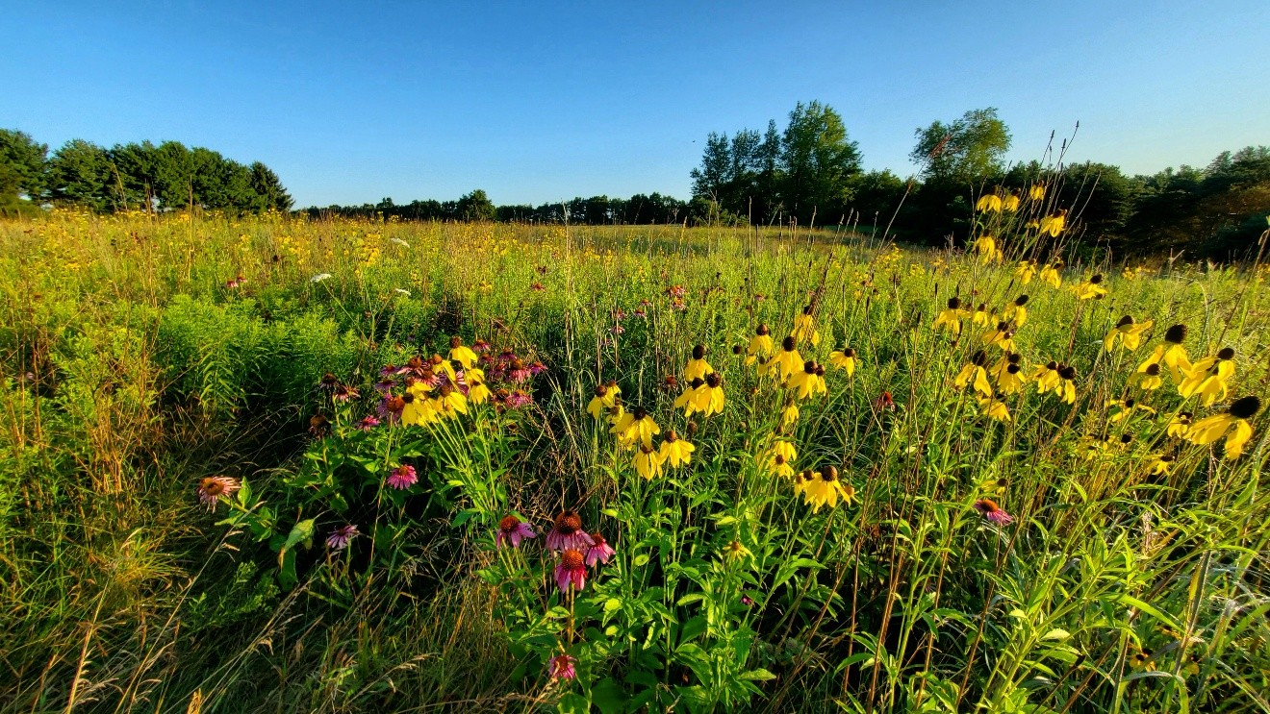

Tallgrass prairie, Southwestern Michigan (Courtesy of Christopher Catano)
THE ISSUE:
A central problem in ecology is understanding why some ecosystems support more species than others. In this activity, students analyze patterns of plant productivity and species richness at different sites and scales. They consider how local management (mowing, grazing) and global environmental gradients interact to create or obscure the expected relationships predicted by ecological theory.

FOUR-DIMENSIONAL ECOLOGY EDUCATION (4DEE) FRAMEWORK
- Core Ecological Concepts:
  - Communities
  - Ecosystems
- Ecology Practices:
  - Quantitative reasoning and computational thinking
  - Data analysis and interpretation
- Human-Environment Interactions:
  - Human impacts on the environment from local to global scales
- Cross-cutting Themes:
  - Space & time
INTEGRATION ACROSS 4DEE DIMENSIONS
Students apply ecological practices (data interpretation) to explore core concepts (diversity-productivity relationships), while simultaneously thinking about human impacts (land use effects/climate change) and recognizing patterns across scales (different sites show different patterns). By asking students to develop hypotheses about why some sites deviate from expected trends, the activity integrates all four dimensions, requiring them to think critically about mechanisms, methodology, and context.

STUDENT-ACTIVE APPROACHES:
- Figure 1: Through a series of guided inquiry questions completed in small teams, students describe and interpret a figure to reveal the general rule described by the Diversity Equilibrium Model (DEM). In a think, pair, share, students describe the DEM relationship in their own words, then pair and share in their teams.
- Figure 2: Through a series of guided inquiry questions completed in small teams, students describe and interpret a figure that illustrates DEM predictions in a controlled, real-world setting, allowing students to connect theory to empirical evidence. In a think, pair, share, students summarize how the real dataset reinforces the broader principle shown in the DEM figure in their own words, then pair and share in their teams.

- Figure 3: Through a series of guided inquiry questions completed in small teams, students describe and interpret a figure that illustrates the context-dependency of DEM predictions and highlights the effects scale on productivity–diversity relationships. In a think, pair, share, students use the figure to draw conclusions about the strengths and limitations of the Diversity Equilibrium Model (DEM).

STUDENT ASSESSMENTS:
team data analysis answers. Optional concept map or mini research proposal extension activity.

CLASS TIME:
One 75-minute or two 50-minute class periods

COURSE CONTEXT:
Biology majors, upper division undergraduate ecology course

ACKNOWLEDGEMENTS:
This activity was created as part of the Ecological Society of America’s (ESA) Transforming Ecology Education to 4D (TEE) Fall 2025 Faculty Mentoring Network (FMN) led by Dr. Jamie M. Kneitel and Dr. Xuan Chen. The author came up with the concept and created the activity, receiving guidance from other members of the FMN and Dr. Christopher Catano. The manuscript benefitted from feedback from one anonymous reviewer and Christopher Beck. Funding for the activity was provided by a fellowship from the University of California, Riverside’s Hellman Fellowship Program.
OVERVIEW
WHAT IS THE ECOLOGICAL ISSUE?
Understanding the factors that regulate species diversity is a central problem in ecology. One long-standing hypothesis is that species richness varies predictably with primary productivity, often forming a unimodal (hump-shaped) relationship, where diversity is highest at intermediate productivity. This pattern is frequently framed within the Diversity Equilibrium Model (DEM) (Huston 1979, 1994), which posits that species diversity results from a dynamic balance between competitive exclusion and disturbance. At low productivity, resource scarcity limits the number of species that can persist; at high productivity, competitive dominants exclude slower-growing species unless disturbance prevents monopolization. Disturbance, including both natural (fire, flooding) and anthropogenic (grazing, mowing, nutrient addition) events, slows competitive exclusion, allowing species coexistence. The interaction between productivity and disturbance thus shapes community structure and species richness across ecosystems.

Grasslands provide an ideal system to explore these dynamics because they are productive, species-rich ecosystems that are strongly influenced by disturbance regimes and human management. For example, studies of British pastures and grasslands have demonstrated that species richness often peaks at intermediate productivity, consistent with DEM predictions (Al-Mufti et al. 1977). In these systems, productivity is typically quantified as aboveground biomass, measured through standardized harvesting of live and dead plant material, while disturbances arise primarily from annual mowing and grazing, which are relatively uniform across sites. These managed systems allow students to investigate clear, well-documented productivity–diversity relationships with minimal confounding variation in disturbance, making them a robust example of theory in practice.

However, global analyses reveal that DEM predictions do not universally hold. Studies across multiple grassland sites show high variability in productivity–diversity relationships, including nonsignificant, positive, negative, concave-up, and concave-down patterns (Adler et al. 2011). This variability arises from a combination of local factors—such as species pool composition, functional traits, soil fertility, microclimate, and disturbance type—and regional or global differences, including historical land use and biogeography. Human activities, including grazing, fertilization, habitat conversion, and climate change, have further modified these patterns, creating novel ecosystems with altered productivity, disturbance regimes, and species interactions (Ellis 2011). Consequently, what holds true at a single site may not generalize across broader spatial scales, highlighting the importance of scale as a cross-cutting concept in ecology.

This figure set and associated activity enable instructors to engage students with these issues by linking core ecological concepts (community and ecosystem ecology) to ecology practices (data interpretation, quantitative reasoning), human-environment interactions, and cross-cutting themes such recognizing patterns across scales. By examining both predictable patterns in controlled systems (British pastures) and variable patterns across global datasets, students learn how ecological theory is applied, tested, and sometimes challenged in real-world contexts. They also gain an appreciation of the interplay between biotic and abiotic factors, human impacts, and scale, setting the stage for inquiry-based learning and participation in global collaborative projects such as the Nutrient Network (NutNet).

FIGURE SETS TABLE

Figure Set | Student-active Approach | Cognitive Skill
Productivity–Diversity Relationships, from theory to practice | Guided group work to describe and interpret figures, then make predictions. Think, pair, shares used for formative assessment. Post-activity concept map suggestions. | Interpretation, comparing, explaining, applying, integrating

Learning Objectives:

- Interpret ecological data to identify patterns of species richness, productivity, and disturbance in graphs.
- Compare observed patterns to ecological theory, including the Diversity Equilibrium Model, and explain similarities or differences.
- Explain how competition, resources, and disturbance affect species diversity.
- Hypothesize the effects of human activities such as grazing, mowing, and nutrient addition on biodiversity patterns.
- Compare local and global datasets to understand how scale and context affect ecological patterns.

Student Assessments: Instructors could assess written team answers to figure analysis questions. Formative assessment checks in the form of think, pair, shares, are included in the question set for each figure. Instructors could use these questions as pause points to quickly assess whether students are on the right track and catch any misunderstandings. Optionally, post-activity, the instructor could assign a concept map where students draw a simple causal diagram linking productivity, competition, disturbance, and diversity. A more detailed concept map could have students linking productivity, disturbance, species interactions, energy and matter flow, and human activities (thus assessing students’ ability to make cross-cutting connections). A higher stakes post-activity assessment could have students making predictions (e.g., about changes in productivity, expected diversity pattern, mechanisms driving those changes) based on a hypothetical ecosystem (e.g., fertilized pasture, fire-suppressed grassland). Lastly, students could be tasked with making a mini-research proposal where they develop a testable question related to productivity and diversity and describe a hypothesis grounded in DEM, a predicted pattern, and an explanation of scale and human influences

Figure Set Background:

Figure 1. Diversity Equilibrium Model (Huston 1979, 1994)
- Conceptual diagram showing predicted species richness as a function of productivity and disturbance.

- Diversity peaks at intermediate productivity and disturbance, forming a ridge along the diagonal. Low productivity or low disturbance leads to fewer species due to resource limitation or competitive exclusion, respectively.

- Provides a theoretical framework for students to interpret real data and predict patterns in species richness. It introduces the mechanism by which productivity influences competition and how disturbance mediates competitive exclusion.

Figure 2. British Pastures and Grasslands (Al-Mufti et al. 1977)
- Dataset: Herbaceous plant species richness measured across a gradient of aboveground biomass (live + dead).

- Disturbance: Relatively uniform annual mowing and grazing.

- Pattern: Clear unimodal (hump-shaped) relationship between productivity and species richness.

- Use: Illustrates DEM predictions in a controlled, real-world setting, allowing students to connect theory to local empirical evidence.

Figure 3. Global Grassland Dataset (Adler et al. 2011)
- Dataset: Within-site relationships between productivity (peak live biomass) and species richness from 48 grassland sites worldwide.

- Pattern: High variability: nonsignificant, linear positive, linear negative, concave-up, and concave-down patterns.

- Use: Shows the context-dependency of DEM predictions and highlights the effects of species pool, disturbance type, land-use history, and scale on productivity–diversity relationships.

- Implication: Prepares students to think critically about ecological theory and human-environment interactions and sets up a transition to NutNet experiments.

Figure 1

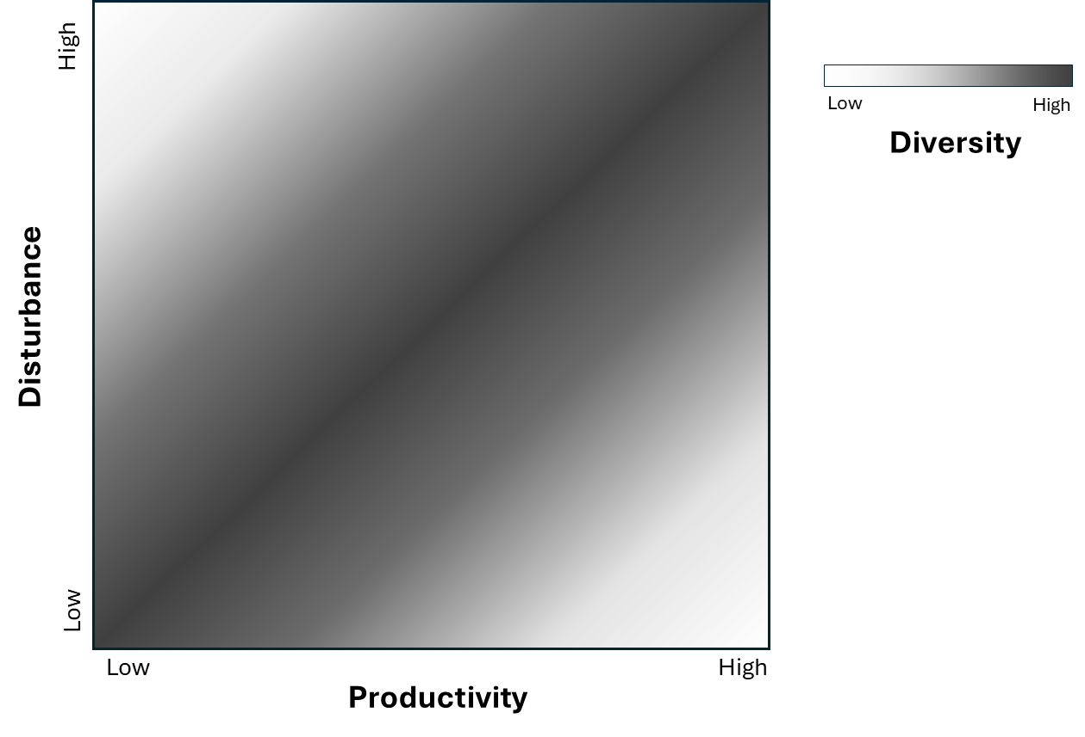
Fig. 1 Legend Predictions of species diversity made by the Dynamic Equilibrium Model (DEM) (redrawn from Huston 1979, 1994), showing the interactive effects of productivity (e.g., Net Primary Productivity, plant growth rates) and disturbance (e.g., herbivory, fire) on species diversity. Levels of species diversity are indicated by shading, with the highest species diversity predicted along the darkest diagonal, from lower left to upper right.

Introduction: Ecologists have long observed that species diversity varies across environments that differ in productivity (resource availability) and disturbance (events that disrupt populations). The Diversity Equilibrium Model (DEM), proposed by Michael Huston, predicts how diversity changes as these two factors interact. Use the figure showing diversity across productivity and disturbance to explore patterns and develop explanations for why species diversity is highest under certain conditions.

- In the figure, where is species diversity highest? Mark this area on the figure with x’s.
  - What combination of productivity and disturbance corresponds to this region?

- Where is species diversity lowest? Make this area on the figure with o’s.
  - What do productivity and disturbance look like in those regions?

- Based on the DEM, as you move from low to high productivity at low disturbance, how is diversity predicted to change?
  - Sketch this relationship in the space below. Be sure to label the axes.
Predicted Species Diversity at Low Disturbance

- When disturbance is low, when would you expect the highest species diversity? Hypothesize why.

- Based on the DEM, what is predicted to happen to species diversity as you move from low to high productivity at high disturbance?
  - Sketch this relationship in the space below. Be sure to label the axes.
Predicted Species Diversity at High Disturbance

- When disturbance is high, when would you expect the highest species diversity? Hypothesize why.

- Draw a horizontal line on the DEM graph at an intermediate level of disturbance. How does diversity change from low to high productivity?
  - Sketch this relationship in the space below.

Predicted Species Diversity at Intermediate Disturbance

- When disturbance is intermediate, when would you expect the highest species diversity? Hypothesize why.

- Based on your explanations above, how do productivity and disturbance interact to influence how fast competitive exclusion happens?

- Based on your answers to the questions above, independently summarize the general rule the DEM is proposing. After you have written your general rule, pair with a neighbor and share your responses.

- In some ecosystems, climate change may increase productivity (e.g., more CO₂ and nutrients) and increase disturbance (e.g., more storms/fires) together proportionally. Based on the DEM, what would you predict happens to biodiversity in these systems?
  - What would you predict happens to species diversity if productivity and disturbance shift unevenly?

Figure 2

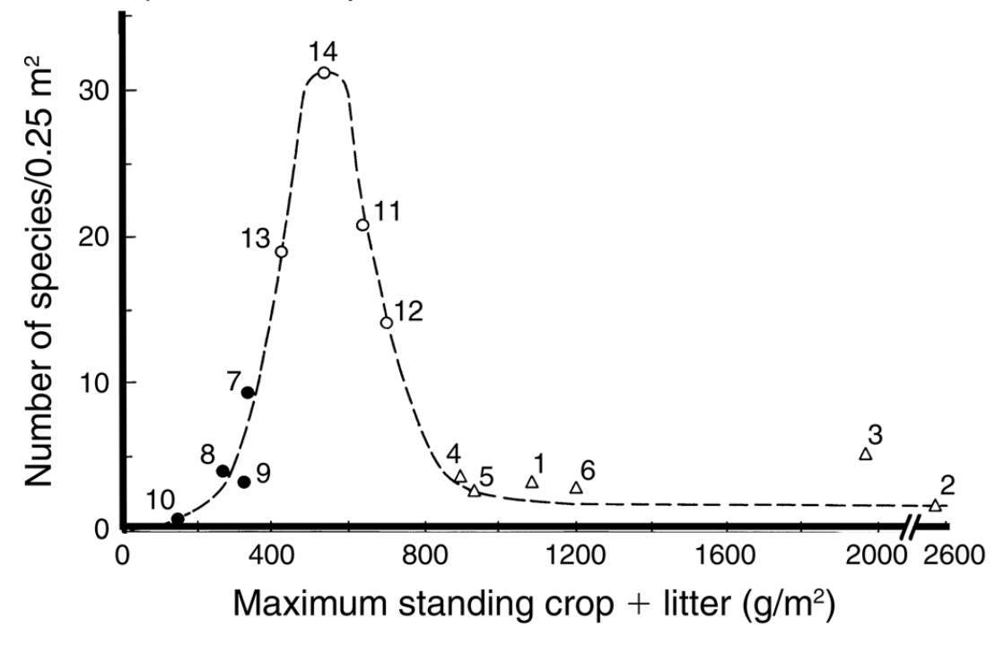
Fig. 2 Legend: Herbaceous plant species richness in relation to live and dead plant biomass in British pastures and grasslands (Al-Mufti et al. 1977). Each numbered point indicates a different site.

Introduction: Now that you’ve explored theoretical predictions from the Diversity Equilibrium Model (DEM), let’s examine a real dataset from British pastures. In these grasslands, researchers measured productivity (standing crop + litter in g/m²) and counted herbaceous plant species in matched plots. The disturbance regime (mowing + grazing) is fairly uniform across sites, which lets us look at the relationship between productivity and diversity without disturbance varying much. Your task is to observe patterns, explain them using ecological concepts, and connect them to real ecosystems and human management.

- What overall pattern do you see in species richness along the productivity gradient?

- What part of the graph shows the highest number of species?

- What happens to species richness when productivity is very high (e.g., 1500–2600 g/m²)?

- What happens at very low productivity (<200 g/m²)?

- Compare the shape of this curve to the predictions from the DEM figure you worked with in Figure 1. Which of your sketched predictions does Figure 2 most closely match?

- Why might diversity be low in low-productivity pastures?

- Why might diversity also be low in high-productivity pastures?

- How could competition intensity change across this gradient?

- Disturbance is fairly consistent across these pastures (mowing + grazing). How does this help isolate the effect of productivity?

- Refer again to your sketched prediction from Figure 1 that Figure 2 most closely matches. How does this productivity–diversity curve reflect the mechanism of the DEM (balance between competitive exclusion and demographic turnover)?

- Examine the table below which describes three different real-world grassland ecosystems. Based on the information from Figure 2, which grassland would you predict to have the highest plant species richness?

Grassland Ecosystem | Description
Shortgrass Prairie (Colorado, Wyoming, New Mexico, USA) | Receives relatively little rainfall each year. Vegetation is dominated by short grasses, with large areas of exposed soil visible between plants.
Mixed-Grass Prairie (Great Plains, USA and Canada) | Receives moderate rainfall. Vegetation contains a mixture of short and tall grasses, along with many wildflowers and other herbaceous plants.
Tallgrass Prairie (Kansas, Oklahoma, USA) | Receives relatively high rainfall. Vegetation is dense and dominated by tall grasses that can exceed 2 meters in height, creating a nearly continuous canopy causing little light to reach the soil surface.

- How might human management (fertilizer addition) shift a pasture along this curve?

- How might reducing grazing or mowing frequency affect the system?

- Imagine you’re a land manager aiming for high plant diversity. What practices could keep the system near intermediate productivity?

- Based on your answers to the questions above, independently summarize how this real dataset reinforces the broader principle shown in the DEM figure. After you have written your summary, pair with a neighbor and share your responses.

Figure 3
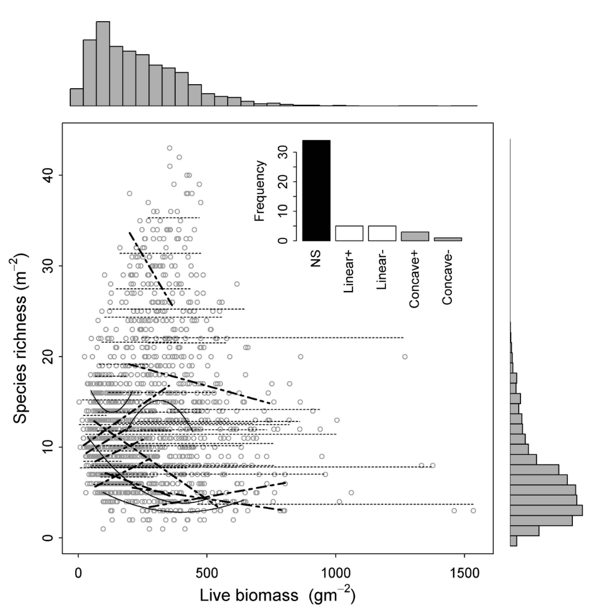

Fig. 3 Legend: Relationships between productivity (measured as peak live biomass (i.e., dry weight)) and species richness (Adler et al. 2011). Each point represents a plot within a site. Lines show the relationship between live biomass and species richness at each of the 48 sites in the study. The inset shows the frequencies of relationships that were nonsignificant (NS, thin dashed lines), positive or negative linear (thick dashed lines), and concave-up (+) or -down (–) (solid curves). The marginal histograms show the frequency of species richness and peak live biomass across all sites.

Introduction: In Figure 2, you examined the relationship between productivity and species richness in one region. What if we scale up? In this study, researchers conducted standardized sampling in 48 herbaceous-dominated plant communities on five continents. This work was made possible by the cooperative effort called the Nutrient Network (NutNet) – a global network of hundreds of scientists that collect data from a broad range of sites in a consistent manner to allow direct comparisons of environment-productivity-diversity relationships among systems around the world.

- What overall pattern do you see across all the 48 sites when you look at species richness vs. productivity in the main scatterplot?

- The inset shows five types of within-site relationships (NS, positive, negative, concave-up, concave-down). Which type occurs most often?

- How many of the 48 sites show the classic DEM ‘hump-shaped’ curve (concave-down)?

- What do the marginal histograms tell you about the range of species richness and productivity values across all sites?

- Compare the pattern in this global dataset to the pattern you observed in the British pasture dataset. How are they different?

- Why might different ecosystems show different productivity–diversity relationships even if the DEM predicts a general pattern?

- How might differences in species identity (traits, competitive strategies, growth forms) affect productivity–diversity relationships?

- How could differences in disturbance regimes affect these relationships?

- The DEM expects a productivity gradient. What happens in a site where productivity does not vary much?

- How does scale (local vs. regional vs. global) influence the relationship between productivity and diversity?

- Based on these observations, what additional ecological factors does DEM not fully account for?

- Consider the three ecosystems in the table below and answer the following questions.

Ecosystem | Characteristics
Agricultural Cornfield | Extremely productive due to irrigation and fertilizer inputs but often dominated by one or a few crop species. Soil is tilled annually, and weeds are regularly removed by humans.
Tropical Rainforest | Very high productivity and very high species diversity. Large disturbances are relatively infrequent.
Coral Reef | High productivity and extremely high species diversity. Subject to periodic disturbances such as storms, bleaching events, and predator outbreaks.

  - Which of these ecosystems would be most difficult to explain using the Diversity Equilibrium Model (DEM), which predicts species diversity based primarily on productivity and disturbance? Explain your reasoning.
  - What additional factors besides productivity might help explain the diversity patterns in these ecosystems?

- How might human activities blur or distort productivity–diversity patterns?

- If you were designing your own field study, what additional variables would you measure to understand productivity–diversity relationships beyond the DEM framework?

- What challenges do ecologists face when comparing productivity–diversity relationships among natural ecosystems?

- How might a standardized, replicated global experiment (like the Nutrient Network (NutNet)) help us understand when the DEM holds and when it does not?

- How might a standardized, replicated global experiment help us understand when the DEM holds and when it does not?

- Using evidence from all three figures, independently explain what the figures collectively suggest about the strengths and limitations of the Diversity Equilibrium Model (DEM). In your response, discuss (1) a pattern that supports the model, (2) a pattern that challenges the model, and (3) what these results suggest about the importance of scale and context in ecology. After you have written your explanation, pair with a neighbor and share your responses.

STUDENT INSTRUCTIONS
One of the central goals of ecology is to understand why some communities have more species than others. Ecologists have long suspected that primary productivity (the amount of plant biomass produced) and disturbance (events that remove biomass or organisms, such as grazing, mowing, fire, or storms) play major roles in shaping species diversity.

Michael Huston’s Diversity Equilibrium Model (DEM) predicts that species richness is highest when productivity and disturbance are balanced. When productivity is very low, few species can survive due to limited resources. When productivity is very high and disturbance is low, strong competitors can dominate and exclude other species. Disturbance can slow competitive exclusion by removing dominant species, allowing more species to coexist. The DEM therefore predicts highest diversity at intermediate levels of productivity and/or disturbance.

In this activity, you will examine:
- A conceptual model (DEM) that predicts how productivity, disturbance, and diversity are related.
- Empirical data from British pastures where productivity was measured as plant biomass under relatively uniform disturbance.
- Global grassland data showing that productivity–diversity relationships are not always consistent across sites.

As you work through the figures, you will connect ecological theory, data interpretation, human impacts, and cross-cutting themes such as scale.

NOTES TO FACULTY
This activity works well as a scaffolded, theory-to-data progression. The key is to resist the urge to explain the DEM upfront. Let the figures do the work.

A recommended flow:
- Start with Figure 1 (Huston’s DEM) as a prediction, not a conclusion. Ask students to describe patterns before naming mechanisms.
- Move to the British pasture data to show a clean, empirical example where the DEM appears to work remarkably well.
- End with the global grassland figure to intentionally destabilize students’ confidence in a “one-size-fits-all” model and open the door to complexity, scale, and context.

This sequence mirrors how ecologists actually work: theory → local tests → broader synthesis → recognition of limits.

Common Student Responses & Misunderstandings to Anticipate:

- Students often leave the DEM thinking that intermediate productivity always equals high diversity. The global dataset is crucial for breaking this misconception. Ask, “If intermediate productivity is ‘best,’ why don’t we see that pattern everywhere?”

- Students may focus on richness without thinking about who the species are. Prompt with: “Would 20 grasses behave the same as 20 grasses + legumes + forbs?” or “How might dominant species matter here?”

- Many students assume that patterns observed at one site should generalize globally. Emphasize that in the British pastures disturbance was consistent and there were similar species pools across sites. In the global grasslands, we are dealing with different climates, histories, species pools, and human impacts. This is an excellent moment to explicitly name scale as a cross-cutting theme.

Key

Figure 1

Fig. 1 Legend Predictions of species diversity made by the Dynamic Equilibrium Model (DEM) (redrawn from Huston 1979, 1994), showing the interactive effects of productivity (e.g., Net Primary Productivity, plant growth rates) and disturbance (e.g., herbivory, fire) on species diversity. Levels of species diversity are indicated by shading, with the highest species diversity predicted along the darkest diagonal, from lower left to upper right.

Introduction: Ecologists have long observed that species diversity varies across environments that differ in productivity (resource availability) and disturbance (events that disrupt populations). The Diversity Equilibrium Model (DEM), proposed by Michael Huston, predicts how diversity changes as these two factors interact. Use the figure showing diversity across productivity and disturbance to explore patterns and develop explanations for why species diversity is highest under certain conditions.

- In the figure, where is species diversity highest? Mark this area on the figure with x’s.
It is highest along the diagonal from bottom left to top right.
  - What combination of productivity and disturbance corresponds to this region?
When they are at similar levels, diversity is predicted to be the highest. Many students initially misinterpret the DEM with the assumption that greater productivity always supports greater biodiversity. Rather than immediately correcting incorrect responses, consider using probing questions that encourage students to examine the entire pattern shown in the figure and identify the underlying mechanism. For example, if students correctly identify one portion of the high-diversity region but fail to recognize that the pattern extends across the figure, ask them to compare multiple locations on the graph and ask, "What do all of the high-diversity regions have in common?”. Having students arrive at the conclusions themselves often leads to a deeper understanding of the model and better prepares them to interpret the subsequent empirical figures.

- Where is species diversity lowest? Make this area on the figure with o’s.
In the top left and bottom right corners.
  - What do productivity and disturbance look like in those regions?
In the top left, productivity is low, but disturbance is high. In the bottom right productivity is high, but disturbance is low.

- Based on the DEM, as you move from low to high productivity at low disturbance, how is diversity predicted to change?
Diversity goes down as you move from low to high productivity at low disturbance.
  - Sketch this relationship in the space below. Be sure to label the axes.
Predicted Species Diversity at Low Disturbance

Predicted Species Diversity at Low Disturbance
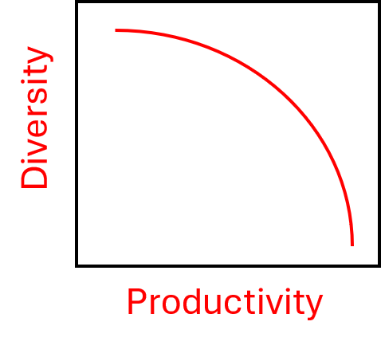
Students may draw a negative relationship, but as a straight line. This response demonstrates that the student correctly understands the overall trend predicted by the DEM—diversity decreases as productivity increases when disturbance remains low. However, it may not fully capture the shape of the relationship shown in the figure. You could ask, "Does the figure suggest diversity decreases at a constant rate across the entire productivity gradient?". For introductory students, focus primarily on whether they identify the correct direction of change. The distinction between a linear and curvilinear decline can be used as a discussion point.

Students may accidentally describe movement up the disturbance axis rather than across the productivity axis. Prompt students with "Which variable are we changing in this question?" or "Can you point to the path you are following on the figure?". Many students understand the pattern but are examining the wrong axis. Encourage them to physically trace the pathway on the figure.

- When disturbance is low, when would you expect the highest species diversity? Hypothesize why.
When disturbance is low, we would expect the highest species diversity when productivity is also low.

This may be because they are resource-limited but stable for very long periods (low disturbance), the species have evolved to partition resources extremely finely (specialization), competition is slow, so many species can coexist despite low productivity.

You can give students the example of the Arctic tundra (stable, low disturbance patches). Here, productivity is low (short growing season, cold temperatures, limited nutrients) and disturbance is low (outside of occasional localized events like frost heave or small grazing pressure), yet you can still get relatively high plant diversity at local scales. You often find a mix of mosses and lichens,
dwarf shrubs (e.g., willow, birch shrubs), sedges and grasses, scattered forbs adapted to nutrient limitation. In these systems no species can grow fast enough to completely dominate because energy and nutrients are tightly limited, growth is slow, so competitive exclusion unfolds very weakly and many species persist by tolerating stress rather than outcompeting others. Microhabitat variation (soil moisture, permafrost depth, exposure) also creates many small niches.

- Based on the DEM, what is predicted to happen to species diversity as you move from low to high productivity at high disturbance?
Diversity goes up as you move from low to high productivity at high disturbance.
  - Sketch this relationship in the space below. Be sure to label the axes.
Predicted Species Diversity at High Disturbance

Predicted Species Diversity at High Disturbance

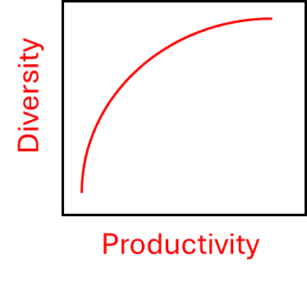

- When disturbance is high, when would you expect the highest species diversity? Hypothesize why.

At high disturbance, the highest species diversity would be observed where productivity is also high.

This may be because resources are abundant (high productivity), so many species could thrive. Disturbance is frequent or intense enough to prevent a few fast-growing species from monopolizing resources (but not so extreme that species cannot persist between disturbance events).

You can use the example of the East African savanna (e.g., Serengeti ecosystem) to illustrate this point, which has high disturbance: frequent fire regimes and intense grazing by large herbivores (wildebeest, zebras, elephants). It also has high productivity and high diversity (grasses, forbs, shrubs, and a large diversity of herbivores and predators coexist).

- Draw a horizontal line on the DEM graph at an intermediate level of disturbance. How does diversity change from low to high productivity?
Diversity starts low, then goes up, then decreases again. Diversity is highest at intermediate levels of disturbance.
  - Sketch this relationship in the space below.

Predicted Species Diversity at Intermediate Disturbance

Predicted Species Diversity at Intermediate Disturbance

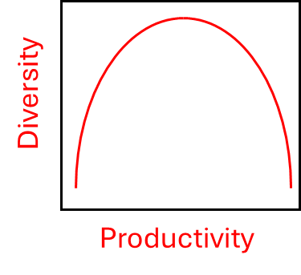

- When disturbance is intermediate, when would you expect the highest species diversity? Hypothesize why.
At intermediate productivity, the highest species diversity would be observed where disturbances are also intermediate.

This may be because productivity is high enough to support more than a few species and disturbance occurs often enough to prevent total competitive dominance.

An example of an ecosystem like this are temperate grasslands and prairies with managed fire/grazing where fire is enough to prevent total dominance but not frequent enough to maintain maximum richness like highly dynamic savanna systems.

- Based on your explanations above, how do productivity and disturbance interact to influence how fast competitive exclusion happens?
Productivity controls how fast competitive exclusion can proceed (higher productivity → faster exclusion). Disturbance resets competitive dynamics (intermediate levels slow exclusion enough to allow coexistence). The combination determines where diversity is maximized; along the diagonal both factors change together so exclusion and reset rates remain balanced.

- Based on your answers to the questions above, independently summarize the general rule the DEM is proposing. After you have written your general rule, pair with a neighbor and share your responses.
Diversity is maximized when productivity and disturbance are balanced; along either single gradient diversity is highest at intermediate values (bell-shaped), and when productivity and disturbance change together diversity can remain high across that range.

- In some ecosystems, climate change may increase productivity (e.g., more CO₂ and nutrients) and increase disturbance (e.g., more storms/fires) together proportionally. Based on the DEM, what would you predict happens to biodiversity in these systems?
These ecosystems would maintain their diversity (i.e., they would move along the diagonal in the figure).
  - What would you predict happens to species diversity if productivity and disturbance shift unevenly?
Ecosystems may move off the diagonal and lose diversity. The outcomes would depend on the magnitude and direction of change of the interacting factors.

Figure 2

Fig. 2 Legend: Herbaceous plant species richness in relation to live and dead plant biomass in British pastures and grasslands (Al-Mufti et al. 1977). Each numbered point indicates a different site.

Introduction: Now that you’ve explored theoretical predictions from the Diversity Equilibrium Model (DEM), let’s examine a real dataset from British pastures. In these grasslands, researchers measured productivity (standing crop + litter in g/m²) and counted herbaceous plant species in matched plots. The disturbance regime (mowing + grazing) is fairly uniform across sites, which lets us look at the relationship between productivity and diversity without disturbance varying much. Your task is to observe patterns, explain them using ecological concepts, and connect them to real ecosystems and human management.

- What overall pattern do you see in species richness along the productivity gradient?
Species richness increases as productivity increases, peaking around ~400–500 g/m², then declines as productivity gets higher.

- What part of the graph shows the highest number of species?
The peak is around ~30 species/0.25 m² at intermediate biomass levels.

- What happens to species richness when productivity is very high (e.g., 1500–2600 g/m²)?
High productivity seems to be linked with low diversity.

- What happens at very low productivity (<200 g/m²)?
Low productivity also has low diversity.

- Compare the shape of this curve to the predictions from the DEM figure you worked with in Figure 1. Which of your sketched predictions does Figure 2 most closely match?
It matches the unimodal curve. This looks like the figure “Predicted Species Diversity at Intermediate Disturbance.”

- Why might diversity be low in low-productivity pastures?
There might not be enough resources for many plants to survive. Only a few stress-tolerant species can grow.

- Why might diversity also be low in high-productivity pastures?
Fast-growing species outcompete the others. A few dominant plants take over when resources are abundant.

- How could competition intensity change across this gradient?
At high productivity, competition becomes intense and fast-growing species win quickly. At low productivity, growth is slow for everyone, so species numbers are limited.

- Disturbance is fairly consistent across these pastures (mowing + grazing). How does this help isolate the effect of productivity?
Since disturbance is similar everywhere, the differences in diversity must mainly come from productivity.

- Refer again to your sketched prediction from Figure 1 that Figure 2 most closely matches. How does this productivity–diversity curve reflect the mechanism of the DEM (balance between competitive exclusion and demographic turnover)?
At intermediate productivity, competitive exclusion is slow enough that many species can coexist. This is the central slice of the DEM along the productivity axis.

- Examine the table below which describes three different real-world grassland ecosystems. Based on the information from Figure 2, which grassland would you predict to have the highest plant species richness?

Grassland Ecosystem | Description
Shortgrass Prairie (Colorado, Wyoming, New Mexico, USA) | Receives relatively little rainfall each year. Vegetation is dominated by short grasses, with large areas of exposed soil visible between plants.
Mixed-Grass Prairie (Great Plains, USA and Canada) | Receives moderate rainfall. Vegetation contains a mixture of short and tall grasses, along with many wildflowers and other herbaceous plants.
Tallgrass Prairie (Kansas, Oklahoma, USA) | Receives relatively high rainfall. Vegetation is dense and dominated by tall grasses that can exceed 2 meters in height, creating a nearly continuous canopy causing little light to reach the soil surface .

The mixed-grass prairie would likely have the highest plant species richness.

Students should reason that:

- The shortgrass prairie appears resource-limited because of lower rainfall and sparse vegetation, which may limit the number of species that can persist.
- The tallgrass prairie appears highly productive because of abundant rainfall and dense vegetation. In these systems, competition for light can become intense, allowing a few dominant species to exclude others.
- The mixed-grass prairie appears to represent an intermediate condition, with sufficient resources to support many species but without the extreme dominance expected in highly productive systems.

- How might human management (fertilizer addition) shift a pasture along this curve?
Adding fertilizer increases productivity → moves the pasture to the right → probably lowers species diversity.

- How might reducing grazing or mowing frequency affect the system?
Less disturbance → more litter builds up → productivity rises → diversity goes down. It could push the system toward the high-productivity, low-diversity end.

- Imagine you’re a land manager aiming for high plant diversity. What practices could keep the system near intermediate productivity?
Use moderate grazing. Avoid over-fertilization. Periodic mowing to prevent dominance.

- Based on your answers to the questions above, independently summarize how this real dataset reinforces the broader principle shown in the DEM figure. After you have written your summary, pair with a neighbor and share your responses.
Both figures show that diversity peaks at intermediate productivity when disturbance is kept constant. It shows that the DEM isn’t just a theory — real data match it.

Figure 3

Fig. 3 Legend: Relationships between productivity (measured as peak live biomass (i.e., dry weight)) and species richness (Adler et al. 2011). Each point represents a plot within a site. Lines show the relationship between live biomass and species richness at each of the 48 sites in the study. The inset shows the frequencies of relationships that were nonsignificant (NS, thin dashed lines), positive or negative linear (thick dashed lines), and concave-up (+) or -down (–) (solid curves). The marginal histograms show the frequency of species richness and peak live biomass across all sites.

Introduction: In Figure 2 you examined the relationship between productivity and species richness in one region. What if we scale up? In this study researchers conducted standardized sampling in 48 herbaceous-dominated plant communities on five continents. This work was made possible by the cooperative effort called the Nutrient Network (NutNet) – a global network of hundreds of scientists that collect data from a broad range of sites in a consistent manner to allow direct comparisons of environment-productivity-diversity relationships among systems around the world.

- What overall pattern do you see across all of the 48 sites when you look at species richness vs. productivity in the main scatterplot?
There’s no clear pattern. It looks like a cloud—species richness doesn’t consistently increase OR decrease with productivity. There is no clear relationship between productivity and fine-scale (meters−2) richness within sites, within regions, or across the globe.

- The inset shows five types of within-site relationships (NS, positive, negative, concave-up, concave-down). Which type occurs most often?
Nonsignificant relationships are most common. Concave-down (the DEM hump) is not the dominant pattern.

- How many of the 48 sites show the classic DEM ‘hump-shaped’ curve (concave-down)?
From the inset 2-3, which is far fewer than expected if DEM was universal.

- What do the marginal histograms tell you about the range of species richness and productivity values across all sites?
The histograms tell us about where the data are concentrated on each axis. Across all sites, the histograms show that extreme productivity and extreme richness values are relatively uncommon across sites, with most observations clustering in intermediate ranges. Note: some students may try to say something about the relationship between richness and productivity based on the histograms. It is important to note that histograms are not about association, only distribution along one axis at a time. They do not show how richness and productivity co-vary—that relationship is only visible in the scatterplot.

- Compare the pattern in this global dataset to the pattern you observed in the British pasture dataset. How are they different?
British pastures showed a clear unimodal curve. Here, the patterns differ from site to site. Across many sites, there is no universal relationship.

- Why might different ecosystems show different productivity–diversity relationships even if the DEM predicts a general pattern?
Different species pools. Different limiting factors. Species interact differently.

- How might differences in species identity (traits, competitive strategies, growth forms) affect productivity–diversity relationships?
Differences in species identity can strongly shape productivity–diversity relationships because species vary in traits such as growth rate, resource use strategy, and competitive ability. At higher productivity, fast-growing, resource-acquisitive species often gain a competitive advantage and can exclude slower-growing, stress-tolerant species, reducing diversity. In contrast, communities with greater functional trait diversity can promote niche partitioning and allow more species to coexist across productivity gradients. Differences in growth forms (e.g., grasses vs. forbs vs. shrubs) also influence outcomes by altering light competition and vertical structure, which can further shift which species dominate as productivity increases.

- How could differences in disturbance regimes affect these relationships?
Some sites may have frequent fires, others rare grazing, storms, floods, frost, etc. Disturbance frequency, intensity, and type all matter—DEM only models rate, not type.

- The DEM expects a productivity gradient. What happens in a site where productivity does not vary much?
If productivity does not vary much within a site, the DEM predicts that productivity will have little to no detectable effect on species diversity within that site. Instead, diversity patterns will be driven more strongly by other factors, especially disturbance. In such cases, the expected productivity–diversity relationship may appear weak, flat, or inconsistent because there is insufficient variation in productivity to generate a clear gradient response.

- How does scale (local vs. regional vs. global) influence the relationship between productivity and diversity?
At one site (British pastures), the pattern was clear. Across many sites, each with different conditions, the pattern disappears. What’s true at one scale is not always true at another.

- Based on these observations, what additional ecological factors does DEM not fully account for?
Species traits and identities (functional diversity). Species pool differences (biogeography). Disturbance types (not just rates). Historical contingencies (land use history). Abiotic constraints (soil type, climate).

- Consider the three ecosystems in the table below and answer the following questions.

Ecosystem | Characteristics
Agricultural Cornfield | Extremely productive due to irrigation and fertilizer inputs but often dominated by one or a few crop species. Soil is tilled annually, and weeds are regularly removed by humans.
Tropical Rainforest | Very high productivity and very high species diversity. Large disturbances are relatively infrequent.
Coral Reef | High productivity and extremely high species diversity. Subject to periodic disturbances such as storms, bleaching events, and predator outbreaks.

  - Which of these ecosystems would be most difficult to explain using the Diversity Equilibrium Model (DEM), which predicts species diversity based primarily on productivity and disturbance? Explain your reasoning.
In the cornfield there is high productivity, high disturbance but low diversity. The DEM would predict high diversity. Here, human management maintains a community dominated by a single crop species. In the tropical rainforest there is high productivity and high diversity with low disturbance. The DEM would predict low diversity. While productivity may help support many species, productivity alone cannot explain why hundreds of species coexist rather than a few dominant competitors excluding the rest. In the coral reef there is high productivity, high diversity, and intermediate disturbance. The DEM would predict intermediate diversity. Diversity appears to be influenced by factors beyond productivity and disturbance.
  - What additional factors besides productivity might help explain the diversity patterns in these ecosystems?
Several factors not included in the DEM may influence biodiversity:
    - Habitat complexity: Tropical rainforests and coral reefs contain many different niches and microhabitats that allow species to specialize and coexist.
    - Species pool: Tropical regions often have access to a larger regional pool of species than temperate ecosystems.
    - Evolutionary history: Long periods of environmental stability can allow species to accumulate over time.
    - Species interactions: Predation, mutualisms, herbivory, and other interactions can prevent competitive exclusion and promote coexistence.
    - Human management: In agricultural systems, humans strongly influence which species are present regardless of productivity.
    - Disturbance characteristics: The frequency, intensity, and type of disturbance may matter, not just the overall disturbance rate.
    - Species identity and functional traits: Different species compete and respond to environmental conditions in different ways.

- How might human activities blur or distort productivity–diversity patterns?
Fertilizer alters productivity quickly. Land-use change alters species pools. Grazing intensity varies because of livestock practices.

- If you were designing your own field study, what additional variables would you measure to understand productivity–diversity relationships beyond the DEM framework?
Species traits, functional groups. Soil nutrients, moisture, climate variables. Disturbance type and frequency. Presence of invasive species.

- What challenges do ecologists face when comparing productivity–diversity relationships among natural ecosystems?
Natural ecosystems differ in many ways besides productivity, including climate, soils, species pools, disturbance regimes, and land-use history. Because these factors vary simultaneously, it can be difficult to determine which factors are responsible for observed differences in biodiversity patterns.

- How might a standardized, replicated global experiment (like the Nutrient Network (NutNet)) help us understand when the DEM holds and when it does not?
A standardized experiment allows researchers to manipulate the same factors (such as nutrient availability or herbivory) using identical methods across many sites. This reduces methodological differences among studies and helps isolate the effects of specific ecological drivers. By comparing results across ecosystems, scientists can determine whether DEM predictions are broadly applicable or whether they depend on local conditions.

- Using evidence from all three figures, independently explain what the figures collectively suggest about the strengths and limitations of the Diversity Equilibrium Model (DEM). In your response, discuss (1) a pattern that supports the model, (2) a pattern that challenges the model, and (3) what these results suggest about the importance of scale and context in ecology. After you have written your explanation, pair with a neighbor and share your responses.

The figures suggest that the Diversity Equilibrium Model (DEM) is a useful framework for understanding how productivity and disturbance can influence biodiversity, but that it does not fully explain biodiversity patterns in all ecosystems.

(1) A pattern that supports the DEM is shown in Figure 2, where species richness in British grasslands peaks at intermediate levels of productivity and declines at both low and high productivity. This hump-shaped relationship is consistent with the DEM prediction that diversity should be highest when productivity and competitive exclusion are balanced.

(2) A pattern that challenges the DEM is shown in Figure 3, where productivity–diversity relationships vary considerably among grassland sites around the world. Many sites show weak, nonsignificant, positive, or negative relationships rather than the unimodal pattern predicted by the DEM. This suggests that factors other than productivity and disturbance influence biodiversity.

(3) Together, these figures highlight the importance of scale and context in ecology. The DEM successfully explains patterns within some ecosystems, such as the British grasslands, but it is less successful at predicting patterns across many ecosystems that differ in climate, species pools, disturbance regimes, evolutionary history, and human impacts. Ecologists can use models such as the DEM to generate hypotheses and identify general patterns, but they must also consider the unique characteristics of individual ecosystems when applying ecological theory.

LITERATURE CITED
Adler, P. B., et al. 2011. Productivity is a poor predictor of plant species richness. Science 333:1750–1753.
Al-Mufti, M. M., C. L. Sydes, S. B. Furness, J. P. Grime, and S. R. Band. 1977. Species density in relation to productivity and management of grasslands in Britain. Journal of Ecology 65:341–351.
Ellis, E. C. 2011. Anthropogenic transformation of the terrestrial biosphere. Philosophical Transactions of the Royal Society B 366:201–204.
Huston, M. A. 1979. A general hypothesis of species diversity. American Naturalist 113:81–101.
Huston, M. A. 1994. Biological Diversity: The Coexistence of Species on Changing Landscapes. Cambridge University Press.

